# Pupil premium strategy statement 2021 – 2024

# School overview

|  |  |
| --- | --- |
| **Detail** | **Data** |
| School name | **Red Hall Primary School** |
| Number of pupils in school | **207 (2021 – 2022)**  **213 (2022 – 2023)**  **222 (2023 – 2024) October 2023** |
| Proportion (%) of pupil premium eligible pupils | **70.5% (2021-22)**  **66% (2022 – 2023)**  **65% (2023 – 2024) October 2023** |
| Academic year/years that our current pupil premium strategy plan covers **(3-year plans are recommended)** | **2021 - 2024** |
| Date this statement was published | **October 2021**  **Reviewed and revised November 2022**  **Reviewed and revised October 2023**  Reviewed October 2024 |
| Date on which it will be reviewed | **November 2024** |
| Statement authorised by | **Julie Davidson**  **Governors 7th December 2022**  **Governors December 2023** |
| Pupil premium lead | **Julie Davidson** |
| Governor lead | **Andrew Buckton** |

## Funding overview

|  |  |
| --- | --- |
| **Detail** | **Amount** |
| Pupil premium funding allocation this academic year | **£184.206 (2021 – 2022)**  **£176, 070 (2022 – 2023)**  **£175,009 (2023 – 2024)** |
| Recovery premium funding allocation this academic year | **£16,675 (2021 – 2022)**  **£17,395 (2022 – 2023)**  **£17,395 (2023 – 2024)** |
| Pupil premium funding carried forward from previous years (enter £0 if not applicable) | **£0** |
| **Total budget for this academic year** | **£200,881 (2021 – 2022)**  **£193,465 (2022 – 2023)**  **£192, 404 (2023 – 2024)** |

# Part A: Pupil premium strategy plan

**Statement of intent**

## Demography and School Context

Red Hall Primary School is an average sized, one form entry, Local Authority maintained Primary School on Red Hall in Darlington. From September 2021, our school has expanded to incorporate, an alternative provision which will cater for 16 full time pupils with EHCP’s with a primary identified need of Social, Emotional and Mental Health.

**Deprivation (IDACI report created November 2021)**

### According to the 2019 Income Deprivation Affecting Children Index 2019 we know that 90% of our pupils live within the top 5% most deprived areas in England (this is an increase of 5% since 2015)

The key factors that affect our families are; **low income, education, employment and crime.**

When making decisions about using Pupil Premium funding it is important to consider the context of the school and the subsequent challenges faced. This sits alongside research conducted by the EEF when creating this strategy. Common barriers to learning for disadvantaged children can be: less support at home, poor language and communication skills, social, emotional and mental health difficulties and attendance and punctuality issues. There may also be complex family situations with emotional well-being needs not being met, that prevent children from flourishing. The challenges are varied and there is no “one size fits all”.

At Red Hall Primary School, we aim to:

* Ensure that the teaching and learning opportunities that we provide, meet the needs of all the pupils.
* Provide pupils with appropriate provision, support and intervention to enable them to achieve age related expectations.
* Target support for emotional health and well-being to those pupils and families who require this additional support by providing intensive pastoral support for pupils and their parent/carers.
* Improve the attendance of disadvantaged pupils in school.

|  |
| --- |
| * Invest in our pupils having access to wider opportunities that support and engage them in education. We will facilitate pupils accessing a wide range of enrichment experiences both in and out of school, which will positively impact on their academic achievement and well-being.     We also recognise that not all pupils in receipt of Pupil Premium will be socially disadvantaged and that some pupils in our school may be socially disadvantaged and may not qualify for Pupil Premium. We therefore reserve the right to allocate the funding to support any group of pupils the school itself has identified as socially disadvantaged.    We aim to do this through:   * Additional 1-1 and small group learning support * Paying for activities such as; educational visits and residentials to enrich children’s first hand experiences that can be used to support learning within and beyond the classroom. * Support the funding of specialist learning software. * To allow the children to learn a musical instrument at Key Stage 2. * Behaviour and nurture support during lunchtimes by providing play activities to engage and promote social development. * Ensuring all teaching is good or better thus ensuring that the quality of teaching experienced by all children is improved. * To allocate a teaching assistant to each Year Group - providing small group work focussed on overcoming gaps in learning * Additional teaching and learning opportunities provided through trained Academic Mentors. * Emotional Well Being support services.     This list is not exhaustive and will change according to the needs and support our socially disadvantaged pupils require. |

## Challenges

This details the key challenges to achievement that we have identified among our disadvantaged pupils.

|  |  |
| --- | --- |
| **Challenge number** | **Detail of challenge** |
| 1 | In 2022 and 2023 data, attainment of disadvantaged pupils is significantly below their peers in Reading, Writing, Maths at KS1 and KS2, the gaps in learning need to be addressed for whole class and disadvantaged children through Quality First Teaching, to meet the needs of all children. |
| 2 | Poor Early Language and Communication skills  Our disadvantaged pupils have limited vocabulary knowledge, therefore they have lower starting point in Speech and Language on entry to school. This therefore impacts on their fluency when reading and ability to decode when reading. For our disadvantaged pupils, the lack of exposure to high quality texts impacts on the quality of writing too. |
| 3 | Low attainment on entry to the Early Years Foundation Stage in all areas. |
| 4 | Phonics  Assessments, observations, and discussions indicate that disadvantaged pupils generally have greater difficulties with phonics than their peers. This negatively impacts their development as readers. |
| 5 | Increased numbers of pupils with complex needs, including speech and language, social communication, attention difficulties, motor skills, social emotional and mental health. |
| 6 | Attendance, reducing the number of hours pupils are in school. |
| 7 | Parental and Family engagement in children’s learning. |
| 8 | Limited life experiences and opportunities for enrichment |

## Intended outcomes

This explains the outcomes we are aiming for **by the end of our current strategy plan**, and how we will measure whether they have been achieved.

|  |  |
| --- | --- |
| **Intended outcome** | **Success criteria** |
| Improved speech and language skills and increased vocabulary | Assessments and observations indicate significantly improved oral language among disadvantaged pupils. |
| Improved English and Maths skills through quality first teaching and further developed through small group or 1:1 intervention. | Outcomes at KS1 and 2 are at least in line with National Outcomes in 2024/2025 show that disadvantaged pupils met the expected standard in line with their peers (except where significant SEN is present). |
| Improved Phonics skills and knowledge for Early Readers | Phonics outcomes improve and are back in line with historical data and at least in line with National. |
| To achieve and sustain improved attendance for all pupils, particularly our disadvantaged pupils. | Sustained and improved attendance.  Ensure attendance of disadvantaged pupils is above 95% |
| Improved emotional well-being among pupils/parents and carers. | Families are supported to reduce barriers to children’s achievement –    Evidence gathered from pupil and parent voice surveys and teacher observations is positive. |

## Activity in this academic year

This details how we intend to spend our pupil premium (and recovery premium funding) **this academic year** to address the challenges listed above.

### Teaching (for example, CPD, recruitment and retention)

Budgeted cost: **£137,000**

|  |  |  |
| --- | --- | --- |
| **Activity** | **Evidence that supports this approach** | **Challenge number(s) addressed** |
| **TA support in every class for English and Maths to assist with effective delivery of attainment grouping.** | EEF states that Within class attainment grouping has a positive impact, on average, of 2 months additional progress. Extra adult support is essential to ensuring all groups are supported and challenged where necessary. | 1 |
| **Training for staff to embed metacognitive strategies improving quality first**  **teaching** | [https://educationendowmentfoundation.org.uk/education-](https://educationendowmentfoundation.org.uk/education-evidence/teaching-learning-toolkit/metacognition-and-self-regulation)  [evidence/teaching-learning-toolkit/metacognition-and-self-regulation](https://educationendowmentfoundation.org.uk/education-evidence/teaching-learning-toolkit/metacognition-and-self-regulation) | 1 |
| **Ensure the continued effectiveness of our Phonics programme through training and the use high quality resources (including books) to secure stronger phonics teaching for all pupils but especially those who are disadvantaged.** | Phonics approaches have a strong evidence base that indicates a positive impact on the accuracy of word reading (though not necessarily comprehension), particularly for disadvantaged pupils: Phonics | EEF (educationendowmentfoundation.org.uk)    [https://educationendowmentfoundation.org.uk/educationevidence/teaching-learning-toolkit/phonics](https://educationendowmentfoundation.org.uk/education-evidence/teaching-learning-toolkit/phonics)    [Phonics | Toolkit Strand | Education Endowment Foundation | EEF](https://educationendowmentfoundation.org.uk/evidence-summaries/teaching-learning-toolkit/phonics/) | **1,2,3,4** |
|  |  | **1,2 ,4** |
| **Additional level 3 Teaching Assistant working within the SEN team to support**  **SEN in EYFS** | In Nursery, 45% of disadvantaged children are below expectation for  Listening and Attention and Speaking. (2021)    67% of the cohort are below expected on entry to Reception 2021 (60% of these disadvantaged).    26% of disadvantaged children have significant SEND/ learning difficulties.    There is a strong evidence base that suggests oral language interventions, including dialogic activities such as high-quality classroom discussion, are inexpensive to implement with high impacts on reading:    [https://educationendowmentfoundation.org.uk/educationevidence/teaching-learning-toolkit/oral-language-interventions](https://educationendowmentfoundation.org.uk/education-evidence/teaching-learning-toolkit/oral-language-interventions) |  |
| **Additional afternoon for Inclusion Lead to focus on inclusion and attendance** | A large proportion of our disadvantaged children are SEND requiring additional support and monitoring. | **4, 5** |
| **Use of the Mastering**  **Number Programme in**  **Reception to Year 2 with a full commitment to the training and development programme** | The Mastering Number Programme will have a daily teacher led session of 10 to 15 minutes, children in Reception, Year 1 and Year 2. This is designed to ensure that pupils develop fluency with, and understanding of, number that is crucial to future success in maths and academic progress more generally Early numeracy approaches |  EEF (educationendowmentfoundation.org.uk) | **1, 3** |
| **Employment of Child and**  **Family Wellbeing Lead**    Engagement with families to promote attendance and engagement in school, particularly with disadvantaged families. | WORKING WITH PARENTS TO SUPPORT CHILDREN’S LEARNING/ EEF | **2, 3, 5, 6, 7** |

### Targeted academic support (for example, tutoring, one-to-one support structured interventions)

Budgeted cost: **£110,150**

|  |  |  |
| --- | --- | --- |
| **Activity** | **Evidence that supports this approach** | **Challenge number(s) addressed** |
| **Parent/Carer Workshops for Phonics** | Parent/carer workshops to support targeted families with strategies for Phonics and provide packs of resources | **4,** |
| **Engaging with the NTP programme to provide academic mentoring with a focus on Phonics and Reading for pupils whose education has been most impacted by the pandemic in Key Stage 1 and 2.** | Tuition targeted at specific needs and knowledge gaps can be an effective method to support low attaining pupils or those falling behind, both one-to-one:  [One to one tuition | EEF (educationendowmentfoundation.org.uk)](https://educationendowmentfoundation.org.uk/education-evidence/teaching-learning-toolkit/one-to-one-tuition) And in small groups:  [Small group tuition | Toolkit Strand | Education Endowment Foundation | EEF](https://educationendowmentfoundation.org.uk/evidence-summaries/teaching-learning-toolkit/small-group-tuition/) | **3, 6** |
| Phonics approaches have a strong evidence base indicating a positive impact on pupils, particularly from disadvantaged backgrounds. Targeted phonics interventions have been shown to be more effective when delivered as regular sessions over a period up to 12 weeks:  [https://educationendowmentfoundation.org.uk/educationevidence/teaching-learning-toolkit/phonics](https://educationendowmentfoundation.org.uk/education-evidence/teaching-learning-toolkit/phonics)    [Phonics | Toolkit Strand | Education Endowment Foundation | EEF](https://educationendowmentfoundation.org.uk/evidence-summaries/teaching-learning-toolkit/phonics/) | **3** |
| **Employ X 3 ELSA (Emotional Literacy Support Assistants) working with small groups and 1:1 with pupils.** | *The EEF states that ‘Improvements appear more likely when social and emotional approaches are embedded into routine educational practices and supported by professional development and training for staff. In* | **4,** |
| **Delivering for example:**  ***Emotional Literacy***  ***Sand Play***  ***Drawing and Talking***  ***Therapies***  ***Bereavement Support***        **Counsellor employed through North East Well Being Trust increased to 1.5 days per week due to increased number of pupils significantly affected.** | *addition, the implementation of the programme and the degree to which teachers are committed to the approach appear to be important*    There is extensive evidence associating childhood social and emotional skills with improved outcomes at school and in later life (e.g., improved academic performance, attitudes, behaviour and relationships with peers):  [EEF_Social_and_Emotional_Learning.pdf(educationendow mentfoundation.org.uk)](https://educationendowmentfoundation.org.uk/public/files/Publications/SEL/EEF_Social_and_Emotional_Learning.pdf)    No longer available for 2023/2024 |  |
| **Subscribe to online learning programmes that provide**  **1:1 instruction**  **Times Table**  **Rockstars and Numbots**  **(£202 annually)** | Pupil and staff voice show this is highly effective at engaging pupils and families in learning at home.  EEF states that digital technology can be used effectively to provide individualised instruction, providing an increase of four months over the course of a year    [https://educationendowmentfoundation.org.uk/educationevidence/teaching-learning-toolkit/individualised-instruction](https://educationendowmentfoundation.org.uk/education-evidence/teaching-learning-toolkit/individualised-instruction) | **6** |
| **Use of diagnostic assessments.**  **Training for staff to ensure assessments are interpreted and administered correctly.** | Standardised tests can provide reliable insights into the specific strengths and weaknesses of each pupil to help ensure they receive the correct additional support through interventions or teacher instruction:    Standardised tests | Assessing and Monitoring Pupil Progress |  Education Endowment Foundation | EEF | **1** |
| **Range of Communication, Language and Literacy CPD to be arranged and staff identified to attend linked to CLL; LL Staff to attend Story Dough Training,**  **Nursery staff to access**  **Drawing Club training, All**  **Early Years Staff to revisit Helicopter Story Training, staff to access ‘Early Talk Boost’, the Speech and**  **Language UK (Formerly ICAN) language intervention for 3 and 4 year olds** | There is a strong evidence base that suggests oral language interventions, including dialogic activities such as high quality  classroom discussion, are inexpensive to implement with high impact      Oral language interventions | Toolkit Strand | Education Endowment Foundation | EEF | **1,2,3** |

### Wider strategies (for example, related to attendance, behaviour, wellbeing)

Budgeted cost: **£18, 494**

|  |  |  |
| --- | --- | --- |
| **Activity** | **Evidence that supports this approach** | **Challenge number(s) addressed** |
| **Staff training in Zones of Regulation and shared scripts to support children’s SEMH across school and during free times (lunch and play).** | The EEF published a recent report on Behaviour Policy, and found “the importance of consistency and coherence when it comes to behaviour policies”. We think that this is especially important when working with children around the SEMH needs. Working with external agencies, school has been praised for our inclusive, nurturing, consistent approach – training has been given for keyworkers and teams who support identified children, using scripts, Emotion Coaching and the Zones. This will continue into this year. | 5 |
| **Additional Lunchtime Support to provide high quality games and activities to engage pupils**    **Additional resources to support play based learning and continuous provision throughout the school.** | There is a positive relationship between play and early outcomes. Due to the National Pandemic concerns have arisen regarding the physical health and social skills of our disadvantaged children and we need to support and teach our children how to play again.      [https://educationendowmentfoundation.org.uk/educationevidence/early-years-toolkit/play-based-learning](https://educationendowmentfoundation.org.uk/education-evidence/early-years-toolkit/play-based-learning) | 1, 2, 4, 7 |
| **Data Analysis**  **(including attendance data)(£1580)**    **Bespoke deprivation report – used to identify key deprivation barriers specific to our school**  **(£350)** | The level of detail that goes into these reports allows us to clearly identify the complex factors which create barriers to learning. | **4,5** |
| **Embedding principles of good practice set out in the DfE’s Improving School Attendance advice. This will involve training and release time for staff to develop and implement forensic procedures and to be robust with the LA regarding cases that have been referred.** | The DfE guidance has been informed by engagement with schools that have significantly reduced levels of absence and persistent absence. | **6** |
| **Subsidy of residential visits and enrichment opportunities/memorable experiences (e.g theatre experiences, trip to the seaside) Investment in Wilderness Schooling sessions and training for a range of school staff.**    **Agreement with Durham Music Service to pay for music tuition for Pupil Premium children to allow equality of opportunity.** | Over 90% of our pupils only time away from home during the year is on school residentials. It is essential that children experience different settings before writing about them. Memorable experiences are used to engage children in their thematic learning.  Y3/4 Residential Trip to the Lake District  Y6 Residential Trip to Kingswood    Every child has the right to learn to play an instrument    *EEF States that ‘studies of adventure learning interventions consistently show positive benefits on academic learning. On average, pupils who participate in adventure learning interventions make approximately four additional months’ progress. There is also evidence of an impact on non-cognitive outcomes such as self-confidence.’* | **1, 4, 7** |

**Total budgeted cost: £265, 644**

# Part B: Review of outcomes in the previous academic year

## Progress against Success criteria for ongoing 2021 – 24 Strategy Pupil

## Premium strategy outcomes 2023/2024

This details the impact that our pupil premium activity had on pupils in the 2023 to 2024 academic year.

**2024 EYFS**

70% of pupils are Disadvantaged (14 pupils). 57% of Disadvantaged pupils achieved the GLD.

Disadvantage pupil’s performance in EYFS is similar or better than Disadvantaged pupils nationally, but still

Below ‘other’ pupils nationally.

**Year 1 Phonics**

81% of pupils are Disadvantaged - 25 pupils (16 boys and 9 girls).32% of Disadvantaged pupils achieved the standard compared to 83% of 'Other' pupils Nationally. Therefore, there is an achievement gap of 51%.

National Disadvantaged is 67%. Disadvantaged pupils are below Disadvantaged pupils Nationally. Over the last three years 40% of disadvantaged pupils (23/57) have achieved the expected standard

**Key Stage 1**

78% of pupils are Disadvantaged (21 pupils).

**Reading**

38% of Disadvantaged pupils achieved the extended standards compared to 63% of ‘Other’ pupils nationally. Therefore, there is an achievement gap of 34%. National Disadvantage is 51%. Over the last three years 45% of disadvantaged pupils have achieved the expected standard or above.

**Writing**

38% of Disadvantaged pupils achieved the extended standards compared to 72% of ‘Other’ pupils nationally. Therefore, there is an achievement gap of 25%. National Disadvantage is 41%. Over the last three years 38% of disadvantaged pupils have achieved the expected standard or above.

**Maths**

38% of Disadvantaged pupils achieved the extended standards compared to 73% of ‘Other’ pupils nationally. Therefore, there is an achievement gap of 35%. National Disadvantage is 52%. Over the last three years 43% of disadvantaged pupils have achieved the expected standard or above.

**Key Stage 2**

70% of pupils are Disadvantaged (21 pupils).

**Reading**

52% of Disadvantaged pupils achieved the extended standards compared to 80% of ‘Other’ pupils nationally. Therefore, there is an achievement gap of 28%. National Disadvantage is 64%. Over the last three years 56% of disadvantaged pupils have achieved the expected standard or above.

**Writing**

57% of Disadvantaged pupils achieved the extended standards compared to 83% of ‘Other’ pupils nationally. Therefore, there is an achievement gap of 26%. National Disadvantage is 65%. Over the last three years 57% of disadvantaged pupils have achieved the expected standard or above.

**Maths**

19% of Disadvantaged pupils achieved the extended standards compared to 81% of ‘Other’ pupils nationally. Therefore, there is an achievement gap of 62%. National Disadvantage is 64%. Over the last three years 38% of disadvantaged pupils have achieved the expected standard or above.

## Premium strategy outcomes 2022/2023

This details the impact that our pupil premium activity had on pupils in the 2022 to 2023 academic year.

**Outcomes at KS1 and 2 are at least in line with National**

### KS2 Disadvantaged Performance Data 2023

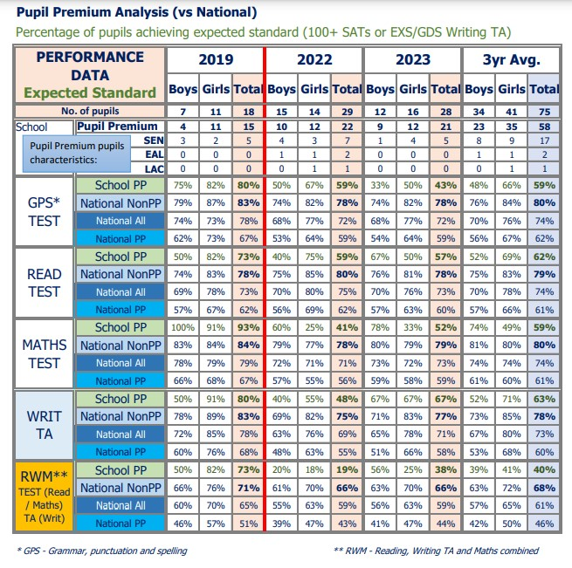

### Key Stage 1 Disadvantaged Performance Data

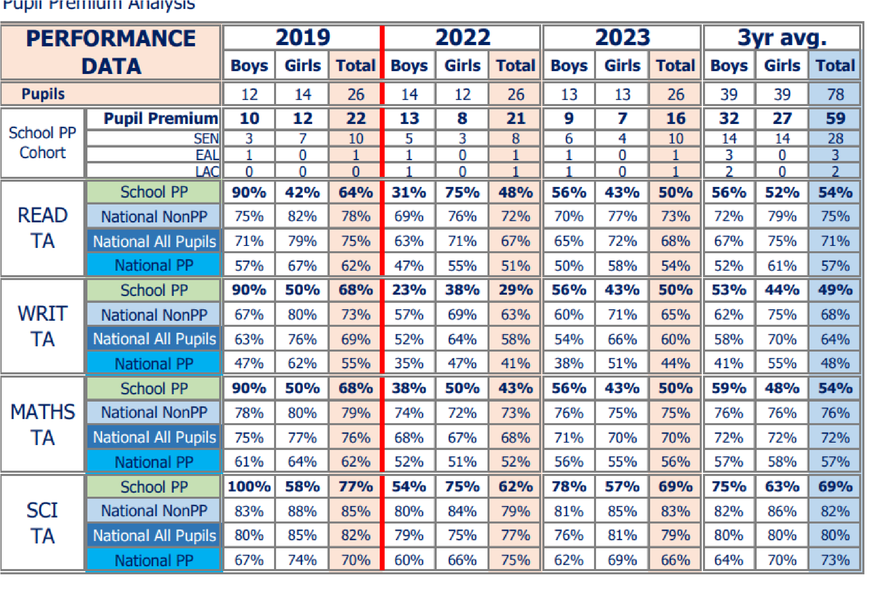

**Phonics outcomes improve and are back in line with historical data and at least in line with National.**

The hard work of our Phonics and Early Years Lead around the Early Reading curriculum is now evidenced in improvements in outcomes for our Early Readers which will eventually impact on outcomes for all pupils. Leads have looked at how Phonics is taught through the Early Years and is adapted from 2 – Year 1.

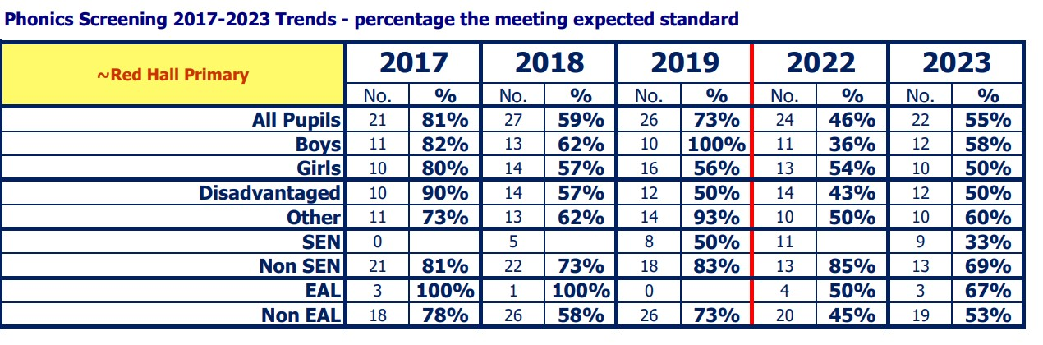

53% of Disadvantaged pupils achieved the standard compared to 84% of 'Other' pupils Nationally. Therefore, there is an achievement gap of 31%. National Disadvantaged is 71%. Disadvantaged pupils are below Disadvantaged pupils Nationally however there has been an increase since last academic year of 13% showing improvements in phonics achievement.

#### 2023 EYFS School Disadvantaged vs National 'Other' (Not Disadvantaged) 85% of pupils are Disadvantaged

35% of Disadvantaged pupils achieved the GLD. Disadvantaged pupils are below Disadvantaged pupils Nationally **Sustained and improved attendance. Ensure attendance of disadvantaged pupils is above 95%**

Attendance is improving and last academic year was in line with new National Averages with the percentage of persistent absentees, dramatically reduced.

A strong focus on leaders acting in a timely and persistent manner around attendance has meant that attendance has improved and persistent absence figures reduced. This has been achieved through rigorous monitoring and challenge through first day calling, letters regarding attendance, the non-authorisation of holidays during term time, and short term action plans with targets negotiated with families. Our attendance at the end of last academic year was 93.91% (91.2% for the same period last academic year). Persistent absence was 8.2% (35% for the same period last academic year). Absence figures are currently in line with National Figures recently released by DFE based on 2021/22 data (National Attendance 93.7%) and our Persistent Absence rate is better than average (17.7%).

Improved emotional well-being among pupils/parents and carers.

Separate case studies on individual pupils/families supported through this can be shared on request but are confidential for publication of impact.

## Pupil premium strategy outcomes 2021/2022

This details the impact that our pupil premium activity had on pupils in the 2021 to 2022 academic year.

**Outcomes at KS1 and 2 are at least in line with National**

### KS2 Disadvantaged Performance Data 2022

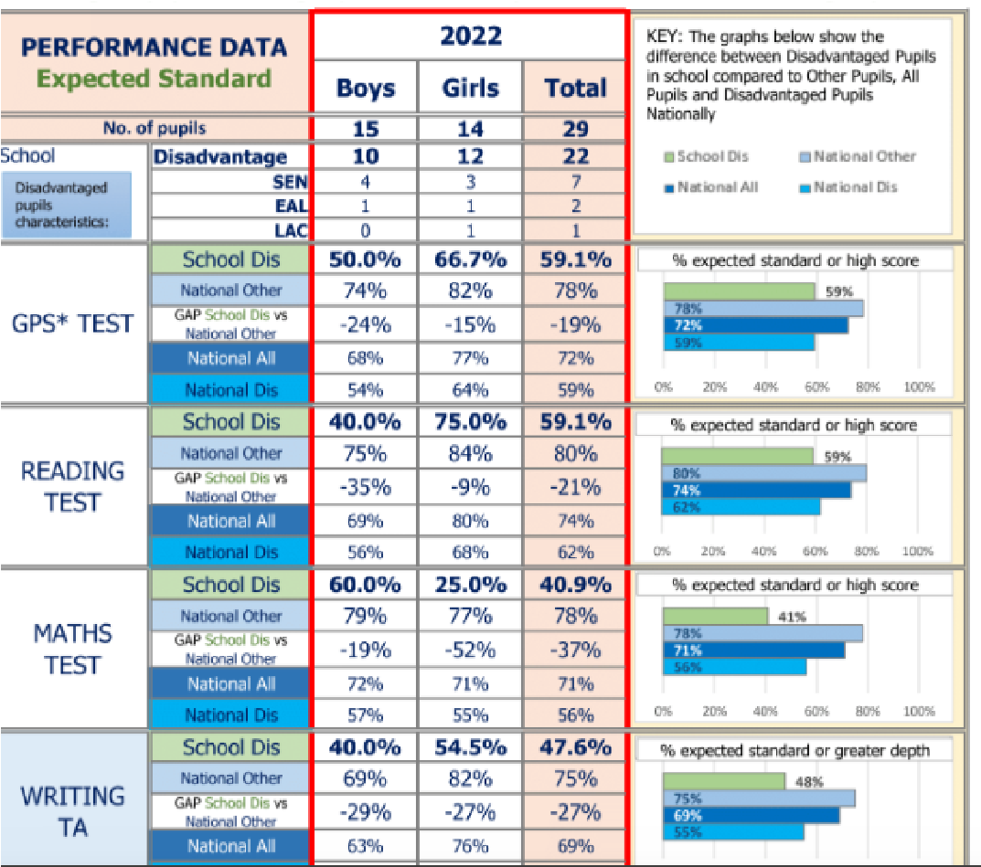

### Key Stage 1 Disadvantaged Performance Data

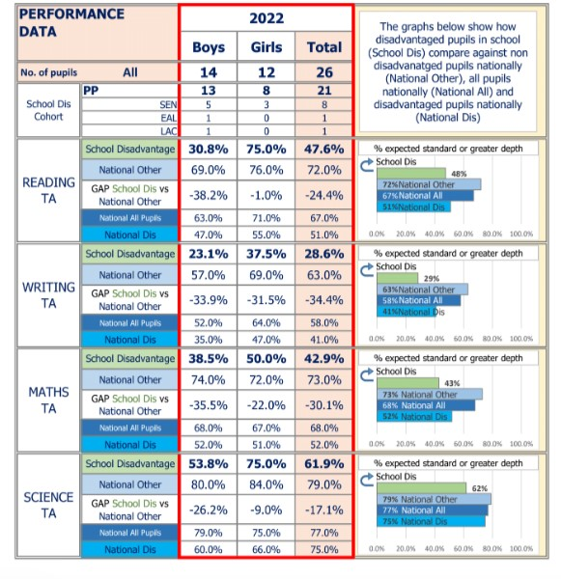

Key Stage 2 attainment of the expected standard in Reading, Writing and Maths was significantly below national and in the lowest 20% of schools in 2022. Our disadvantaged children at KS1 and KS2 2022, achieved lower than nondisadvantaged children in Reading, Writing and Maths. The actions taken across last year will therefore be continued into this year across the school.

**Phonics outcomes improve and are back in line with historical data and at least in line with National.**

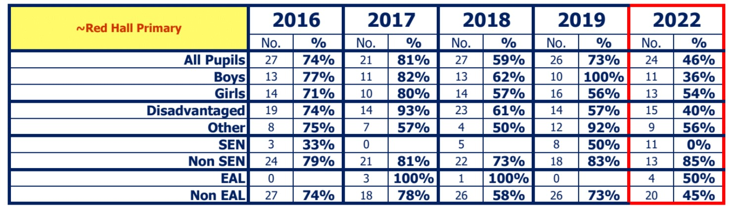

The proportion of pupils achieving the expected standard in Phonics for Red Hall Primary School was significantly below the national average and in the lowest 20% of all schools.

The percentage of disadvantaged children achieving the expected standard in Phonics at the end of 2022, was below the attainment of non-disadvantaged children by 16%. There is a 3-year trend showing a decrease in the performance of disadvantaged children in Phonics. Strategies in place to close the gap need to be continued. **Sustained and improved attendance. Ensure attendance of disadvantaged pupils is above 95%**

At the end of 2022, the overall attendance of disadvantaged pupils was 90.4% compared to 93.2% for our non disadvantaged pupils.We have worked with our new inclusion lead to put a strong strategy in place to improve overall attendance and punctuality which includes regular monitoring by the Inclusion lead.

Only 50% of disadvantaged pupils in EYFS achieved a GLD at the end of 2022.

## Pupil premium strategy outcomes 2020/2021

Our internal assessments during 2020/21 suggested that the performance of disadvantaged pupils was lower than in the previous years in key areas of the curriculum.

The Covid-19 impact is evident and learning was seriously disrupted which disrupted all areas to varying degrees. As evidenced in schools across the country, school closure was most detrimental to our disadvantaged pupils, and they were not able to benefit from our pupil premium funded improvements to teaching and targeted interventions to the degree we had intended.

Our assessments and observations indicated that pupil behaviour, wellbeing and mental health were significantly impacted last year, primarily due to COVID-19-related issues. The impact was particularly acute for disadvantaged pupils. We used pupil premium funding to provide wellbeing support for all pupils, and targeted interventions where required. We are building on that approach with the activities detailed in this plan.

## Externally provided programmes

*Please include the names of any non-DfE programmes that you purchased in the previous academic year. This will help the Department for Education identify which ones are popular in England*

|  |  |
| --- | --- |
| **Programme** | **Provider** |
| Times Tables Rockstars and Numbots | TT Rockstars |
| Music Tuition - guitar | Durham Music Service |
| Data analysis / Demographic analysis / Assessment / Attendance | Anthony Conlin Data Company |

# Further information

|  |
| --- |
|  |