RED HALL PRIMARY SCHOOL
MATHS CURRICULUM OVERVIEW
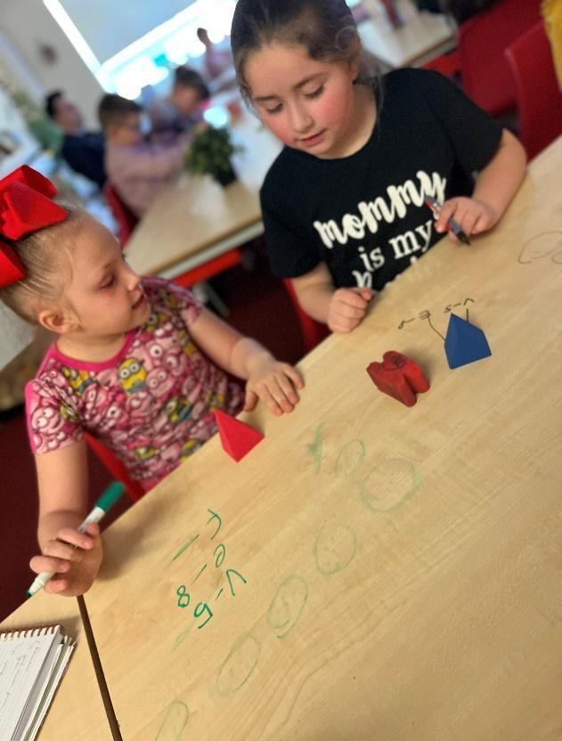
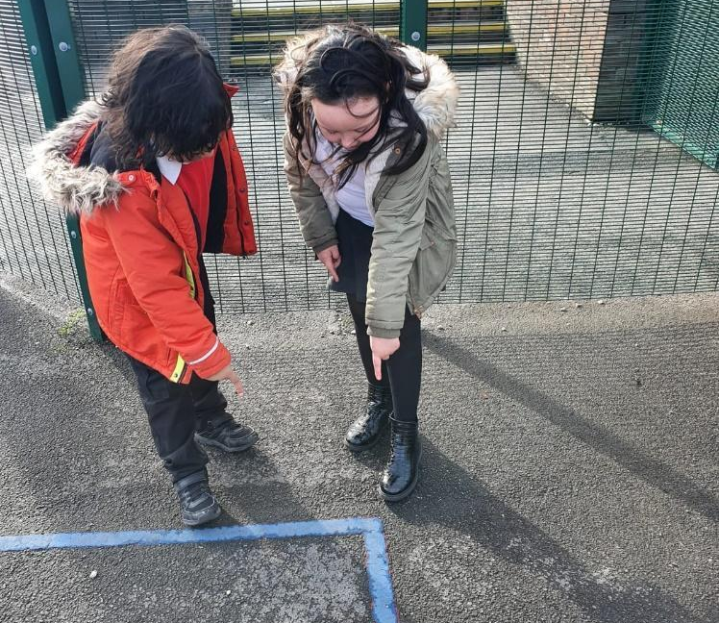
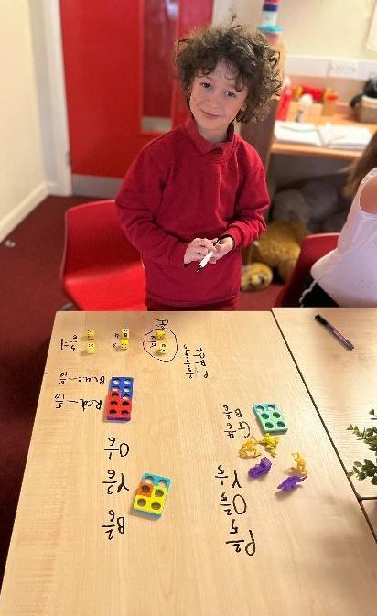
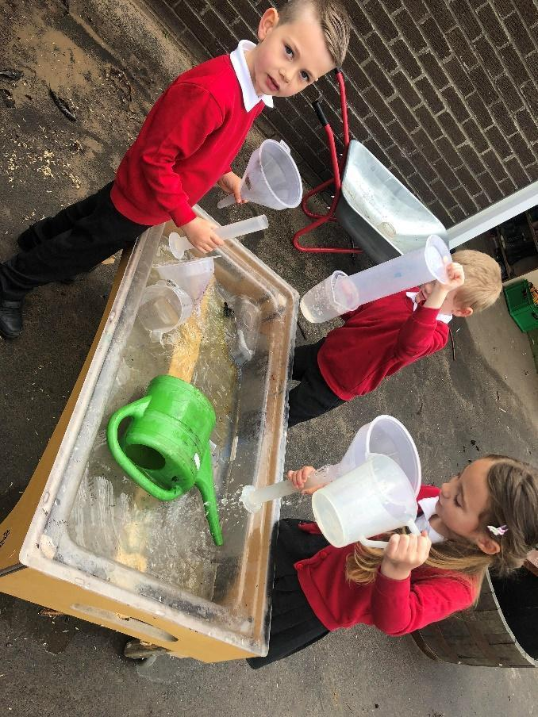

What is the intent of our Maths curriculum?  … to teach our children how to make sense of the world around them by developing their ability to calculate, reason and solve problems. We want our children to recognise and understand relationships and patterns in numbers in the world around them. We expect Mathematics to be utilised as a tool beyond the daily Mathematics lessons and beyond the classroom.  At Red Hall, we aim to provide our children with access to high quality teaching and learning in mathematics, which is both challenging and enjoyable! We use a Mastery approach to teaching (which means it can be a little bit tricky at times!), aiming for the deepest levels of understanding. | What experiences will the children receive?  … memorable Maths lessons, using a range of manipulatives (an object which can be used to help the children understand something a little bit better) to help develop a deepened understanding of mathematical concepts and make connections to life beyond the classroom. Objects, pictures, words, numbers and symbols are everywhere; the approach to mathematics we use here at Red Hall incorporates all of these, in order to enrich the learning experience and help children to explore and demonstrate their mathematical understanding.  We invite parents and carers into the classroom environment to work alongside their children across all areas of our curriculum. We recognise and understand that some of the adults we serve within the community are not confident with Maths themselves, which is why we need to help our parents and carers too. SATs meetings / stay and play sessions / progress checks / access to Times Tables Rock Stars are some of the examples of the different things we do with the children AND parents to ensure they are all learning together.  Children will to develop their understanding of managing money, through opportunities to fundraise and projects such as ‘Make £5 Grow…’
By the end of their time at Red Hall, what will all of our children have?
… the ability to be independent learners with inquisitive minds (which means that they are curious and keen to explore), with a secure mathematical foundation. Children will be fluent in the fundamentals (necessary skills) of mathematics, with the ability to reason mathematically and solve problems by applying their mathematics to a variety of routine and non-routine problems with increasing sophistication. They will have a good understanding of how Mathematics relates to real life situations: managing money, telling the time to name just a couple of examples.
Children will be resilient, and know that it is OK to make mistakes, that we learn from mistakes, and we need to persevere with challenges we may face in later life.

Whole School Themes
Autumn 1: Community  A Moment In Time | Autumn 2: Aspirational  Tell Me a Story | Spring 1: Respect  The Most Amazing Journey | Spring 2: Inclusive  We Are Family | Summer 1: Nurturing  Magic, Mystery and Mayhem | Summer 2: Growing together  Dream BIG
Most maths teaching is discrete some lessons, if appropriate and where maths is the focus, follow the school themes. |  |  |  |  |  | Y6 – Skills for the future

How is Maths taught at Red Hall?
EYFS
Open ended activities which allow the children to develop their independence
Invitations which encourage problem solving
High level questioning from staff to develop and enhance learning experiences, modelling mathematical vocabulary
Invitations, provocations and enhancements within the classroom to support the development of mathematical skills
Opportunities for children to independently apply skills developed
Encouraging children to persevere and be resilient learners when faced with challenges
A mix of adult-led / child-led learning
Maths Mastery at Red Hall
Mastering maths means pupils acquiring a deep, long-term, secure and adaptable understanding of the subject. The phrase ‘teaching for mastery’ describes the elements of classroom practice and school organisation that combine to give pupils the best chances of mastering maths.
At Red Hall, we adopted this approach I 2018, following a trial year in Year 5, during which we measured the impact. We continue to network with the NCETM Maths Hub to ensure we deliver the most up-to-date practice at our school.
The Five Big Ideas in Maths Mastery
Representation and Structure
Expose the concept being taught using visual representations,
concrete manipulatives and real life resources
Fluency
Quick and efficient recall of facts
Mathematical Thinking
Demonstrating a deeper understanding through reasoning and making explicit links between new learning and prior learning.
Coherence
Learning is broken into small steps, which enable children to develop a deepened understanding before moving learning forward too quickly. Small steps are sequenced according to the concept.
Variation
How the teacher represents the concept being taught, often in more than one way, to draw attention to critical aspects, and to develop deep and holistic understanding. It is a sequencing of the episodes, activities and exercises used within a lesson and follow up practice, paying attention to what is kept the same and what changes, to connect the mathematics and draw attention to mathematical relationships and structure.

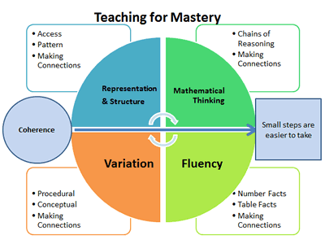

Year 1 – Year 6
A sequence of learning is followed in all concepts which are discretely taught.
Step 1 – Practical, using manipulatives and natural resources to support learning. However, this may not always be used for all introductions to concepts in Year 5 and Year 6.
Step 2 – Fluency. Practicing the skill being taught and developed using visual representations and manipulatives to support learning.
Step 3 – Varied Fluency. Moving to a more abstract representation of the concept / skill being taught. Although children may continue to use manipulatives / visual representations depending on their needs.
Step 4 – Problem Solving. Beginning to look at a range of ways this skill / understanding may be applied.
Step 5 – Reasoning. Children are taught the skills to reason and show their developed, deepened understanding of a skill / concept.

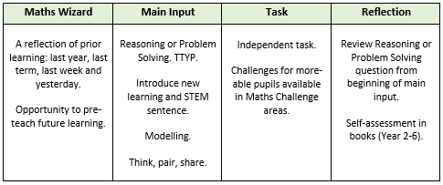
Lesson sequence: Coverage of Times Tables and Key Number Facts:
 | Year 1 | Year 2 | Year 3 | Year 4 | Year 5 | Year 6
Times Tables | 2  5  10 | 2  5  10  3 | 3  4  8 | 6  7  8  11  12 | Prime, squared and cubed numbers | Prime, squared and cubed numbers
Number Facts | Number bonds to 10 | Number bonds to 10 and 20 | Number bonds to 10, 20 and 100 | Number bonds to 10, 20, 100 and 1000 | Number bonds to a whole number | Number bonds to a whole number

Resources to support Maths Curriculum and delivery:
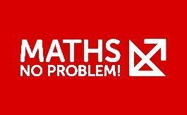
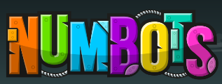

Sequence of Lessons and Arithmetic
Year 1 children continue to develop skills, knowledge and understanding through continuous provision during the Autumn term, which is ran similar to how children learn in EYFS. In the Spring and Summer term, the children move to ‘Challenges’ within the areas and the teacher will do a daily masterclass, where a member of staff with work with small groups at a time while the other children explore the environment.
Year 2 children continue to develop their skills, knowledge and understanding through challenge areas and masterclasses in the Autumn term, and then progress to formal lessons in Spring.
The rest of the school follow a sequence of lessons, which you can see below:

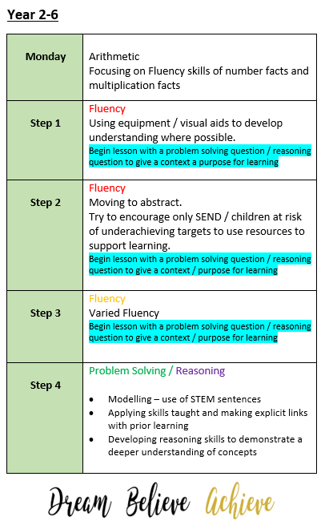
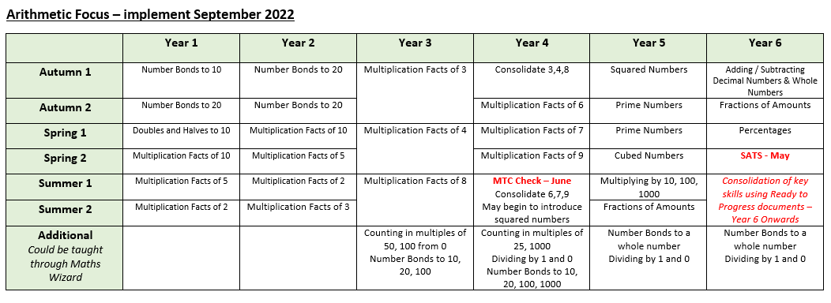

Skills of Progression EYFS
 | Lullaby Lane | Nursery Children | Reception Children | ELG
Autumn Term | - Combines Objects.  - Takes part in finger rhymes with numbers.  - Develops counting like behaviour.  - Counts in everyday contexts, sometimes skipping numbers 1,2,3,5.  - Talk about and explore 2D | - Recite numbers past 5.  - Say one more for each item in order: 1, 2,3,4,5.  - Show ‘finger numbers’ up to 5.  - Begin to describe a sequence of events using words such as ‘first’, ‘then’  - Talk about and explore 2D  - Describe a familiar route. | - Count objects, actions and sounds.  - What is subsitise? (recognise number patterns without counting)  - Link number symbol with its cardinal number value.  - Count beyond ten  - Talk about and explore 2D and 3D shapes.  - Compare length, weight and capacity. | - Subitise up to 5  - Automatically recall number bonds up to 5 including double facts.  - Compare quantities up to 10 in different contexts, recognising when one quantity is greater than, less than or the same as the other quantity.
Key Vocabulary | Number  Count | Order  Numbers up to  Pattern  Triangle  Sides  Straight side  Curved side | Place  Number  Count  Pictorial  Read  Write  Triangle Sides  Straight side  Curved side  Measure  Measurement  Capacity  Balance
Spring Term | - Notice patterns and arrange things in patterns.  - Compares sizes, weights. Uses gesture and language ‘bigger/little/smaller’, ‘high/low/heavy’.  - Show ‘finger numbers’ up to 3  - Counts in everyday contexts up to 5 | - Develop fast recognition of up to 3 objects, without having to count them individually.  - Know that the last number reached when counting a small set of objects tells you how many there are in total. (Cardinal principle)  - Experiment with their own symbols and marks as well as numerals.  - Link numeral and amount up to 5.  - Talk about and identify the patterns around them.  - Make comparisons between objects relating to size, length, weight and capacity. | - Explore the composition of numbers to 10.  - What is subsitise? (recognise number patterns without counting) past 5 eg 5+2 with fingers  - Understand the ‘one more then/one less than’ relationship between consecutive numbers.  - Continue, copy and create repeating patterns.  - Select, rotate and manipulate shapes in order to develop spatial reasoning skills.  - . | - Children have a deep understanding of numbers to 10, including the composition of each number.  - Explore and represent patterns within numbers up to 10, including evens and odds, double facts and how quantities can be distributed equally.
Key Vocabulary  including previous term | First  Second  Next  Shape  Square  Rectangle  Circle  Size  Weight | Subsitise  Estimate  Repeat  Order / ordinal  Compare  Size  Weight  Length | Order  Number line  One more  One less  Count on  Count back  Pattern  Repeat  Order / ordinal  First, Second, ETC  Next
Summer Term | - Reacts to changes of amount in a group of up to 3 items.  - Can solve real world problems up to 3  - Uses language such as ‘on top of’ ‘up’ ‘down’ ‘through’  - Link numeral and amount up to 3. | - Solve real world mathematical problems with numbers up to 5.  - Can write numbers to 10 with support  - Say one more for each item in order: to 10  - Link numeral and amount up to 10.  - Count beyond ten  - Extend and create ABAB patterns – stick, leaf, stick, leaf.  - Notice and correct an error in a repeating pattern.  - Talk about and explore 2D and 3D shapes.  - Understand position through words alone.  - Compare quantities with language: ‘more than’, ‘fewer than’  - Discuss routes and locations using words like ‘in front of’ and ‘behind’  - Select shapes appropriately: flat surfaces for building, triangular prism for roof etc. | - Compare numbers  - Automatically recall number bonds for numbers 0-10.  - Count beyond ten  - Compose and decompose shapes so that children recognise a shape can have other shapes within it, just as numbers can.  - Introducing a clock face and o’clock | - Automatically recall some number bonds to 10, including double facts.  - Verbally count beyond 20, recognising the pattern of the counting system.
Key Vocabulary  including previous term | One more  Size  Weight | One more  Read  Write  Order / ordinal  Move  Movement  Patterns  Shape  Square  Rectangle  Circle  Triangle Sides  Straight side  Curved side  Capacity  Size  Weight | Doubling  Halving  Sharing  Numbers up to  twenty  Answer  Equals  Compare  Solve  Problems  Object  Time

Skills of Progression
Whole School
 | EYFS | Year 1 | Year 2 | Year 3 | Year 4 | Year 5 | Year 6
Number Recall and Place Value | - Count objects, actions and sounds  - Subitise  - Link numeral to quantity  - Count beyond 10  - Compare numbers  - Understand one more/less more/less relationship between consecutive numbers | - Count to and across 100 forwards and backwards, beginning with 0 or 1 from any given number  - in 2’s and 10’s to 100  - Identify 1 more 1 less  - Identify and represent numbers with objects, pictorial, number line.  - Use language of equal to, more than, less than (fewer) most, least.  - Read and write numbers from 1-20 in numerals and words. Read, write and interpret mathematical statements involving  + - and =  - Count, read and write numbers to 100.  - Know and use number bonds and related subtraction facts within 20. | - Identify and represent numbers in different forms  - Recognise place value of each digit in a 2-digit no  - Recall facts to 20  - Add 2 digit to a 1-digit number  - Know and use number bonds and related subtraction facts within 20.  - Know odd and even numbers  - Count from 0 in steps of 2,3 and 5  - Solve number problems and practical problems  - Identify and represent numbers with objects, pictorial, number line.  - Use <> = to compare numbers  - Estimate numbers using different forms  - Compare and order numbers from 0 to 100  - Read and write numbers in numerals and words to 100  - Use place value and facts to solve problems | - Count from 0 in multiples 4,8,50,100  - Find 10, 100 more or less  - Recognise place value of each digit in a 3-digit no  - Mental addition and subtractions of:  -3-digit and 1  -3-digit and 10s  - 3-digit and 3-digit Identify, represent and estimate number up to 1000 in numerals and words  - Recall multiplication and division facts for 3,4, 8 x tables  - Find 10, 100 more or less  - Recognise place value of each digit in a 3-digit no  - Solve number problems and practical problems Compare and order numbers to 1000 | - Count in multiples of 6,7,9,25 and 1000  - Find 1000 more or less  - Recognise place value in a four-digit number, e.g. 1,000s, 100s, 10s, and 1s.  - Read Roman Numerals to 100 (I to C)  - Recall multiplication and division facts up to 12 x 12  - Write multiplication and division mental skills to x by 1, divide by 1 and 0.  - Count backwards through 0 to include negative numbers.  - Order and compare numbers beyond 1,000.  - Identify, represent and estimate numbers using different representations.  - Solve number & practical problems increasingly large positive numbers.  Rounding  - Round any number to the nearest 10, 100 or 1,000 | - Add and subtract mentally with increasingly large numbers (for example, 12,462 – 2300 = 10,162)  - Read, write, order and compare numbers to at least 1,000,000 and determine the value of each digit Divide 4 digit numbers by 1-digit numbers  - Recognise and use square numbers  - Count backwards and forwards through zero into negative numbers or from negative numbers  - Roman Numerals up to M  Rounding  - Round any number up to 1 000 000 to the nearest 10, 100, 1000, 10,000 and 100,000 | - Read, write, order and compare numbers up to 10,000,000 and determine the value of each digit  - Round any whole number to a required amount of accuracy  - Solve problems which require an answer to be rounded to specific degrees of accuracy  - Identify the value of each digit in numbers up to 3DP  - Multiply and divide numbers by 10,100, 1000 (answers up to 3DP)  - Multiply 1 digit numbers with up t o 2DP by 1 digit numbers  - Use negative numbers in context, calculate integers across 0  - Solve problems for the above  - Perform mental calculations with mixed operations and large numbers
Addition and Subtraction | - Explore composition of numbers to 10  - Recall number bonds from 1-10 | Addition  - Add and subtract 1 and 2 digit numbers to 20 including 0.  - Solve 1 step problems involving addition in a variety of ways (missing number)  Subtraction  - Count to and across 100 forwards and backwards from any given number.  - Solve 1 step problems involving subtraction in a variety of ways (missing number) | - Using objects and pictorial representations:  addition and subtractions of:  -Number  -Quantity  -Measures  - Apply mental and written methods  - Derive facts to 100  - Count to and across 100 forwards and backwards from any given number  - Add 2 digits to a 2-digit number  - Add 2-digit number and tens  - Add 3 and 1 digit numbers  - Use inverse to check answers | - Use of columns up to 3-digits  - Estimation of answers  - Use inverse to check answers  - Solve missing number problems using facts, inverse and place value | - Add and subtract numbers with up to 4-digits using the formal written methods.  - Estimate and use inverse operations to check answers to a calculation.  - Solve addition and subtraction two-step problems in context including money deciding which methods to use and why. | - Solve addition and subtraction multi-step problems in contexts, deciding which operations and methods to use and why.  Equations:  - Solve problems using distributive law and scaling (39 x 7 = 30x 7 and 9 x 7)  - Solve problems involving addition, subtraction, multiplication and division and a combination of these, including understanding the meaning of the equals sign | - Solve multi step problems in context, deciding on method and why  - Solve addition and subtraction problems  - Use estimates to check answers
Multiplication and Division |  | Multiplication  - Solve 1 step problems using x and / using objects and recording pictorially.  - Solve problems using arrays  - Count in 5’s to 100  Division  - Solve one step division problems using pictoral and concrete representations | - Solve one step division problems using pictoral and concrete representations  - Recall multiplication and division facts for 2  ,5 and 10 x tables  - Calculate mathematic statements within the times tables U12 Multiplication and Division:  - Show that multiplication is commutative  - Show that division is not commutative  - Solve multiplication and division problems using: materials, arrays, repeated addition, mental methods and facts. | - Formal written methods of division and multiplication  - Solve number problems in which objects are linked eg. 3 hats and 4 coats, how many outfits?, scale: 4 x higher etc  - Write multiplication and division facts (2 digit x 1 digit) | - Multiply 2-digit and 3-digit numbers by 1-digit number using formal written method.  - Multiply 2 and 3 digit numbers by 1 digit in columns  - Multiply two-digit and three- digit numbers by a one-digit number using formal written layout.  - Recognise and use factor pairs in mental calculations.  - Solve problems using distributive law and scaling ( 39 x 7 = 30 x 7 and 9 x 7) | - Multiply numbers up to 4 digits by a one- or two-digit number using a formal written method, including long multiplication for two- digit numbers  - Divide numbers up to 4 digits by a one-digit number using the formal written method of short division and interpret remainders appropriately for the context Multiplication and Division  - Recognise and use cube numbers, and the notation for cubed (3)  - Solve problems involving multiplication and division including using their knowledge of squares and cubes  Equations:  - Solve problems using distributive law and scaling (39 x 7 = 30x 7 and 9 x 7)  Solve problems involving addition, subtraction, multiplication and division and a combination of these, including understanding the meaning of the equals sign  Prime and Composite Numbers:  - Know and use prime numbers (up to 19) and prime factors  - Know and use composite numbers (non prime)  - Know and use the vocabulary of prime numbers, prime factors and composite (non-  Factors and Multiples  - Identify multiples and factors, including finding all factor pairs of a number, and common factors of two numbers  - Solve problems with factors and multiples Multiply and divide mentally using known facts prime) numbers | - use knowledge of order of operations for 4 operation calculations  - Identify common factors, multiples and prime numbers  - Solve multiplication and division problems  - Multiply 4 digit numbers by 2 digit numbers  - Divide 4 digit numbers by 2 digit numbers using formal long division  - Show remainders as fractions, decimals or rounded
Fractions, Decimals and Percentages | - Understand the composition of numbers to 10 | Fractions  - Recognise find name  ½ as one of 2 equal parts of an object, shape or quantity  - Recognise, find and name ¼ as one of 4 equal parts of an object, shape or quantity. | Fractions:  - Recognise find name ½ as one of 2 equal parts of an object, shape or quantity  - Recognise, find and name ¼ as one of 4 equal parts of an object, shape or quantity  - Recognise, find, name: 1/3 ¼ 2/4 and ¾ of a length, shape or set of objects  - Write simple fractions of amounts  U17 Fractions:  - Recognise simple equivalents | Fractions:  - Count up and down in tenths, recognising that tenths arise from ten equal parts  - Find fractions of amounts of objects  - recognise and show, using diagrams, equivalent fractions with small denominators  - Solve fraction problems | Fractions  - Find the effect of ÷ a 1 or 2- digit number by 10 and 100, identifying the value of the digits.  - Count up and down in hundredths.  - Add and subtract fractions with the same denominator.  - Solve harder problems with quantities and non-unit numbers.  - Recognise and show, using diagrams, families of common equivalent fractions  Fractions including decimals:  - Compare numbers with the same number of decimal places up to 2 decimal places.  - Recognise and write decimal equivalents of ¼ ½ ¾  - Round decimals with 1 decimal place to the nearest whole number  - Recognise and write decimal equivalents of any number of tenths or hundreds  - Solve simple money problems and measure problems involving fractions and decimals to 2DP | Fractions  - Identify, name and write equivalent fractions of a given fraction, represented visually, including tenths and hundredths  - Compare and order fractions with denominators which are multiples of each other  - Identify and name equivalents including 10ths, 100ths and 1000thsDecimal Fractions  - Recognise mixed numbers as improper fractions  - Add and subtract fractions with same denominator or multiples of same denominator  Fractions including decimals:  - Read and write decimal numbers as fractions (for example, 0.71 = 71/100)  - Round decimals with two decimal places to the nearest whole number and to one decimal place  - Read, write, order and compare numbers with up to three decimal places  - Solve problems involving numbers up to three decimal places Fractions  Percentages:  - Recognise per cent % and number of parts per 100  - Write percentages as a fraction of 100 and as a decimal  - Solve problems using percentage and decimal equivalents for ½, ¼,1/5, 2/5 and 4/5 and fractions with denominators of a multiple of 10, or 25  - Solve problems involving multiplication and division, including scaling by simple fractions and problems involving simple rates (for example, percentages of amounts, 10%  discounts etc.) | Fractions:  - Use and recall equivalence between simple fractions, decimals and percentages in different contexts  - Use common factors to simplify fractions  - Use common multiples to express fractions in the same denominator  - Compare and order fractions less than 1  - Add and subtract fractions  - Multiply simple pairs of fractions (writing the answers in simplest form)  - Divide proper fractions by whole numbers
Geometry | - Select rotate and manipulate shapes to develop spatial reasoning skills  - Compose and decompose shapes, identifying shapes within | Shape and Properties  - Recognise and name common 2D and 3D shapes  Position and Direction  - Describe position, direction, movement including whole, half, quarter and ¾ turns | Shape and Properties  - identify and describe the properties of 2-D shapes, including the number of sides and line symmetry in a vertical line  - Identify and compare common 3D shapes  - Know the 2D faces in a 3D shape  - Identify the properties of 3D shapes (edges, faces, vertices)  - Compare and sort everyday 3D objects  Position and Direction  - Order combinations of objects in patterns and shape (orientation)  - Use mathematical language to describe position, direction and movement. ( rotation, clockwise and anticlockwise) | Shape and Properties  - Recognise angles, angles as shape properties and turns  - Identify angles and turns, less than more than right angle  - Draw 2D shape  - Make 3D shapes  - Describe 3D shapes and recognise them  - Identify horizontal, perpendicular, parallel and vertical lines | Properties of Shape:  - Compare and classify geometric shapes, including quadrilaterals and triangles.  - Identify acute and obtuse angles, and compare and order angles.  Position and Direction:  - Describe positions as coordinates (1st quadrant).  - Describe movements between positions as translations of a given unit e.g. Left/right and up/down.  - Plot specified points and draw sides to complete a given polygon. | Shape and Properties  - Recognise 3D shapes from 2D representations  Angles  - Know angles are measured in degrees, estimate and compare angles (acute, obtuse and reflex)  - Draw given angles  - Identify angles on points and one whole turn, straight line and half turn  - Use properties of rectangles to deduce related facts and missing lengths and angles  Position and Direction:  - Identify, describe and represent the position of a shape following a reflection or translation, using the appropriate language, and know that the shape has not changed. Volume/3D Shape | Shape and Properties  - Describe positions on full coordinate grid (4-quadrants)  - Draw and translate simple shapes and reflect them in the axes  - Recognise and build 3D shapes (inc nets)  - compare and classify geometric shapes based on properties  Angles  - Find missing angles in any triangles, quadrilaterals and regular polygons  - Recognise angles where they meet at a point, are on a straight line or are vertically opposite, finding missing angles  - Draw 2D shapes using given dimensions
Measures | - Compare length, width and capacity | Measurement  - Compare describe and solve practical problems for:  - Length and height  - Mass and weight  - Capacity and volume  - Measure and begin to record length, mass, capacity and time  - Mass and weight  - Capacity and volume  - Length and height  Money  - Recognise and know the value of different denominations of coins and notes.  Time  - Sequence events in chronological order  - recognise and use language relating to dates, including days, weeks months and years  - Tell the time to the hour and half past  - Measure and record time hours minutes seconds | Measurement  - Choose appropriate standard units to measure: length/height(m/cm), mass (kg/g), temperature (°C), volume/capacity (l/ml) to the nearest unit.  - Compare and order length, mass etc using < > =  Money  - recognise and use symbols for pounds (£) and pence (p); combine amounts to make a particular value  - find different combinations of coins that equal the same amounts of money  - solve simple problems in a practical context involving addition and subtraction of money of the same unit, including giving change  Time  - Tell the time to the hour and half past  - Measure and record time in hours, minutes, seconds  - Tell and write the time to 5 minutes  - Know quarter past and to the hour  - Know the number of minutes in an hour and number of hours in a day | Measurement  - measure, compare, add and subtract: lengths (m/cm/mm); mass (kg/g); volume/capacity (l/ml)  - Measure the perimeter of  simple 2D shapes  - Know the number of seconds, minutes and days  - Tell and write time  Money  - Add and subtract money to give change in practical context  Time  - Estimate and read time to the nearest minute  - Compare duration of events Compare and sequence intervals of time  - tell and write the time from an analogue clock, including using Roman numerals from I to XII, and 12-hour and 24-hour clocks  - compare durations of events, for example to calculate the time taken by particular events or tasks  - estimate and read time with increasing accuracy to the nearest minute; record and compare time in terms of seconds, minutes, hours and o’clock | Measurement  - Measure and calculate the perimeter of a rectilinear figure (including squares) in centimetres and metres  - Find the area of rectilinear shapes by counting squares  - Convert between different units of measure [for example, kilometre to metre; hour to minute]  - Estimate, compare and calculate different measures, including money in pounds and pence.  Time  - Read, write and convert time between analogue and digital 12- and 24-hour clocks.  - Solve conversion problems,  e.g. hrs to mins, years to months, weeks to days. | Measurement  - Convert units of metric measure  - measure and calculate the perimeter of composite rectilinear shapes in centimetres and metres  - calculate and compare the area of squares and rectangles including using standard units, square centimetres (cm2) and square metres (m2) and estimate the area of irregular shapes  - Understand and use conversions between metric and imperial measurements  - Estimate volume [for example, using 1 cm3 blocks to build cuboids (including cubes)] and capacity [for example, using water]  Time  - Read, complete and interpret information in tables, timetables  - Solve problems converting units of time | Measurement  - recognise that shapes with the same area have different perimeters and vice versa  - recognise when a formula can be used for area and volume  - calculate the area of parallelograms and triangles  - calculate, estimate and compare volume of cubes and cuboids using standard units, including centimetre cubed (cm3) and cubic metres (m3), and extending to other units such as mm3 and km3.  - Know diameter is twice the radius  - Illustrate and name parts of a circle (radius, diameter and circumference)  - Read, write and convert between standard measures of;  -length  -mass  -volume  -time (using decimals up to 3DP)  - Convert between miles and km
Statistics |  |  | - Interpret and construct pictograms, tally charts, block diagrams and simple tables  - Ask and answer simple questions by counting categories and sorting categories  - Ask and answer questions about totalling | - Interpret and present data on bar, pictograms and tables  - Solve problems one and two-step problems using data from charts and tables | - Interpret and present discrete and continuous data including bar charts and time graphs.  - Solve comparison, sum and difference problems using information presented in bar charts, pictograms, tables etc. | - complete, read and interpret information in tables, including timetables  - Solve comparison, sum and difference problems using information presented in a line graph | - Interpret and construct pie charts and line graphs and use these to solve problems  - Calculate and interpret the mean as an average
Algebra |  |  |  |  |  |  | - Use simple formulae  - Generate and describe linear number sequences  - Express missing number problems algebraically  - Find pairs of numbers that satisfy an equation with two unknowns  Enumerate all possibilities of combinations of two variables
Ratio and Proportion |  |  |  |  |  |  | Statements only appear in Year 6 but should be connected to previous learning, particularly fractions and multiplication and division  - solve problems involving the relative sizes of two quantities where missing values can be found by using integer multiplication and division facts  - solve problems involving the calculation of percentages [for example, of measures, and such as 15% of 360] and the use of percentages for comparison  - solve problems involving similar shapes where the scale factor is known or can be found  - solve problems involving unequal sharing and grouping using knowledge of fractions and multiples.

National Curriculum Coverage: Year 1 – Year 6
Year 1 |  |  | Ready to Progress Document  DfE
Autumn | Spring | Summer | EYFS  Prior | YEAR 1  Now | YEAR 2  Next
Place Value  • Count to and across 100 – forwards and back from any given number  • Given a number, identify one more and one less  • Identify and represent numbers using objects and pictures  • Read and Write numerals in numbers and words 1-20  • Use mathematical language: equal to, more/less than, most, least  • Read and write numbers to 100 in numerals  Addition and Subtraction  • Confidently recall number bonds to 10  • Recall doubles and halves to 10  • Confidently recall number bonds to 20  • Add and subtract 1-digit from a 2-digit number up to 20 – including 0  • Solve 1-step problems involving addition and subtraction, using resources  Multiplication and Division  • Solve 1-step problems involving multiplication and division, using resources  • Count in multiples of 2, 5 and 10 | Fractions, Decimals and Percentages  • Recognise, find and name fractions – ½ and ¼  • Find ½ and ¼ of shapes and quantities  • Use reasoning when discussing fractions, using correct mathematical language e.g. equal parts  Geometry  • Describe position using language  • Recognise and name common 2D shapes  • Recognise and name common 3D shapes  • Describe movement using language: whole turn, half turn, three-quarter turn, clockwise  • Begin to identify some of the properties of 2D shapes  • Begin to identify some of the properties of 3D shapes  • Make connections between movement language and the movement on the face of a clock e.g. turning clockwise | Measure  • Compare and describe practical problems for: length and height, mass/weight, capacity and volume, time  • Recognise different denominations of coins and notes  • Measure and begin to record: length and height, mass/weight, capacity and volume, time  • Solve practical problems for: length and height, mass/weight, capacity and volume, time  • Sequence events in chronological order  • Recognise and use language relating to dates  • Tell the time to 1 hour / half past the hour, and be able to demonstrate by drawing hands on a clock | - Count objects, actions and sounds to 10.  - Subitise  - Link numeral to quantity  - Count beyond 10  - Compare numbers  - Understand one more/less more/less relationship between consecutive numbers  - Explore composition of numbers to 10  - Recall number bonds from 1-10  - Explore composition of numbers to 10, including knowing odd and even numbers  - Compare length, width and capacity  - Select rotate and manipulate shapes to develop spatial reasoning skills  - Compose and decompose shapes, identifying shapes within  - Understand the composition of numbers to 10 | - Count within 100, forwards and backwards, starting with any number.  - Reason about the location of numbers to 20 within the linear number system, including comparing using bigger, smaller, equal  - Compose numbers to 10 from 2 parts, and partition numbers to 10 into parts, including recognising odd and even numbers  - Develop fluency in addition and subtraction facts within 10.  - Read, write and interpret equations containing addition (+), subtraction ( -) and equals (=) symbols, and relate additive expressions and equations to real-life contexts.  - Count forwards and backwards in multiples of 2, 5 and 10, up to 10 multiples, beginning with any multiple, and count forwards and backwards through the odd numbers.  - Measure using non standard unit and continuous counting. Become familiar with ruler use, scales and containers.  - Recognise common 2D and 3D shapes presented in different orientations, and know that rectangles, triangles, cuboids and pyramids are not always similar to one another.  - Compose 2D and 3D shapes from smaller shapes to match an example, including manipulating shapes to place them in  - particular orientations.  - Find ½ and ¼ in lots of contexts, objects, shapes and numbers. | - Count through the number system. Place value within  - 100. Compare and order numbers. Add and subtract within 100.  - Reason about the location of larger numbers within the linear number system.  - Compare and order numbers. Read scales.  - Add and subtract within 10.  - Add and subtract across 10. All future additive calculation.  - Add within a column during columnar addition when the column sums to less than 10 (no regrouping). Subtract within a column during columnar subtraction when the minuend of the column is larger than the subtrahend (no exchanging).  - Represent composition and decomposition of numbers using equations.  - Recall the 2, 5 and 10 multiplication tables. Carry out repeated addition and multiplication of 2, 5, and 10,  - and divide by 2, 5 and 10.  - Identify multiples of 2, 5 and  - 10. Unitise in tens. Identify odd and even numbers.  - Use symbols for £ and p  - Use standard units of measure Use ‘half as high, twice as long’  - Fluency in telling the time  - Describe properties of shape. Categorise shapes. Identify similar shapes.  - Find the area or volume of a compound shape by decomposing into constituent shapes. Rotate, translate and reflect 2D shapes. Identify congruent shapes.  - ½ 1/3 ¼ and simple equivalents.  - Using objects, find fractions of amounts.
Key Vocabulary
same, different, number, number names, digit, count, object, count backwards / forwards, left over,  equal, more, less, least, fewer than, most, least, sum, total, plus, addition, subtraction, minus, double, number line, biggest, smallest, difference, share, ones, tens, multiples, first, second, third, fourth, order, amount, value, halve, pair, how much, how many, compare, bonds, altogether | fraction, half, quarter, equal, parts, part, whole  left, right, up, down, back, forward, under, forwards, backwards, near, around, whole turn, half-turn, clockwise  shape names, sides, 2D, 3D | weight, weigh, heavy, heavier, heaviest, light, lighter, lightest, balance, scales, ruler, taller, longer, shorter, more, less, equal, cm, distance, measure, volume  coin, note, money, pound, pence, coin values  hour, minute, year, days of the week, months of the year, today, tomorrow, yesterday, morning, afternoon, evening, clock, clock face o’clock, hands, early, late

Year 2 |  |  | Ready to Progress Document  DfE
Autumn | Spring | Summer | Year 1  Prior | YEAR 2  Now | YEAR 3 onwards  Next
Place Value  • I can demonstrate an understanding of place value, using apparatus to support me  • I can read and write numbers correctly in numerals up to 100  • I can count in twos, fives and tens from 0 and use counting strategies to solve problems  • I can partition two-digit numbers into different combinations of tens and ones, using resources if needed  Addition and Subtraction  • I can use number bonds and related subtraction facts within 20  • I can recall doubles and halves to 20  • I can add and subtract a 2-digit number and ones and a 2-digit number and tens, where no regrouping is required  • I can subtract mentally a two-digit number from another two-digit number when there is no regrouping required  • I can recognise the inverse relationships between addition and subtraction and use this to check calculations and work out missing number problems e.g. Δ − 14 = 28  • I can add 2 two-digit numbers within 100 (e.g. 48 + 35) and can demonstrate my method using concrete apparatus or pictorial representations  • I can use estimation to check that my answers to a calculation are reasonable  Multiplication and Division  • I can recall and use multiplication and division facts for the 2, 3, 5 and 10 multiplication tables to solve simple problems, demonstrating an understanding of commutativity as necessary | Fractions, Decimals and Percentages  •I can identify 1/3, 1/4, 1/2, 2/4, 3/4 and knows that all parts must be equal parts of the whole  • I can find and compare fractions of amounts (e.g. 1/4 of £20 = £5 and 1/2 of £8 = £4)  Geometry  • I can recognise and name common 2-D shapes, including for example, rectangles, squares, circles and triangles and name some differences  • I can recognise and name common 3-D shapes, including for example, cuboids, cubes, pyramids and spheres and name some differences  • I can describe properties of 2-D and 3-D shapes  Statistics  • I can read and interpret tally charts, pictograms and bar charts | Measure  • I can compare, measure, describe and solve practical problems for: mass/weight using scales and mathematical language  • I can compare, measure, describe and solve practical problems for: capacity and volume using containers and mathematical language  • I can recognise and know the value of different denominations of coins and notes  • I can read scales in divisions of ones, twos, fives and tens in a practical situation where all numbers on the scale are given  • I can use different coins to make the same amount  • I can compare and sequence intervals of time: tell and write the time to fifteen minutes, including quarter past/to the hour and draw the hands on a clock face to show these times  • I know the number of minutes in an hour and the number of hours in a day | - Count within 100, forwards and backwards, starting with any number.  - Reason about the location of numbers to 20 within the linear number system, including comparing using bigger, smaller, equal  - Compose numbers to 10 from 2 parts, and partition numbers to 10 into parts, including recognising odd and even numbers  - Develop fluency in addition and subtraction facts within 10.  - Read, write and interpret equations containing addition (+), subtraction ( -) and equals (=) symbols, and relate additive expressions and equations to real-life contexts.  - Count forwards and backwards in multiples of 2, 5 and 10, up to 10 multiples, beginning with any multiple, and count forwards and backwards through the odd numbers.  - Measure using non-standard unit and continuous counting. Become familiar with ruler use, scales and containers.  - Recognise common 2D and 3D shapes presented in different orientations, and know that rectangles, triangles, cuboids and pyramids are not always similar to one another.  - Compose 2D and 3D shapes from smaller shapes to match an example, including manipulating shapes to place them in  - particular orientations.  - Find ½ and ¼ in lots of contexts, objects, shapes and numbers. | - Count through the number system. Place value within  - 100. Compare and order numbers. Add and subtract within 100.  - Reason about the location of larger numbers within the linear number system.  - Compare and order numbers. Read scales.  - Add and subtract within 10.  - Add and subtract across 10. All future additive calculation.  - Add within a column during columnar addition when the column sums to less than 10 (no regrouping). Subtract within a column during columnar subtraction when the minuend of the column is larger than the subtrahend (no exchanging).  - Represent composition and decomposition of numbers using equations.  - Recall the 2, 5 and 10 multiplication tables. Carry out repeated addition and multiplication of 2, 5, and 10,  - and divide by 2, 5 and 10.  - Identify multiples of 2, 5 and  - 10. Unitise in tens. Identify odd and even numbers.  - Use symbols for £ and p  - Use standard units of measure Use ‘half as high, twice as long’  - Fluency in telling the time  - Describe properties of shape. Categorise shapes. Identify similar shapes.  - Find the area or volume of a compound shape by decomposing into constituent shapes. Rotate, translate and reflect 2D shapes. Identify congruent shapes.  - ½ 1/3 ¼ and simple equivalents.  - Using objects, find fractions of amounts. | - Compare and order numbers. Add and subtract using mental and formal written methods  - Compare and order numbers. Round whole numbers. Subtract ones from a multiple of 10, for example:  - Add within a column during columnar addition when the column sums to less than 10 (no regrouping).  - Subtract within a column during columnar subtraction when the minuend of the column is larger than the subtrahend (no exchanging).  - Add and subtract within 100: add and subtract any 2 two digit numbers, where the ones sum to 10 or more, for example: 26+37= 63  - Add and subtract across other boundaries, for example:1.3-0.5=0.8  - Add within a column when the column sums to more than 10 (regrouping), for example,126+148= Exchange- for example, for: 453-124=  - Contextual subtraction problems for all three subtraction structures (reduction, partitioning and difference) and combining with other operations. Add and subtract using mental and formal written methods.  - Division with other divisors. Factor and multiples.  - Long and shot divisions of whole numbers.  - Use multiplication to represent repeated addition contexts for other group sizes. Memorise multiplication tables.  - Be able to solve problems with money. Use cm then mm  - Tell the time and solve problems with time and duration.  - Identify similar shapes. Describe and compare angles. Draw polygons by joining marked points Identify parallel and perpendicular sides. Identify regular polygons Find the perimeter of regular and irregular polygons. Compare areas and calculate the area of rectangles (including squares) using standard units. Compare areas and calculate the area of rectangles (including squares) using standard units  - Count in 1/10s and understand the whole amount and fractions of.  - Add fractions with same denominator.  - Interpret and present data in simple chart form.  - Solve multi step problems.
Key Vocabulary (as well as prior year groups)
digit, numeral, multiple, commutative, place value, step counting, > as ‘greater than’, < as ‘less than’, partition, place holder, place value, estimate, estimation, inverse, array, calculate, multiplication, division, times tables | sharing, grouping, third, quarter, equivalent, half as much, twice as much, numerator, denominator  vertices, edges, faces, symmetry, vertical, horizontal, quadrilateral, straight, curved, rotate, angle  pictogram, tally chart, block diagram, table, data, category | clockwise, anticlockwise, half past, quarter past, quarter to  gram, kilogram, height, width, metre, centimeter, millimeter, litre, degrees, Celsius

Year 3 |  |  | Ready to Progress Document  DfE
Autumn | Spring | Summer | YEAR 2  Prior | YEAR 3  Now | YEAR 4 onwards  Next
Place Value  • Find 10 or 100 more / less than any given number  • Read and write numbers up to 1000 in numerals  • Recall number bonds within 100  • Recognise the value of each digit in numbers up to 1000  • Compare and order numbers to 1000  • Write, in word, any number to 1000  • Solve number problems and practical problems involving place value  • Count in groups of 4, 8, 50 and 100 from 0  Addition and Subtraction  • Mentally subtract: 3-digit – 1-digit, 3-digit – tens, 3-digit – hundreds  • Calculate missing number problems  • Use column addition and column subtraction with numbers up to 4-digits  • Use the inverse operation to check answers  • Solve complex addition and subtraction problems  Multiplication and Division  • Recall 3, 4, 8 times tables  • Use formal method to multiply 2-digit by 1-digit – short multiplication  • Use formal method to divide 2-digit by 1-digit – short division  • Solve 2-step multiplication and division problems  Fractions, Decimals and Percentages  • Recognise fractions and use mathematical language e.g. numerator, denominator, equal parts  • Calculate fractions of quantities  • Compare and order fractions | Fractions, Decimals and Percentages  • Count up and down in tenths  • Recognise, find and write fractions of a discrete set of objects – small denominators  • Recognise and show equivalent fractions with the same denominator  • Solve problems involving fractions  Geometry  • Recognise and name common 2D shapes and list properties  • Recognise and name common 3D shapes and list properties  • Draw 2D shapes  • Recognise angles as a property of a shape / description of a turn  • Identify right angles within 2D shapes  • Understand and recognise perpendicular / parallel lines | Measure  • Know the number of seconds in an hour, hours in a day, days in each month, days in a year / leap year  • Measure and compare: length and height, mass/weight, capacity and volume, time  • Measure the perimeter of 2D shapes  • Add and subtract amounts of money to give change  • Measure time from analogue clock as well as 12-hour and 24-hour clocks  Statistics  • Represent and interpret data from bar charts, pictograms and tables, and solve 1-step problems associated with the data  • Solve 2-step problems associated with the data | - 2NPV–1 Recognise the place value of each digit in two- digit numbers, and compose and decompose two digit numbers using standard and nonstandard partitioning.  - 2NPV–2 Reason about the location of any two-digit number in the linear number system, including identifying the previous and next multiple of 10.  - 2NF–1 Secure fluency in addition and subtraction facts within 10, through continued practice.  - 2AS–1 Add and subtract across 10, for example:  - 8+5 = 13  - 13-5= 8  - AS–2 Recognise the subtraction structure of ‘difference’ and answer questions of the form, “How many more…?”.  - 2AS–3 Add and subtract within 100 by applying related one-digit addition and subtraction facts: add and subtract only ones or only tens to/from a two-digit number.  - 2MD–2 Relate grouping problems where the number of groups is unknown to multiplication equations with a missing factor, and to division equations (quotitive division).  - 2MD–1 Recognise repeated addition contexts, representing them with multiplication equations and calculating the product, within the 2, 5 and 10 multiplication tables.  - Use symbols for £ and p  - Use standard units of measure  - Use ‘half as high, twice as long’  - Fluency in telling the time  - 2G–1 Use precise language to describe the properties of 2D and 3D shapes, and compare shapes by reasoning about similarities and differences in properties  - ½ 1/3 ¼ and simple equivalents.  - Using objects, find fractions of amounts.  - Construct pictograms, tallys, block diagrams and simple tables. | - Compare and order numbers. Add and subtract using mental and formal written methods  - Compare and order numbers. Round whole numbers. Subtract ones from a multiple of 10 3NPV–1 Know that 10 tens are equivalent to 1 hundred, and that 100 is 10 times the size of 10; apply this to identify and work out how many 10s there are in other three-digit multiples of 10.  - 3NPV–2 Recognise the place value of each digit in three-digit numbers, and compose and decompose three-digit numbers using standard and non-standard partitioning.  - Add within a column during columnar addition when the column sums to less than 10 (no regrouping).  - Subtract within a column during columnar subtraction when the minuend of the column is larger than the subtrahend (no exchanging).  - Add and subtract within 100: add and subtract any 2 two digit numbers, where the ones sum to 10 or more, for example: 26+37= 63  - Add and subtract across other boundaries, for example:1.3-0.5=0.8  - Add within a column when the column sums to more than 10 (regrouping), for example,126+148=  - Exchange- for example, for: 453-124= Contextual subtraction problems for all three subtraction structures (reduction, partitioning and difference) and combining with other operations.  - Add and subtract using mental and formal written methods.  - Division with other divisors. Factor and multiples.  - Long and shot divisions of whole numbers.  - Use multiplication to represent repeated addition contexts for other group sizes. Memorise multiplication tables.  - 3NPV–4 Divide 100 into 2, 4, 5 and 10 equal parts, and read scales/number lines marked in multiples of 100 with 2, 4, 5 and 10 equal parts.  - 3NF–2 Recall multiplication facts, and corresponding division facts, in the 10, 5, 2, 4 and 8 multiplication tables, and recognise products in these multiplication tables as  - multiples of the corresponding number.  - Be able to solve problems with money. Use cm then mm  - Tell the time and solve problems with time and duration.  - 3NPV–4 Divide 100 into 2, 4, 5 and 10 equal parts, and read scales/number lines marked in multiples of 100 with 2, 4, 5 and 10 equal  - parts.  - Identify similar shapes. Describe and compare angles. Draw polygons by joining marked points Identify parallel and perpendicular sides. Identify regular polygons Find the perimeter of regular and irregular polygons. Compare areas and calculate the area of rectangles (including squares) using standard units. Compare areas and calculate the area of rectangles (including squares) using  - standard units  - Count in 1/10s and understand the whole amount and fractions of.  - Add fractions with same denominator.  - 3F–1 Interpret and write proper fractions to represent 1 or several parts of a whole that is divided into equal parts.  - 3F–2 Find unit fractions of quantities using known division facts (multiplication tables fluency).  - 3F–3 Reason about the location of any fraction within 1 in the linear number system. 3F–4 Add and subtract fractions with the  - same denominator, within 1.  - Interpret and present data in simple chart form.  - Solve multi step problems. | - Solve multiplication problems that that involve a scaling structure, such as ‘ten times as long’.  - Compare and order numbers. Add and subtract using mental and formal written methods.  - Read scales on graphs and measuring instruments  - Use multiplication facts during application of formal written layout. Use division facts during short division and long division.  - Read scales on graphs and measuring instruments  - Compare angles. Estimate and measure angles in degrees.  - Find the area or volume of a compound shape by decomposing into constituent shapes. Find the perimeter of regular and irregular polygons  - Use unit fractions as the basis to understand non unit fractions, improper fractions and mixed numbers: 2/5 is 2 1/5  - Apply knowledge of unit fractions to non-unit fractions. Compare and order fractions. Add and subtract improper and mixed fractions with the same denominator, including bridging whole numbers.  - Solve discrete and continuous data problems including: sum, difference and comparison  - problems.
Key Vocabulary (as well as prior year groups)
hundreds, thousands, multiple(s), inverse operation, integer, decimal, remainder | fifths, sixths, sevenths, eighths, ninths, tenths, numerator, denominator, order, unit-fraction, non-unit fraction  degree(s), right angle, perpendicular, parallel, horizontal, vertical, quadrilateral, polygon, acute, obtuse, reflex, reflection | am, pm, noon, midnight, analogue clock, digital clock, duration  millimetre, perimeter, scales  interpret, data, scale

Year 4 |  |  | Ready to Progress Document  DfE
Autumn | Spring | Summer | YEAR 3  Prior | YEAR 4  Now | YEAR 5 onwards  Next
Place Value  • Recognise the value of each digit in numbers up to 10,000  • Compare and order numbers beyond 1000  • Write, in words, 4-digit numbers beyond 1000  • Solve number problems and practical problems involving place value  • Recognise Roman numerals to 100  • Count forward and back through 0, to include negative numbers  • Round numbers to the nearest 10, 100, 1000  Addition and Subtraction  • Use column addition and column subtraction with numbers up to 4-digits  • Use the inverse operation to check answers  • Solve complex 2-step addition and subtraction problems  Multiplication and Division  • Count in multiples of 6, 7, 8, 9, 25 and 1000  • Recall factors and understand commutativity  • Multiply 3 numbers e.g. 10 x 6 x 4  • Use formal method to multiply 2-digit by 1-digit – short multiplication  • Use formal method to multiply 3-digit by 1-digit – short multiplication  • Use formal method to divide 2-digit by 1-digit – short division  • Solve 2-step multiplication and division problems  • Recall all multiplication and division facts up to 12x12  Fractions, Decimals and Percentages  • Recognise fractions and use mathematical language e.g. numerator, denominator, equal parts  • Calculate fractions of quantities  • Recognise and show common equivalent fractions  • Add and subtract fractions which have the same denominator | Fractions, Decimals and Percentages  • Count up and down in hundredths  • Recognise and write decimal equivalents of ½, ¼, ¾, 1/10. 1/100  • Divide two digit numbers by 10 and 100  • Round decimals to 1dp and nearest whole numbers  • Order and compare decimals to 2dp  • Solve problems involving fractions  Geometry  • Compare and classify quadrilaterals and triangles based on size and properties  • Describe positions on a 2-D grid as coordinates in the first quadrant  • Identify acute and obtuse angles  • Identify lines of symmetry in 2D shapes  • Complete a simple symmetric figure with respect to a specific line of symmetry  • Describe movements between positions as translations of a given unit to the left/right and up/down  • Plot specified points and draw sides to complete a given polygon | Measure  • Read and write the time on analogue, digital 12/24 hour clocks  • Convert units of measure – hours to minutes, km to m  • Measure the perimeter of rectilinear shapes in cm and m  • Calculate the area of squares and rectangles  • Convert between analogue and digital times  Statistics  • Represent and interpret data from bar charts and time graphs, and solve 1-step problems associated with the data  • Solve 2-step problems associated with the data – comparisons, sum, difference | - Compare and order numbers. Add and subtract using mental and formal written methods  - Compare and order numbers. Round whole numbers. Subtract ones from a multiple of 10 3NPV–1 Know that 10 tens are equivalent to 1 hundred, and that 100 is 10 times the size of 10; apply this to identify and work out how many 10s there are in other three-digit multiples of 10.  - 3NPV–2 Recognise the place value of each digit in three-digit numbers, and compose and decompose three-digit numbers using standard and non-standard partitioning.  - Add within a column during columnar addition when the column sums to less than 10 (no regrouping).  - Subtract within a column during columnar subtraction when the minuend of the column is larger than the subtrahend (no exchanging).  - Add and subtract within 100: add and subtract any 2 two digit numbers, where the ones sum to 10 or more, for example: 26+37= 63  - Add and subtract across other boundaries, for example:1.3-0.5=0.8  - Add within a column when the column sums to more than 10 (regrouping), for example,126+148=  - Exchange- for example, for: 453-124= Contextual subtraction problems for all three subtraction structures (reduction, partitioning and difference) and combining with other operations.  - Add and subtract using mental and formal written methods.  - Division with other divisors. Factor and multiples.  - Long and shot divisions of whole numbers.  - Use multiplication to represent repeated addition contexts for other group sizes. Memorise multiplication tables.  - 3NPV–4 Divide 100 into 2, 4, 5 and 10 equal parts, and read scales/number lines marked in multiples of 100 with 2, 4, 5 and 10 equal parts.  - 3NF–2 Recall multiplication facts, and corresponding division facts, in the 10, 5, 2, 4 and 8 multiplication tables, and recognise products in these multiplication tables as multiples of the corresponding number.  - 4NF–2 Solve division problems, with two-digit dividends and one-digit divisors, that involve remainders and interpret remainders  - appropriately according to the context.  - Be able to solve problems with money. Use cm then mm  - Tell the time and solve problems with time and duration.  - 3NPV–4 Divide 100 into 2, 4, 5 and 10 equal parts, and read scales/number lines marked in multiples of 100 with 2, 4, 5 and 10 equal  - parts.  - Identify similar shapes. Describe and compare angles. Draw polygons by joining marked points Identify parallel and perpendicular sides. Identify regular polygons Find the perimeter of regular and irregular polygons. Compare areas and calculate the area of rectangles (including squares) using standard units. Compare areas and calculate the area of rectangles (including squares) using standard units  - Count in 1/10s and understand the whole amount and fractions of.  - Add fractions with same denominator.  - 3F–1 Interpret and write proper fractions to represent 1 or several parts of a whole that is divided into equal parts.  - 3F–2 Find unit fractions of quantities using known division facts (multiplication tables fluency).  - 3F–3 Reason about the location of any fraction within 1 in the linear number system.  - 3F–4 Add and subtract fractions with the same denominator, within 1.  - Interpret and present data in simple chart form.  - Solve multi step problems. | - Solve multiplication problems that that involve a scaling structure, such as ‘ten times as long’.  - 4NPV–3 Reason about the location of any four-digit number in the linear number system, including identifying the previous and next multiple of 1,000 and 100, and rounding to the nearest of each.  - Compare and order numbers. Add and subtract using mental and formal written methods. 4NPV–2 Recognise the place value of each digit in four-digit numbers, and compose and decompose four-digit numbers using standard and non-standard partitioning.  - Read scales on graphs and measuring instruments  - Use multiplication facts during application of formal written layout. Use division facts during short division and long division. 4NF–1 Recall multiplication and division facts up to 12x12, and recognise products in multiplication tables as multiples of the corresponding number.  - 4MD–1 Multiply and divide whole numbers by 10 and 100 (keeping to whole number quotients); understand this as equivalent to making a number 10 or 100 times the size.  - Read scales on graphs and measuring instruments  - 4NPV–4 Divide 1,000 into 2, 4, 5 and 10 equal parts, and read scales/number lines marked in multiples of 1,000 with 2, 4, 5 and 10 equal parts.  - Compare angles. Estimate and measure angles in degrees.  - Find the area or volume of a compound shape by decomposing into constituent shapes. Find the perimeter of regular and irregular polygons 4G–1 Draw polygons, specified by coordinates in the first quadrant, and translate within  - the first quadrant.  - Use unit fractions as the basis to understand non unit fractions, improper fractions and mixed numbers: 2/5 is 2 1/5  - Apply knowledge of unit fractions to non-unit fractions.  - Compare and order fractions.  - Add and subtract improper and mixed fractions with the same denominator, including bridging whole numbers.  - 4F–2 Convert mixed numbers to improper fractions and vice versa.  - Solve discrete and continuous data problems including: sum, difference and comparison problems. | - Compare and order numbers. Estimate and approximate to the nearest multiple of 1,000, 100 or 10.  - Compare and order numbers. Add and subtract using mental and formal written methods.  - Use multiplication facts during application of formal written methods. Use division facts during application of formal written methods.  - 4NF–2 Solve division problems, with two-digit dividends and one-digit divisors, that involve remainders, for example: and interpret remainders appropriately according to the context.  - Convert between different metric units of measure. Apply multiplication and division by 10 and 100 to calculations involving  - decimals, for example  - Read scales on graphs and measuring instruments.  - Draw polygons, specified by coordinates in the 4 quadrants  - Draw, compose and decompose shapes according to given properties, dimensions, angles or area.  - Compare and order fractions. Add and subtract fractions where calculation bridges whole numbers.  - Connect coordinates and scales to time graphs.  - Make choices on appropriate presentation of data.
Key Vocabulary (as well as prior year groups)

thousands, round, rounding, negative, operation, factor, factor pairs, distributive, associative, remainder, Roman numerals | decimal place, decimal equivalent, hundredths  classify, regular, irregular, reflex, coordinates, quadrant, plot, grid, translate, translation, axis/axes, scale, isosceles, scalene, equilateral | convert, conversion, rectilinear, area, dimensions, kilometre, 24-hour clock  label, graph

Year 5 |  |  |  |  | Ready to Progress Document  DfE
Autumn |  | Spring |  | Summer | YEAR 4  Prior | YEAR 5  Now | YEAR 6 onwards  Next
Place Value  • Recognise the value of each digit in numbers up to 1,000,000  • Order and compare number to at least 1,000,000  • Count forward and back from any given number, in powers of 10, up to 1,000,000  • Round to the nearest 10, 100, 1000, 10,000, 100,000  • Solve number problems for place value  • Recognise Roman numerals to 1000  Addition and Subtraction  • Use column addition and column subtraction with numbers beyond 4-digits  • Solve multi-step problems involving addition and subtraction  Multiplication and Division  • Recall multiples and factors up to 12x12  • Recall prime numbers to 100  • Understand and be able to recall factor pairs and common factors  • Multiply 4-digit numbers by 1-digit numbers – short multiplication  • Be able to square and cube numbers to 10  • Multiply numbers with up to 4-digits by 2-digits – long multiplication  • Divide 4-digit numbers by 1-digit – short division  • Multiply and divide numbers by 10, 100 and 1000, including decimal numbers  • Solve multiplication problems involving 2-steps  Fractions, Decimals and Percentages  • Compare fractions of the same denominator  • Identify, name and write equivalent fractions, representing visually  • Read and write decimal numbers as fractions e.g. ½ = 0.5  • Add and subtract fractions with the same denominator |  | Fractions, Decimals and Percentages  • Convert mixed numbers to improper fractions and vice versa  • Multiply fractions, including multiplying fractions by whole numbers  • Round decimals with 2dp to the nearest whole number and 1dp  • Read, write, order and compare decimals  • Recognise % and write percentages as decimals and fractions  • Solve problems involving fractions, decimals and percentages  Geometry  • Recognise 3D shapes from 2D representations  • Estimate acute, obtuse and reflex angles  • Measure angles using a protractor  • Draw angles using a protractor  • Identify, describe and represent the position of a shape following a reflection or translation, using the appropriate language, and know that the shape has not changed  •Understand ratio and proportion |  | Measure  • Convert units of measure – km/m, cm/m, g/kg, l/ml  • Measure the perimeter of composite rectilinear shapes in cm and m  • Estimate volume and capacity  • Calculate the area of squares and rectangles  • Solve problems involving converting measures, including time  Statistics  • Complete, read and interpret data using a range of graphs / charts, including time tables  • Solve 2-step problems associated with the data – comparisons, sum, difference  •Calculate and interpret mean as average, mode, median and range | - Solve multiplication problems that that involve a scaling structure, such as ‘ten times as long’.  - 4NPV–3 Reason about the location of any four-digit number in the linear number system, including identifying the previous and next multiple of 1,000 and 100, and rounding to the nearest of each.  - Compare and order numbers. Add and subtract using mental and formal written methods.  - 4NPV–2 Recognise the place value of each digit in four-digit numbers, and compose and decompose four-digit numbers using standard and non-standard partitioning.  - Read scales on graphs and measuring instruments  - Use multiplication facts during application of formal written layout. Use division facts during short division and long division.  - 4NF–1 Recall multiplication and division facts up to 12x12, and recognise products in multiplication tables as multiples of the corresponding number.  - 4MD–1 Multiply and divide whole numbers by 10 and 100 (keeping to whole number quotients); understand this as equivalent to making a number 10 or 100 times the size.  - Read scales on graphs and measuring instruments  - 4NPV–4 Divide 1,000 into 2, 4, 5 and 10 equal parts, and read scales/number lines marked in multiples of 1,000 with 2, 4, 5 and 10 equal parts.  - Compare angles. Estimate and measure angles in degrees.  - Find the area or volume of a compound shape by decomposing into constituent shapes. Find the perimeter of regular and irregular polygons  - 4G–1 Draw polygons, specified by coordinates in the first quadrant, and translate within the first quadrant.  - Use unit fractions as the basis to understand non unit fractions, improper fractions and mixed numbers: 2/5 is 2 1/5  - Apply knowledge of unit fractions to non-unit fractions.  - Compare and order fractions.  - Add and subtract improper and mixed fractions with the same denominator, including bridging whole numbers.  - 4F–2 Convert mixed numbers to improper fractions and vice  - Solve discrete and continuous data problems including: sum, difference and comparison problems.versa. | - Compare and order numbers. Estimate and approximate to the nearest multiple of 1,000, 100 or  - 10.  - Compare and order numbers. Add and subtract using mental and formal written methods.  - Use multiplication facts during application of formal written methods. Use division facts during application of formal written methods.  - 4NF–2 Solve division problems, with two-digit dividends and one-digit divisors, that involve remainders, for example: and interpret remainders appropriately according to the context.  - Convert between different metric units of measure. Apply multiplication and division by 10 and 100 to calculations involving decimals, for example  - Read scales on graphs and measuring instruments  - .  - Draw polygons, specified by coordinates in the 4 quadrants Draw, compose and decompose shapes according to given properties, dimensions, angles or area.  - Compare and order fractions. Add and subtract fractions where calculation bridges whole numbers.  - Connect coordinates and scales to time graphs.  - Make choices on appropriate presentation of data. | - 6NPV–1 Understand the relationship between powers of 10 from 1 hundredth to 10 million, and use this to make a given number 10, 100,  - 1,000, 1 tenth, 1  - hundredth or 1 thousandth times the size (multiply and divide by 10, 100 and 1,000).  - 6NPV–2 Recognise the place value of each digit in numbers up to 10 million, including decimal fractions, and compose and decompose numbers up to 10 million using standard and nonstandard partitioning.  - 6NPV–4 Divide powers of 10, from 1 hundredth to  - 10 million, into 2, 4, 5 and 10 equal parts, and read scales/number lines with labelled intervals divided into 2, 4, 5 and 10 equal parts.  - 6AS/MD–1 Understand that 2 numbers can be related additively or multiplicatively, and quantify additive and multiplicative relationships (multiplicative relationships restricted to multiplication by a whole number).  - 6AS/MD–3 Solve problems involving ratio  - relationships.  - 6G–1 Draw, compose, and decompose shapes according to given properties, including dimensions, angles and area, and solve related problems  - 6F–1 Recognise when fractions can be simplified, and use common factors to simplify fractions.  - 6F–2 Express fractions in a common denomination and use this to compare fractions that are similar in value.  - 6F–3 Compare fractions with different denominators, including fractions greater than 1, using reasoning, and choose between reasoning and common denomination as a comparison strategy.
Key Vocabulary (as well as prior year groups)

million(s), Roman numerals, linear sequence, power(s), prime, composite, prime factor, squared, cubed, equivalence, common factors, common multiples | mixed number, percent, percentage, thousandths  x-axis, y-axis, point, reflection |  | composite, metric, imperial, inch, foot, yard, mile, pound (lb), pint

Year 6 |  |  | Ready to Progress Document  DfE
Autumn | Spring | Summer | YEAR 5  Prior | YEAR 6  Now | YEAR 6 onwards
Place Value  • I can order and compare numbers up to 10,000,000, as well as 3-digit numbers with up to 3 decimal places  • I can round any given number to the nearest 10, 100, 1000  • I can use negative numbers in context, and calculate intervals across zero  • I can read Roman numerals to 100 (|-C)  Addition and Subtraction  • I can add and subtract numbers beyond 4-digits using the formal written method, learning how to estimate first  • I can calculate mentally, using efficient strategies  • I can use formal methods to solve multi-step problems involving addition and subtraction  Multiplication and Division  • Rapidly recall multiplication and division facts up to 12x12  • I can identify common multiples, common factors and prime numbers  • Multiply numbers with up to 4-digits by 1-digit numbers – short multiplication  multiplication and division  • Multiply 4-digit numbers by 2-digit – long multiplication  • Divide 4-digit numbers by 2-digit –long division  • Solve multiplication and division problems involving 2-steps  Fractions, Decimals and Percentages  • I can recognise and show, using diagrams, families of common equivalent fractions  • I can compare and order fractions greater than 1  • I can use common factors to write fractions in their simplest forms  • Convert mixed numbers to improper fractions and vice versa  • Multiply fractions, including multiplying fractions by whole numbers  • I can write fractions as decimals | Fractions, Decimals and Percentages  • Recognise % and write percentages as decimals and fractions  • I can calculate using fractions, decimals and percentages (addition, subtraction, multiplication and division) and use apply these skills to problem solving  Geometry  • I can draw regular and irregular polygons using given angles  • I can measure angles in degrees using a protractor  • I can use my mathematical reasoning to calculate missing angles, including vertically opposite angles  • I can use rotation and translation, using a four-quadrant grid  • Recall properties of 3D shapes and be able to recognise 3D shapes from 2D representations  • Build simple 3D shapes, including making nets  • I can compare and classify geometric shapes based on their properties and sizes  • I can illustrate and name parts of circles, including radius, diameter and circumference, knowing that the diameter is twice the radius  - Understand ratio and proportion  Measure  • I can calculate and compare the area of parallelograms and triangles and estimate the area of irregular shapes  • I can substitute values into a simple formula to solve problems  • I can use, read and convert between units of measure  • I can use all four operations to solve multi-step word problems involving measure | Statistics  • Complete, read and interpret data using a range of graphs / charts, including time tables, line graphs and pie charts  • I can solve problems involving the relative sizes of two quantities where missing values can be found by using integer multiplication and division facts  • I can calculate and interpret the mean as an average  • Solve 2-step problems associated with the data – comparisons, sum, difference, using reasoning to justify answers  • In Algebra, I can:  - use simple formulae  - generate and describe linear sequences  - express missing number problems algebraically  - find pairs of numbers that satisfy an equation with two unknowns  Consolidation of skills and knowledge which may not have appeared secure during SAT’s. This will be personalised learning to different ability groups.  Deepening understanding of previously taught concepts. This will be done through a series of investigative activities, allowing children to demonstrate and develop their application of mathematical skills.  Financial Project – preparing children for managing money later in life. | Compare and order numbers. Estimate and approximate to the nearest multiple of 1,000, 100 or  10.  Compare and order numbers. Add  and subtract using mental and  formal written methods.  Use multiplication facts during application of formal written methods. Use division facts during  application of formal written  methods.  4NF–2 Solve division problems,  with two-digit dividends and one-  digit divisors, that involve  remainders, for example: and  interpret remainders appropriately  according to the context.  Convert between different metric units of measure. Apply  multiplication and division by 10  and 100 to calculations involving  decimals, for example  Read scales on graphs and measuring instruments  .  Draw polygons, specified by coordinates in the 4 quadrants Draw, compose and decompose shapes according to given properties, dimensions, angles or area.  Compare and order fractions. Add and subtract fractions where calculation bridges whole numbers.  Connect coordinates and scales to  time graphs.  Make choices on appropriate  presentation of data. | 6NPV–1 Understand the relationship between powers of 10 from 1 hundredth to 10 million, and use this to make a given number 10, 100, 1,000, 1  tenth, 1 hundredth or 1 thousandth times the size (multiply and divide by 10, 100  and 1,000).  6NPV–2 Recognise the place value of each digit in numbers up to 10 million, including decimal fractions, and compose and decompose numbers up to 10 million using standard and nonstandard partitioning.  6NPV–4 Divide powers of 10, from 1 hundredth to 10 million,  into 2, 4, 5 and 10 equal parts,  and read scales/number lines  with labelled intervals divided  into 2, 4, 5 and 10 equal parts.  6AS/MD–1 Understand that 2  numbers can be related  additively or multiplicatively, and  quantify additive and  multiplicative relationships  (multiplicative relationships restricted to multiplication by a whole number).  6AS/MD–3 Solve problems  involving ratio relationships.  Work systematically with a range of measures in a range of contexts. Apply all 4 operations.  6G–1 Draw, compose, and decompose shapes according to given properties, including dimensions, angles and area, and solve related problems  6F–1 Recognise when fractions can be simplified, and use common factors to simplify fractions.  6F–2 Express fractions in a common denomination and use this to compare fractions that are similar in value.  6F–3 Compare fractions with different denominators, including fractions greater than 1, using reasoning, and choose between reasoning and common denomination as a comparison  strategy.  Work systematically with a  range of measures in a range of  contexts. Apply all 4 operations | Understand and use place value for decimals, measures, and integers of any size.  Understand and use place value for decimals, measures, and integers of any size.  Order positive and negative integers, decimals, and fractions.  Use a calculator and other technologies to calculate results accurately and then interpret them appropriately. Use the concepts and vocabulary of prime numbers, factors (or divisors), multiples, common factors, common multiples, highest common factor, lowest common multiple, prime factorisation,  including using product notation and the unique factorisation property. Simplify and manipulate algebraic expressions by  taking out common factors.  Use the 4 operations,  including formal written  methods, applied to  integers, decimals, proper  and improper fractions,  and mixed numbers, all  both positive and  negative.  Interpret when the  structure of a numerical  problem requires  additive,  multiplicative or  proportionalreasoning.  Use the concepts and vocabulary of prime numbers, factors (or divisors), multiples, common factors, common multiples, highest common factor, lowest common multiple, prime factorisation, including using product notation and the unique factorisation property.  Simplify and manipulate algebraic expressions by taking out common factors.  Interpret when the structure of a numerical problem requires additive, multiplicative or proportional  reasoning.  Use standard units of mass,  length, time, money, and other measures, including with decimal quantities. Construct and interpret appropriate tables, charts,  and diagrams.  Interpret mathematical relationships both algebraically and geometrically.  Understand that a multiplicative relationship between 2 quantities can be  expressed as a ratio or a fraction.  Express 1 quantity as a fraction of another, where  the fraction is less than 1 and greater than 1.  Use standard units of  mass, length, time,  money, and  other measures, including  with decimal quantities.  Construct and interpret  appropriate tables,  charts, and diagrams.
Key Vocabulary (as well as prior year groups)

interval, long division | simplify, degrees of accuracy  dissect(ion), radius, diameter, circumference, vertically opposite, complementary angles, quadrants  speed | pie chart, mean, median, mode, average, data set  symbol, letter, formula, sequence, equation, variable, constant, unknown

Cultural Capital in Maths at Red Hall
 | EYFS | YEAR 1 | YEAR 2 | YEAR 3 | YEAR 4 | YEAR 5 | YEAR 6
Autumn Term | - Number recognition in the Community  - Number songs | - Number recognition in the Community  - Number songs | - Number recognition in the Community  - Number songs |  |  | - Cummins – International Day of the Girl event (STEM)  - Supporting stalls at the Christmas Fayre (money) | - Cummins – International Day of the Girl event (STEM)  - Victorian Maths Lesson  - Old Money for Rope workshop during visit to Beamish Museum  - Using money in the gift shop  - Supporting stalls at the Christmas Fayre (money)
Spring Term | - Number songs | - Number songs  - Shape Hunts in the Community  - Snack – cutting in half, quarters | - Shape Hunts in the Community  - Snack – cutting in half, quarters | - Shape Hunts in the Community  - Going to the shop  - Visit to town – get the bus and read bus timetables | - Shape Hunts in the Community  - Going to the shop  - Visit to town – get the bus and read bus timetables | - Supporting stalls at the Easter Fayre (money)  - Food Miles | - Visit to town – get the bus and read bus timetables  - Geography Study – food miles, time zones.  - Supporting stalls at the Easter Fayre (money)
Summer Term | - Number songs  - Shape Hunts in the Community | - Number songs  - Shape Hunts in the Community |  |  |  | - Supporting stalls at the Summer Fayre (money) | - Eden Camp - Using money in the gift shop  - Supporting stalls at the Summer Fayre (money)  - Life-Skills unit in Summer Term
Whole School Events throughout the year | Problem Solving – real life scenarios  Maths Week ENGLAND (Autumn Term)  NSPCC Number Day  TTRS (Times Tables Rock Star) Day  Learning about Maths through stories  Well-being Wednesday – cookery sessions, measuring ingredients  Using ICT resources to develop learning and understanding and practice our skills – TTRS, NUMBOTS, Top Marks, White Rose Maths  Ordering Chronological events in History lessons  Measuring temperature / distance in Science  Geography Well-being Walk – use of compass, positional language, directions  PSHE – money matters unit across Y1-Y6  Tuck Shop available daily

