RED HALL PRIMARY SCHOOL
HISTORY CURRICULUM OVERVIEW
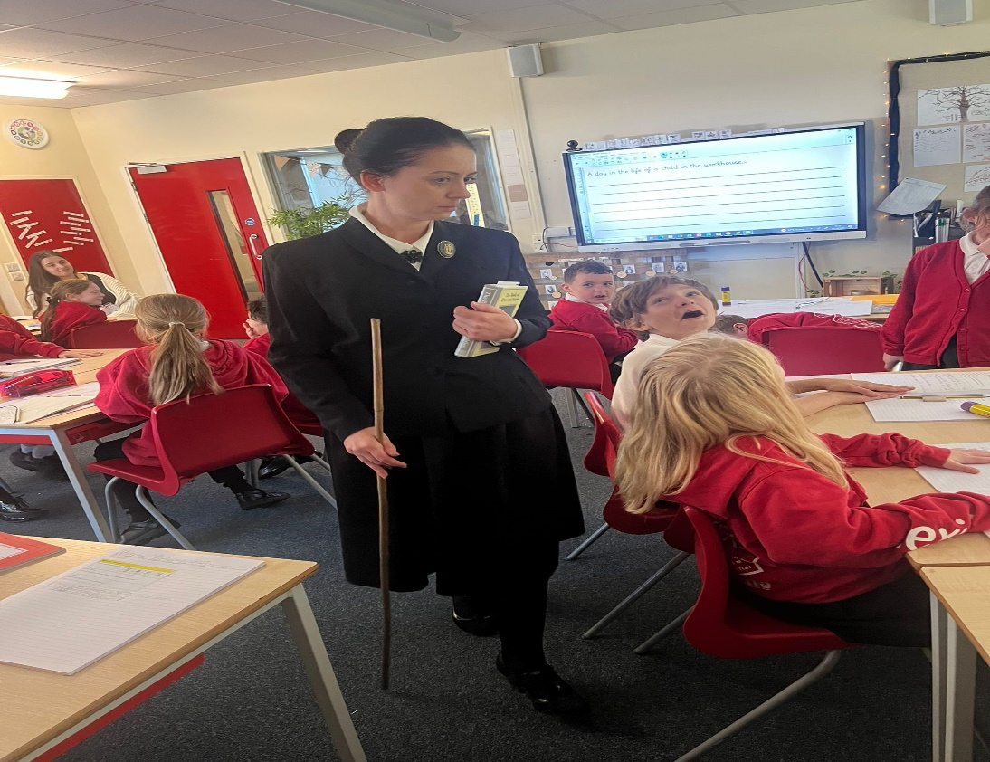 | 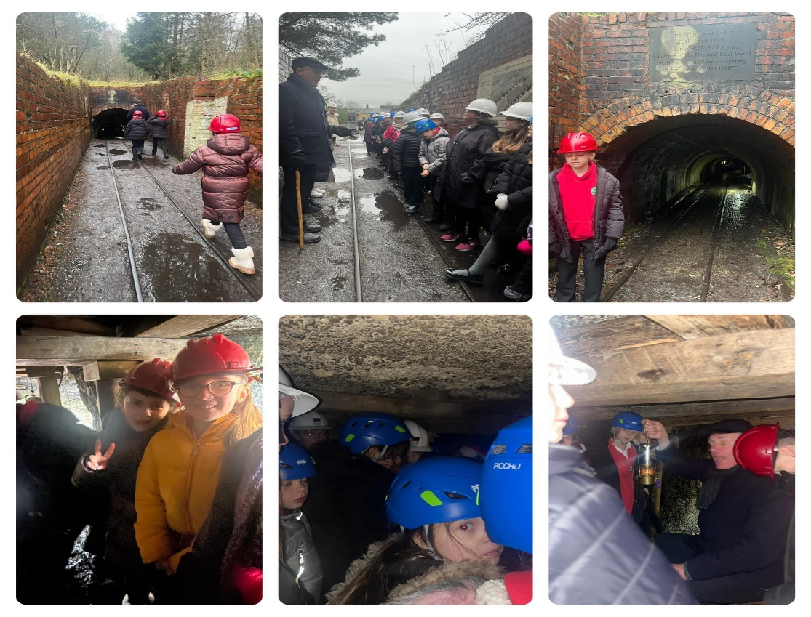 |  | 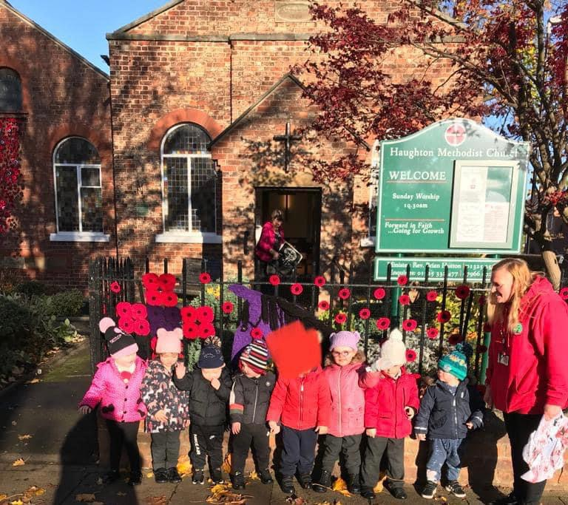
What is the intent of our history curriculum?  To help pupils gain a coherent knowledge and understanding of Britain’s past and that of the wider world. We want our children to become historians! At Red Hall Primary school our aim is to inspire pupils’ curiosity and make learning creative so they want to know more and ask questions about the past. History lessons at our school will encourage children to think critically, gather and understand evidence and discover more about the complexity of people’s lives in our past and how times have changed. Our lessons will be fun, active and centred around children’s interests, we aim to create a love for History and all of its fascinating facts. At times, subjects such as English, Maths and an understanding of what is going on now, can be a struggle, never mind trying to visualise things from a different time in History and imagine how life would have been for these people! This is why lessons are active and a range of resources, invitations and provocations are used to deepen the children’s understanding of the period of time we are studying. To meet the objectives of the National Curriculum, we have planned out which class has to cover certain time periods in history. Our lessons focus on developing historical skills and real life experiences, links to Geography and other subject areas are also explored to deepen children’s knowledge Through the school themes and by creating cross curricular links to other subjects, we will help make connections and make sense of our history and embed knowledge that stick with children throughout their whole school lives and into adulthood. Our children will know more and remember more! |  | What experiences will the children receive?  In our classes we have ‘floorbooks’ and ‘hook books’, these are led by the children and follow the possible lines of development they wish to follow. When a teacher begins a theme they use a ‘hook’ to spark children’s imaginations and, wherever possible, we use the children’s ideas to plan what will be covered in History. As historian’s, children must receive as many experiences as possible to make sense of the world around them. We use many ‘provocations’ and ‘invitations’ into learning as possible, in hope to engage as many children as possible. These gems of learning could be videos, educational trips to amazing places, photographs, books, role-play, letters and so much more. Our children are provided with ‘memorable experiences’ (which the school will mainly fund) to give children as many opportunities as possible. These link to the way we structure our approach to teaching:  1. In our themed sessions we have a powerful ‘engage stage’ which captures children’s imagination. Learning is centred around the wonders of each child.  2. Next we have the ‘develop stage’, during this time children will improve their knowledge and understanding of the question. They develop and practice their new skills.  3. We also have ‘innovate stage’ which helps to steer the children in new directions, re-engage them in a topic or just to spark a new interest.  4. Finally, at the end of each topic, there is an ‘express stage’. This is possibly the most exciting part as all the children have a chance to express what they have learned to parents, carers and the wider community.
By the end of their time at Red Hall, what will all of our children have?
A passion for History and a determination to carry on discovering about the wider world and its past. By the end of their time at Red Hall, we would like children to see themselves as Historians and to have developed a love for the subject which continues into secondary school. It is our aim that every child has made good progress within History and is proud of their effort all the achievements they have made. We hope children are enthusiastic about learning and remember all of the learning they have completed. We hope the children have developed into independent and confident doers and thinkers.

Whole School Themes
Autumn 1: Community  A Moment In Time | Autumn 2: Aspirational  Tell Me a Story | Spring 1: Respect  The Most Amazing Journey | Spring 2: Inclusive  We Are Family | Summer 1: Nurturing  Magic, Mystery and Mayhem | Summer 2: Growing together  Dream BIG
Year One: My Family and Me!  Year Two: The Great fire of London  Year Three: Stone Age to Iron Age  Year Four: The Roman Empire  Year Five: The Changing Power of Monarchs  Year Six: Industrial Revolution | Year One: Tim Peake/ Neil Armstrong  Year Two: Albert Einstein/Rosa Parks/ Marie Curie/ Nelson Mandela  Year Three: Stone Age to Iron Age  Year Four: The Roman Empire  Year Five: The Changing Power of Monarchs  Year Six: Industrial Revolution | Year One: George Stephenson  Year Two: Historical Places in Darlington  Year Three: Year 3 Ancient Egypt and Tutankhamun  Year Four: The Vikings and Anglo-Saxons  Year Five: The Mayans  Year Six: WW2 | Year One: Queens  Year Two: Kings  Year Three: Year 3 Ancient Egypt and Tutankhamun  Year Four: The Vikings and Anglo-Saxons  Year Five: The Mayans  Year Six: WW2 | Year One: Queens  Year Two: Kings  Year Three: Darlington: A Changing Town Full of History  Year Four: Archaeological Dig: What Would We Find in Our Town?  Year Five: A Local History Study  Year Six: The Railways | Year One: Me  Year Two: Lets Reflect  Year Three: Darlington: A Changing Town Full of History  Year Four: Archaeological Dig: What Would We Find in Our Town?  Year Five: A Local History Study  Year Six: The Railways

Progression of Skills
 | Year 1 | Year 2 | Years 3 | Year 4 | Year 5 | Year 6
Chronological Understanding | • I can sequence some events from my own life in order  • I can make some comments about things from the past that have happened to me  • I can describe memories of key events in people’s lives | I can sequence some events from my own life on a timeline.  • I can describe memories of key events in people’s lives | • I can place the time period studied on a timeline  • I can begin to use dates and terms related to the period of study  • I can sequence events and artefacts | • I can place events from the time period studied on a timeline  • I can use dates and terms related to the period of study  • I can make comparisons between different time periods  • I can use more complex terms e.g. BC/AD | • I can place events from the time period studied on a timeline with increasing confidence  • I use relevant dates and terms related to the period of study | • I can position time periods studies to other time periods taught across the school  • I can make more considered comparisons between a growing range of different time periods
Historical Knowledge | • I can recognise the difference between past and present in my own and others’ lives  • I can recount stories from the past | • I know some historical figures and understand why they were important  • I can begin to compare historical periods with life today | • I know about some everyday aspects of people’s lives from different time periods  • I can compare historical periods with life today | • I can identify key features and events of a time studied  • I can describe some changes in the historical period being studied | I can describe changes within and between periods and societies studied  • I can examine causes and results of great events and the impact on people  • I can compare an aspect of life with the same aspect in another life | I can find out about beliefs, behaviour and characteristics of people, recognising that not everyone shares the same views or feelings  • I can give an explanation of past events in terms of cause and effect using evidence to support an explanation  • I can compare and contrast themes between different time periods
Interpretations of History | ∙ I can pick out information about the past from sources like pictures, artefacts and stories | ∙ I can compare pictures or photographs of people or events in the past with now | I can identify and give reasons for different ways the past is represented | ∙ I can begin to evaluate the usefulness of different sources | I can offer some reasons for different versions of events  • I can begin to compare accounts of events from different sources | • I can link sources and work out how conclusions were arrived at  • I am aware that different evidence will lead to different conclusions
Historical Enquiry | • I can find out answers to simple questions about the past from sources of information with support, e.g. artefacts  • I can talk, draw and write down my ideas | • I can use a source/artefact to answer questions about the past on the basis of observations  • I can represent the past in a different ways | • I can use a range of sources to find about a period  • I can begin to select and record relevant information from nonfiction text, online resources and other sources. | • I can use evidence to build up a clearer picture about past events • I can ask a variety of questions • I can use the library and internet for research | • I can begin to discuss primary and secondary sources  • I can use the library and internet for research independently with a given brief | • I can discuss the relevance primary and secondary sources  • I can bring knowledge gathered from several sources together in a fluent account

National Curriculum Coverage
YEAR ONE
 | My Family and Me!  Autumn 1: Community  A Moment In Time | Tim Peake/ Neil Armstrong  Autumn 2: Aspirational  Tell Me a Story | George Stephenson  Spring 1: Respect  The Most Amazing Journey | Queens  Spring 2: Inclusive  We Are Family | Queens  Summer 1: Nurturing  Magic, Mystery and Mayhem | ME  Summer 2: Growing together  Dream BIG
National Curriculum Links | Changes within living memory | Changes within living memory  Lives of significant historical figures | Significant historical events, people and places in their own locality. | Changes beyond living memory Lives of significant historical figure |  | Changes within living memory
Chronological Understanding | - I can sequence some events from my own life in order  • I can make some comments about things from the past that have happened to me  • I can describe memories of key events in people’s lives | I can describe memories of key events in people’s lives  ∙ I can plot memorable events back to Neil Armstrong’s flight  ∙ I know when the first female astronaut went into space | - I can recount stories about my local history | • I can create a time line (order) the last three monarchs.  • I can compare BC/AD and where monarchs come |  | - I can recognise the difference between past and present in my own and others’ lives.  - I can start to think about how I could make history.  • I can recount stories from the past
Historical Knowledge | - I can pick out information about the past from sources like pictures and stories |  | - I can pick out information about the past from sources like pictures, artefacts and stories | - I can recognise the difference between past and present in my own and others’ lives  - I can recount stories from the past |  | - I can recognise the difference between past and present in my own and others’ lives
Interpretation and Enquiry | - I can pick out information about the past from sources like pictures, artefacts and stories  - I can find out answers to simple questions about the past from sources of information, e.g. artefacts  - I can talk, draw and write my ideas | - I can pick out information about the past from sources like pictures, artefacts and stories  - I can predict what things might have been like  - I can find out answers to simple questions about the past from sources of information, e.g. artefacts  - I can talk, draw and write my ideas | - I can pick out information about the past from sources like pictures, artefacts and stories  - I can find out answers to simple questions about the past from sources of information, e.g. artefacts  - I can talk, draw and write my ideas | - I can pick out information about the past from sources like pictures, artefacts and stories  - I can predict what things might have been like  - I can find out answers to simple questions about the past from sources of information, e.g. artefacts  - I can talk, draw and write my ideas |  | - I can find out answers to simple questions about the past from sources of information, e.g. artefacts  - I can talk, draw and write my ideas
Key Vocabulary | Past  Present  Before  After  History  Order  Timeline  Date  Photograph | First  Astronaut  Craft  Buggy  Pioneer  Source  Research | Local  Pioneer  Industrial  Railway  Technology  Locomotive  Steam  Legacy | Queen  King  Monarch  Royalty  Reign  Kingdom  Power |  | Reflect  Memory  Achieve  Accomplish
Cultural Capital | - Parent/carers in to build a family tree together |  | - Trip to the Railway museum |  |  | - Walk around the local area. Find old images/talk

YEAR TWO
 | The Great fire of London  Autumn 1: Community  A Moment In Time | Albert Einstein/Rosa Parks/ Marie Curie/ Nelson Mandela  Autumn 2: Aspirational  Tell Me a Story | Historical Places in Darlington  Spring 1: Respect  The Most Amazing Journey | Kings  Spring 2: Inclusive  We Are Family | Kings  Summer 1: Nurturing  Magic, Mystery and Mayhem | Let’s Reflect  Summer 2: Growing together  Dream BIG
National Curriculum Links | Changes beyond living memory | Lives of significant historical figures | Significant historical events, people and places in their own locality. | Changes beyond living memory  Lives of significant historical figure |  | Changes within and beyond living memory  Lives of significant historical figure  Significant historical events, people and places in their own locality.
Chronological Understanding | - I can describe memories of key events in people’s lives  - Place moments in history on a timeline | - I can describe memories of key events in people’s lives  - I can plot memorable events relating to our school house captains on a time line. | - I can recount stories about my local history | - I can create a time line (order) the last three monarchs.  - I can compare BC/AD and where monarchs come  - I can reflect back on monarchs studied in Year 1 and speak about their importance |  | - I can recognise the difference between past and present in my own and others’ lives.  - I can recount stories from the past  - I can discuss our class timeline and the significant people and times on there.
Historical Knowledge | - I can begin to compare historical times with life today | - I know some historical figures and understand why they were important  - I can begin to compare historical periods with life today | - I can pick out information about the past from sources like pictures, artefacts and stories | - I know some historical figures and understand why they were important  - I can begin to compare historical periods with life today
Interpretation and Enquiry | - I can identify and give reasons for different ways the past is represented  - I can use a source/artefact to answer questions about the past on the basis of observations | - I can compare pictures or photographs of people or events in the past with now  - I can begin to select and record relevant information from non-fiction text, online resources and other sources. | - I can compare pictures or photographs of people or events in the past with now  - I can begin to select and record relevant information from non-fiction text, online resources and other sources. | - I can compare pictures or photographs of people or events in the past with now  - I can use a source/artefact to answer questions about the past on the basis of observations  - • I can represent the past in a different ways |  | - I can compare pictures or photographs of people or events in the past with now  - • I can represent the past in a different ways
Key Vocabulary | Medieval  1666  Diary  Samuel Pepys  Burning  Smoke  King Charles II  Pudding Lane  Thomas Farriner | Activist  Legacy  Radioactivity  Chemistry  Theory  University  Physicist  Science  Nobel Prize  President  Government  Legacy  Race  Equality  Civil rights  Bus  Freedom  Separation/ Segregation  Race  Research  Pioneer  Nobel Prize  Women | Research  Non-fiction  Source  Research  Artefacts  Past  Legacy  Historical | Queen  King  Monarch  Royalty  Reign  Kingdom  Power  Abdicate  Crown  Title  Sovereign |  | Reflect on all key vocabulary in KS1
Cultural Capital | - Build own pudding lane as hook (done by SA) | - Links with BHM  - Links with last year Neil Armstrong/Tim Peake | - Brick train?  - Walk around the local area – lots of pictures can be found of Darlington now/then. Could chn identify where somewhere is based off an old image?

YEAR THREE

 | Stone Age to Iron Age  Autumn 1: Community. A Moment in Time  Autumn 2: Aspirational. Tell Me a Story | Year 3 Ancient Egypt and Tutankhamun  Spring 1: Respect. The Most Amazing Journey  Spring 2: Inclusive. We Are Family | Darlington: A Changing Town Full of History  Summer 1: Nurturing. Magic, Mystery and Mayhem  Summer 2: Growing together. Dream BIG
National Curriculum Links | changes in Britain from the Stone Age to the Iron Age | Achievements of early civilisation | Developing knowledge of local history
Chronological Understanding | - I can place the time period studied on a timeline  - I can begin to use dates and terms related to the period of study  - I can sequence events and artefacts | - I can describe memories of key events in people’s lives  - I can place the time period studied on a timeline | - I can place the time period studied on a timeline  - I can begin to use dates and terms related to the period of studied  - I can sequence events and artefacts
Historical Knowledge | - I know about some everyday aspects of people’s lives from different time periods  - I can compare historical periods with life today | - I know some historical figures and understand why they were important  - I can compare historical periods with life today | - I know about some everyday aspects of people’s lives from different time periods  - I can compare historical periods with life today
Interpretation and Enquiry | - I can identify and give reasons for different ways the past is represented  - I can use a range of sources to find about the period  - I can begin to select and record relevant information from non-fiction text, online resources and other sources. | - I can compare pictures or photographs of people or events in the past with now.  - I can use a source/artefact to answer questions about the past on the basis of observations  - I can represent the past in a different ways. | - I can use a range of sources to find about a period  - I can begin to select and record relevant information from non-fiction text, online resources and other sources.
Key Vocabulary | Glacier  Stone Age  Iron age  Bronze Age  Tundra  Tools  Prehistoric  Homo sapien  Ancestors  Weapons  Source  Period  Housing  Hunters  Gatherers | Artefacts  Sources  Changes  Beliefs  Millions  Canopic jar  Sarcophagus  Ancient  Gods’ names  Egyptians  Preserve  Mummification  Tutankhamun | Changes  Period  Relevant  Information  Variety  Historical  Figures  Build  Darlington  Famous  Reflect  Time  Library/ Market/ Significant figure/ Brick train/ Railway/ War monument/ Statues/ Town clock
Cultural Capital | - Great North Museum – has a workshop looking at prehistory | - School workshops – Ancient Egyptian workshops from an outside agency: Hands on History, Imagining History | - Walk around the town centre – find key monuments. Monday is Market day so there is an opportunity to speak to vendors.

YEAR FOUR

 | The Roman Empire  Autumn 1: Community. A Moment in Time  Autumn 2: Aspirational. Tell Me a Story | The Vikings and Anglo-Saxons  Spring 1: Respect. The Most Amazing Journey  Spring 2: Inclusive. We Are Family | Archaeological Dig: What Would We Find in Our Town?  Summer 1: Nurturing. Magic, Mystery and Mayhem  Summer 2: Growing together. Dream BIG
National Curriculum Links | The Roman Empire and its impact on Britain | The Viking and Anglo-Saxon struggle for the Kingdom of England to the time of Edward the Confessor  Britain’s settlement by Anglo-Saxons and Scots | Developing knowledge of local history
Chronological Understanding | - I can place the time period studied on a timeline  - I can begin to use dates and terms related to the period of study  - I can sequence events and artefacts  - Know in relation to BC AD | - I can place events from the time period studied on a timeline  - I can use dates and terms related to the period of study  - I can make comparisons between different time periods  - I can use more complex terms e.g. BC/AD and identify how many years | - I can place events from the time period studied on a timeline  - I can use dates and terms related to the period of study  - I can make comparisons between different time periods
Historical Knowledge | - I know about some everyday aspects of people’s lives from different time periods  - I can compare historical periods with life today | - I can identify key features and events of a time studied  - I can describe some changes in the historical period being studied | - I can begin to evaluate the usefulness of different sources: interview and people living
Interpretation and Enquiry | - I can identify and give reasons for different ways the past is represented  - I can use a range of sources to find about the period  - I can begin to select and record relevant information from non-fiction text, online resources and other sources. | - I can begin to evaluate the usefulness of different sources  - I can use evidence to build up a clearer picture about past events  - I can ask a variety of questions  - I can use the library and internet for research | - I can begin to evaluate the usefulness of different sources  - I can use evidence to build up a clearer picture about past events  - I can ask a variety of questions  - I can use the library and internet for research
Key Vocabulary | Ballista  Legion  Cohort  Cavalry  Cross bow  Chariot  Armour  Javelin  Citizen  Soldier  Empire  Shield  Leadership  Gladiator  Mosaic  Latin  Colosseum | Barbarian  Conquest  Dane  Expedition  Fierce  God  Heathen  Helmet  Invade  Loyalty  Merchant  Raid  Rune  Settlement  Slave  Warrior  Battle | Archaeology  Artefact  Crypt  Tools  Research  Dig  Findings  Excavate  Fossil  Prehistoric
 | - Vindolonda  - Speak with SA – photos from a trip  - Hadrian’s wall | - Jarrow Hall – trip or people can come into school

YEAR FIVE
 | The Changing Power of Monarchs  Autumn 1: Community. A Moment in Time  Autumn 2: Aspirational. Tell Me a Story | The Mayans  Spring 1: Respect. The Most Amazing Journey  Spring 2: Inclusive. We Are Family | A Local History Study  Summer 1: Nurturing. Magic, Mystery and Mayhem  Summer 2: Growing together. Dream BIG
National Curriculum Links | A study of an aspect or theme in British history that extends pupils’ chronological knowledge beyond 1066 | A non-European society that provides contrasts with British history | A study over time tracing how several aspects of national history are reflected in the locality (this can go beyond 1066)
Chronological Understanding | - I can place events from the time period studied on a timeline with increasing confidence  - I use relevant dates and terms related to the period of study | - I can place events from the time period studied on a timeline with increasing confidence  - I use relevant dates and terms related to the period of study | - I can place events from the time period studied on a timeline with increasing confidence  - I use relevant dates and terms related to the period of study
Historical Knowledge | - I can describe changes within and between periods and societies studied  - can examine causes and results of important events and the impact on people | - I can find out about beliefs, behaviour and characteristics of people, recognising that not everyone shares the same views or feelings  - I can give an explanation of past events in terms of cause and effect using evidence to support an explanation  - I can compare and contrast themes between different time periods | - I can describe changes within and between periods  - I can reflect on prior knowledge and use this in my study
Interpretation and Enquiry | - I can offer some reasons for different versions of events  - I can use the library and internet for research with increasing confidence  - I can begin to discuss primary and secondary sources | - I can link sources and work out how conclusions were arrived at  - I am aware that different evidence will lead to different conclusions | - I can use the library and internet for research independently with a given brief
Key Vocabulary | Abdicate  Commonwealth  Descendant  Entitle  Family Tree  Line of succession  Monarchy  Reining | Glyphs  Civilisation  Maya  Mayan  Century  Millennium  Continent  BC/ AD or BCE/ CE  Empire  Temple  Plaza  Day of dead  Ancestors  Sacrifice origin | Changes  Period  Relevant  Information  Reliable  Historical  Sources  Research  Darlington  Famous  Reflect  Library/ Market/ Significant figure/ Brick train/ Railway/ War monument/ Statues/ Town clock
Cultural Capital |  | - https://www.mayaarchaeologist.co.uk/school-workshops/school-visits/ - this looks great. Unsure of pricing but the virtual tour would be cheaper. | - Trip to the town centre with Year 3? (Same objectives).  - On a Monday it is Market day so this could be a good opportunity to speak to local vendors about THEIR history.

YEAR SIX Children will be working closely with their teacher to develop an understanding of a significant turning point in British history (WW2 – Battle of Britain, The Blitz). Children will guide the learning a direction which sparks their imagination. ∙ Children will also learn to make detailed comments connections, contrasts and trends over periods of time What a way to end our journey into History at Red Hall. Do you have stories at home from great grandparents about times such as WW2? This could really inspire the ch
 | Industrial Revolution  Autumn 1: Community. A Moment in Time  Autumn 2: Aspirational. Tell Me a Story | Titanic  Spring 1: Respect. The Most Amazing Journey  Spring 2: Inclusive. We Are Family | WW2  Summer 1: Nurturing. Magic, Mystery and Mayhem  Summer 2: Growing together. Dream BIG
National Curriculum Links | British History since 1066 | A significant turning point in British history  Reflect on local history | A significant turning point in British history  Reflect on local history
Chronological Understanding | - I can position time periods studies to other time periods taught across the school in previous years  - I can make more considered comparisons between a growing range of different time periods | - I can make more considered comparisons between a growing range of different time periods | - I can make more considered comparisons between a growing range of different time periods
Historical Knowledge | - I can give an explanation of past events in terms of cause and effect using evidence to support an explanation  - I can compare and contrast themes between different time periods | - I can find out about beliefs, behaviour and characteristics of people, recognising that not everyone shares the same views or feelings  - I can give an explanation of past events in terms of cause and effect using evidence to support an explanation | - I can compare and contrast themes between different time periods
Interpretation and Enquiry | - I can link sources and work out how conclusions were arrived at  - I am aware that different evidence will lead to different conclusions  - I can discuss the relevance of primary and secondary sources  - I can bring knowledge gathered from several sources together in a fluent account | - I can link sources and work out how conclusions were arrived at  - I am aware that different evidence will lead to different conclusions  - I can discuss the relevance of primary and secondary sources  - I can bring knowledge gathered from several sources together in a fluent account | - I can discuss the relevance of primary and secondary sources  - I can bring knowledge gathered from several sources together in a fluent account
Key Vocabulary | Industry  Factories  Liberating  Mass production Steel  Labour  Textiles  Europe  Sources  Primary  Secondary  Invention  Revolution  Queen Victoria  Child labour  Workhouse  Cotton mills  mining | Vessel  Industry  Factories  Craft  Liberating  Mass production  Steel  Iron works  Labour  Textiles  Europe  Ireland  Docks  Sources  Accommodate  Achieve  Determined  Disastrous  Guarantee  Privilege  Sacrifice | Leadership  Army  Forces  Troops  Civilians  Tactics  Propaganda  Persecution  Borders  Camps  Prisoners of war  Sources  Primary  Secondary  Account witness  Allies  Axis  Germany  Hitler  Evacuation  Countryside
Cultural Capital | - Victorian lesson with SA  - Trip to Beamish |  | • Eden camp  • Alnwick castle

