RED HALL PRIMARY SCHOOL
DT CURRICULUM OVERVIEW
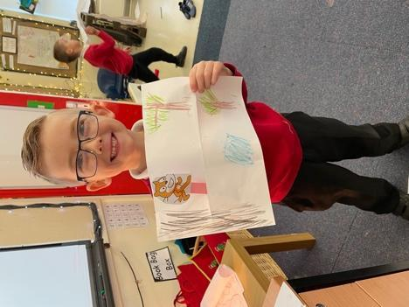 | 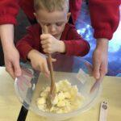 | 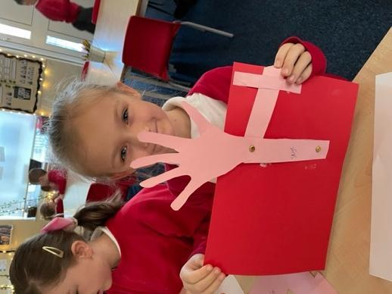
What is the intent of our DT curriculum?  Our aim is to provide our pupils with inspiring and practical learning experiences as well as to provide opportunities to spark curiosity. We view DT as opportunities for pupils to be as creative and as imaginative as possible – the sky is the limit!  We believe that DT is an essential part of children’s education, and like Sark we believe “Invention is the natural outcome of creative thinking”. Our scheme of work, developed from the National Curriculum, includes structures, mechanisms, electrical systems as well as cooking and nutrition. Our lessons are incorporated across the curriculum, making learning practical, creative and accessible by all pupils.  A lot of our pupils also do not experience DT outside of school! With this in mind, we have a minimal curriculum until the children gain skills in the basic techniques. The curriculum uses the children’s imagination to design and make products that solve real and relevant problems. It draws on other subject knowledge including maths, science, computing, and art. Pupils will learn to take risks, become resourceful and innovative. Through evaluating current products, children develop an understanding of daily life and how everything can be improved. Through DT lessons, children will focus on their problem-solving skills as well as their imagination and understanding of inventors. We focus on a unit each term, so the children learn skills to combine into a finished project. Some DT lessons are discrete, and others follow our whole school topics.  In Early Years we focus on exploring fine motor skill, designing, and combining materials. The children will have access to a wide range of tools and art materials. This will help them explore and develop into their potential, the children will be encouraged to develop their own creative ideas. During KS1, we focus on expanding creativity and imagination through providing DT activities relating to the children’s own lives’ and experiences. The children begin to explore structures, textiles, and mechanisms. In Key Stage 2, DT is about deepening the children’s knowledge by building on their skills and understanding from KS1 and introducing the children to more complex activities such as electrical systems. Each year we build upon the year prior and witness children become whizzes with their understanding and applying skills to design and make high-quality prototypes and products. |  | What experiences will the children receive?  At Red Hall Primary School, we want the children to have a say in their learning. We focus on their interests as much as we can, as well providing purposeful and enriching opportunities.  As a pupil at Red Hall, your child will have access to a wide range of experiences:  - Termly DT projects focussing on the structures, mechanisms, textiles and electrical systems (where applicable) as well as whole school DT days experiencing other techniques.  - Real life experiences e.g. creating products that they would use
By the end of their time at Red Hall, what will all of our children have?
- An understanding of basic DT techniques
- Know at least one DT skill they can achieve
- A sense of pride in their achievements and the presentation of their work.
- An understanding of a range of skills that are transferrable to other subjects
- Resilience, to continuously improve and not see this as a failure.
Units Overview
 | Autumn 1  A Moment in Time | Autumn 2  Tell Me A Story | Spring 1  The Most Amazing Journey | Spring 2  We Are Family | Summer 1  Magic, Mystery & Mayhem | Summer 2  Dream BIG
Year 1 |  | Structures |  | Cookery | Mechanisms
Year 2 |  | Textiles |  | Mechanisms |  | Mechanisms
Year 3 |  | Structures |  | Mechanisms |  | Cookery
Year 4 |  | Textiles |  |  | Cookery | Electrical Systems
Year 5 |  | Mechanisms |  | Structures |  | Cookery
Year 6 |  | Electrical Systems |  | Cookery |  | Textiles

Progression of Skills
 | Year 1 | Year 2 | Year 3 | Year 4 | Year 5 | Year 6
Design | - I have my own ideas.  - I can explain what I want to do.  - I can explain what my product is for, and how it will work.  - I can use pictures and words to plan and begin to use models.  - I can design a product for myself following a given design criteria.  - I can research similar existing products.  - I can discuss the intended audience for my product. | - I have my own ideas and plan what to do next.  - I can explain what I want to do and describe how I may do it.  - I can explain the purpose of my product, how it will work and how it will be suitable for the user.  - I can describe my design using pictures, words, models, diagrams and begin to use ICT.  - I can design products following a design criterion.  - I can use my knowledge of existing products to produce ideas. | - I can begin to research others’ needs.  - I can show my design meets a range of requirements.  - I can describe the purpose of the product.  - I can follow a given design criterion.  - I can create a plan which shows order, equipment and tools.  - I can describe my design using an accurately labelled sketch and words.  - I can attempt to make a prototype.  - I can begin to use computers to show design. | - I can research others’ needs.  - I can show my design meets a range of the requirements and is fit for purpose.  - I can begin to create my own design criteria.  - I can produce a plan and say how realistic it is.  - I can explain how the product will work.  - I can make a prototype.  - I can become more confident using computer aided design. | - I can use the internet and questionnaires for research and design ideas.  - I can take a user’s view into account when designing.  - I can begin to consider the needs/wants of individuals or groups when designing a product and ensure it is fit for purpose.  - I can create my own design criteria.  - I have a range of ideas.  - I can produce cross-sectional planning and annotated sketches.  - I can make design decisions considering time and resources.  - I can refine ideas by making prototypes and patterned pieces.  - I can use computer-aided designs. | - I can draw on market research to inform design.  - I can use research of a user’s view into account when designing.  - I can identify features that will appeal to the intended user.  - I can create my own design criteria and specification.  - I can come up with innovative designs.  - I can make design decisions considering resources and costs.  - I can produce cross-sectional planning, exploded diagrams and annotated sketches.  - I can independently model and refine ideas by making prototypes and patterned pieces.  - I can use computer-aided designs.
Make | - I can explain what I’m making and why.  - I can consider what I need to do next  - I can select tools/equipment to cut shape, join, finish and explain my choices.  - I can measure, mark out, cut and shape with support.  - I can choose suitable materials and explain choices.  - I can begin to use finishing techniques to make the product look good.  - I can work in a safe and hygienic manner. | - I can explain what I am making and why it fits the purpose.  - I can make suggestions as to what I need to do next.  - I can join materials/components together in different ways.  - I can measure, mark out, cut and shape materials/components with support.  - I can describe which tools I’m using and why.  - I can choose suitable materials and explain choices depending on characteristics.  - I can use finishing techniques to make the product look good.  - I can work safely and hygienically. | - I can select suitable tools/equipment, explain choices; begin to use them accurately.  - I can select appropriate materials fit for purpose.  - I can work through the plan in order.  - I can begin to measure, mark out, cut and shape materials/components with some accuracy.  - I can begin to assemble, join and combine materials/components with some accuracy/  - I can begin to apply a range of finishing techniques with some accuracy. | - I can select suitable tools/equipment, explain choices in relation to required techniques and begin to use them accurately.  - I can select appropriate materials fit for purpose.  - I can work through the plan in order.  - I can think if the product is going to be of good quality.  - I can begin to measure, mark out, cut and shape materials/components with some accuracy.  - I can begin to assemble, join and combine materials/components with some accuracy.  - I can begin to apply a range of finishing techniques with some accuracy. | - I can select tools and equipment with a good level of precision.  - I can produce lists of tools and materials needed.  - I can choose appropriate materials considering functionality.  - I can create a detailed step-by-step plan.  - I can explain how my product would appeal to an audience.  - I can mainly accurately mark out, cut and shape materials/components.  - I can mainly accurately assemble, join and combine.  - I can mainly accurately apply a range of finishing techniques.  - I can begin to be resourceful in solving practical problems. | - I can select tools and equipment with a good level of precision.  - I can produce lists of tools and materials needed.  - I can choose appropriate materials considering functionality.  - I can create a detailed step-by-step plan.  - I can explain how my product would appeal to an audience.  - I can mainly accurately mark out, cut and shape materials/components.  - I can mainly accurately assemble, join and combine.  - I can mainly accurately apply a range of finishing techniques.  - I can begin to be resourceful in solving practical problems.
Evaluate | - I can verbally evaluate existing books and everyday products that use simple sliders and levers.  - I can talk about my product and explain how it works.  - I can evaluate my product against the design criteria.  - I can begin to talk about what could make my product better. | - I can describe what went well, thinking about the design criteria.  - I can talk about existing products considering: use, materials, how they work, audience, where they might be used, express personal opinion.  - I can evaluate how good existing products are.  - I can talk about what I would do differently if I were to do it again and why. | - I can use the design criteria when evaluating.  - I can begin to evaluate products considering: use, materials, how well they have been made, materials, whether they work, how they have been made, fit for purpose.  - I can begin to understand by whom, when and where products where designed.  - I can learn about some inventors/designers/engineers/chefs/ manufacturers of ground-breaking products. | - I can use the design criteria when evaluating.  - I can begin to evaluate products considering: use, materials, how well they have been made, materials, whether they work, how they have been made, fit for purpose.  - I can begin to understand by whom, when and where products where designed.  - I can learn about some inventors/designers/engineers/chefs/ manufacturers of ground-breaking products.  - I can research whether products can be recycled of reused. | - I can evaluate the finished product against the specification, considering purpose and appearance.  - I can test and evaluate the final product.  - I can evaluate products considering: materials, how well they have been made, materials, whether they work, how they have been made, fit for purpose.  - I can begin to evaluate how much products cost to make and how innovative they are.  - I can research how sustainable the materials are.  - I can talk about some key inventors/designers/engineers/chefs/ manufacturers of ground-breaking products. | - I can evaluate the finished product against the specification, considering purpose and appearance.  - I can test and evaluate the final product considering if it’s fit for purpose and explain possible improvements if different materials had been used.  - I can do thorough evaluations on products considering: materials, how well they have been made, materials, whether they work, how they have been made, fit for purpose.  - I can begin to evaluate how much products cost to make and how innovative they are.  - I can research and discuss how sustainable the materials are.  - I can discuss some key inventors/designers/engineers/chefs/ manufacturers of ground-breaking products.  - I can consider the impact of the product beyond the intended user.
Technical Knowledge | Structures  - I can build a free-standing structure.  - I am beginning to measure and join materials, with some support.  - I can join materials in different ways.  - I can suggest ways to make product stronger, stiffer and more stable.  - I can describe differences in materials.  - I can use joining, rolling or folding to make it stronger.  I can design, make and evaluate a slide for __________ (user) for ________ (purpose). |  | Structures  - I can build a shell structure  - I can use appropriate materials.  - I can work accurately to make cuts and holes.  - I can join materials.  - I can measure carefully to avoid mistakes.  - I can make a strong, stiff structure.  I can design, make and evaluate a gift box for __________ (user) for ________ (purpose). |  | Structures  - I can reinforce and strengthen a 3D frame.  - I can make more complex structures including a frame structure.  - I can measure accurately enough to ensure precision.  - I can make products that are strong and fit for purpose.  I can design, make and evaluate tents for __________ (user) for ________ (purpose).
 | Mechanisms  - I can use levers or sliders to make a moving picture.  - I understand that different mechanisms produce different types of movement.  I can design, make and evaluate a moving picture for __________ (user) for ________ (purpose).  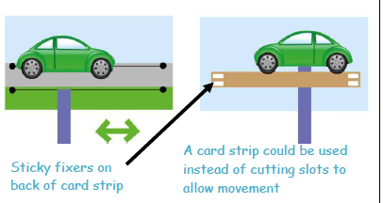 | Mechanisms  - I can use wheels and axles.  I can design, make and evaluate a vehicle for __________ (user) for ________ (purpose). | Mechanical Systems  - I can use pneumatics to create movement.  I can design, make and evaluate a Jack in the Box toy for __________ (user) for ________ (purpose).  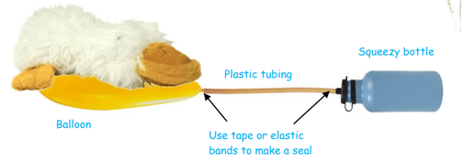 |  | Mechanical Systems  - I can use a pulley to create movement.  I can design, make and evaluate lifting machine for __________ (user) for ________ (purpose).  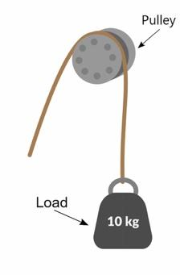
 |  |  |  | Electrical Systems  - I can use number of components in circuit including bulbs and buzzers.  - I can program a computer to control a product.  I can design, make and evaluate a torch for __________ (user) for ________ (purpose).  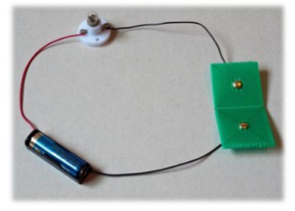 |  | Electrical Systems  (do through Science unit)  - I can use different types of circuits in product including a motor and a switch.  - I can think of ways in which adding a circuit would improve product.  - I can program a computer to monitor changes in environment and control product.  I can design, make and evaluate a light for __________ (user) for ________ (purpose).
 |  | Textiles  - I can measure, cut and join textiles to make a product, with some support  - I can join textiles together to make a product.  - I can carefully cut textiles to produce accurate pieces.  - I can cut out shapes that have been created by drawing around a template onto the fabric.  - I can begin to sew using a range of basic stitches including a running stitch.  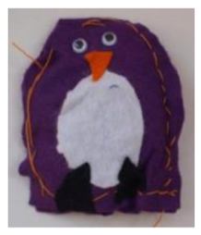  I can design, make and evaluate a finger puppet for __________ (user) for ________ (purpose). |  | Textiles  - I can begin to devise a template.  - I understand that a simple fabric shape can be used to make a 3D textiles project.  - I can join fabrics using a range of stitches with increasing independence.  - My sewing skills are becoming more accurate.  - I can learn to add further decoration by adding buttons, beads, sequins etc.  I can design, make and evaluate a purse for __________ (user) for ________ (purpose). |  | Textiles  - I can use my own template.  - I can consider seam allowance.  - I can use a range of joining techniques including using a blanket stitch.  - I can confidently make 3D products.  - I can pin and tack fabric pieces together.  - I can make products with increasing accuracy and independence.  I can design, make and evaluate a bag for  __________ (user) for ________ (purpose).  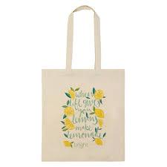
 | Cooking & Nutrition  - I can wash my hands and clean surfaces  - I can think of interesting ways to decorate food.  - I can say where some foods come from, (i.e. plant or animal).  - I can discuss how fruit and vegetables are healthy.  - I can cut, peel and grate safely with support.  I can design, make and evaluate a fruit and vegetable kebab for __________ (user) for ________ (purpose). | Cooking & Nutrition  - I can explain hygiene and keep a hygienic kitchen.  - I can describe the importance of varied diet.  - I can say where food comes from (animal, underground etc.)  - I can describe how food is farmed, home-grown, caught.  - I can draw eat well plate and explain there are groups of food.  - I can describe five a day.  - I can cut, peel and grate with increasing confidence.  - I can begin to measure using measuring cups and digital scales.  I can design, make and evaluate a fruit /vegetable smoothie for __________ (user) for ________ (purpose). | Cooking & Nutrition  - I can follow a recipe.  - I can use equipment safely.  - I can make product look attractive.  - I can think about how to grow plants to use in cooking.  - I can begin to understand food comes from UK and wider world.  - I can describe how healthy diet= variety/balance of food/drinks.  - I can explain how food and drink are needed for active/healthy bodies.  - I can prepare and cook some dishes safely and hygienically.  - I can grow in confidence using some of the following techniques: peeling, chopping, slicing, grating, mixing, spreading.  I can design, make and evaluate wrap for __________ (user) for ________ (purpose). | Cooking & Nutrition  - I can explain how to be safe/hygienic.  - I can think about presenting product in interesting/ attractive ways.  - I understand ingredients can be fresh, pre-cooked or processed.  - I am beginning to understand about food being grown, reared or caught in the UK or wider world.  - I can describe eat well plate and how a healthy diet of food and drinks.  - I can explain importance of food and drink for active, healthy bodies.  - I can prepare and cook some dishes safely and hygienically.  - I can use some of the following techniques: peeling, chopping, slicing, grating, mixing, spreading, kneading and baking.  - I can measure food to the nearest gram accurately.  I can design, make and evaluate a toastie for __________ (user) for ________ (purpose). | Cooking & Nutrition  - I can explain how to be safe / hygienic and follow own guidelines.  - I can present a product well - interesting, attractive, fit for purpose.  - I can begin to understand seasonality.  - I understand that food can be grown, reared or caught in the UK and the wider world.  - I can describe how recipes can be adapted to change appearance, taste, texture, aroma.  - I can explain how there are different substances in food / drink needed for health.  - I can prepare and cook some savoury dishes safely and hygienically including, where appropriate, use of heat source.  - I can use range of techniques such as peeling, chopping, slicing, grating etc.  - I can begin to adapt a recipe by adding / substituting ingredients.  I can design, make and evaluate a pizza __________ (user) for ________ (purpose). | Cooking & Nutrition  - I understand a recipe can be adapted by adding / substituting ingredients.  - I can explain seasonality of foods.  - I can learn about food processing methods.  - I can name some types of food that are grown, reared or caught in the UK or wider world.  - I can adapt recipes to change appearance, taste, texture or aroma.  - I can describe some of the different substances in food and drink, and how they can affect health.  - I can prepare and cook a variety of savoury dishes safely and hygienically including, where appropriate, the use of heat source.  - I can use a range of techniques confidently such as peeling, chopping, slicing, grating, mixing, spreading, kneading and baking.  I can design, make and evaluate a meal (from a different culture) for __________ (user) for ________ (purpose).

National Curriculum Coverage
YEAR ONE
Previous Knowledge | Autumn | Spring | Summer
In Early Years, children will have focussed on using a range of tools, experimented with form, texture and design. | During the Structures unit children will build upon their construction experience in Early Years and construct using card and paper. They will think about how to make structures stiffer and more stable. | During the Cooking unit children will peel, slice and chop fruit / vegetables to make a fruit / vegetable kebab focusing on sensory vocabulary. | During the Mechanisms unit children will make simple flaps, hinges, levers, and linkages. The children will focus on the movement of their product.
Key Vocab

Mechanisms - Mechanism, slider, lever, pivot, slot, join, up, down, straight, forwards, backwards, linkage, lever, bridge, guide
Structures – structure, wall, framework, weak, strong, base, edge, corner, 3D shape names
Cooking and Nutrition - fruit / vegetable names, sensory vocab – juicy, crunchy, sweet, sour, skin, slice, peel, taste

YEAR TWO
Previous Knowledge | Autumn | Spring | Summer
In Year 1, the children made fruit kebabs and now understand sensory vocabulary. The children have also explored making structures stiffer. | During the Textiles unit children will explore different fabrics, cut and join using simple techniques and create appealing products. | During the Mechanisms unit children will make a vehicle with moving wheels focussing on vocabulary. | During the Cooking unit children will peel, slice and chop fruit / vegetables to make a fruit / vegetable smoothie focusing on a healthy diet.
Key Vocab
Mechanisms - vehicle, wheel, axle, axle holder, chassis
Textiles - template, mark out, join, decorate, finish, design criteria
Cooking and Nutrition - fruit / vegetable names, sensory vocab – juicy, crunchy, sweet, sour, flesh, skin, pip, seed, slice, peel, healthy diet, taste

YEAR THREE
Previous Knowledge | Autumn | Spring | Summer
In KS1, the children explored healthy eating in cookery, making structures stiff and simple mechanisms such as levers and linkages. | During the Structures unit children will build a shell structure, explore 3D shape nets, and construct strong, stiff structures. | During the Mechanical Systems unit children will use pneumatic mechanisms, understand how materials can be combined to allow movement and create a pneumatic product. | During the Cookery unit children will make a wrap and begin to look at food that is harvested, grown and reared.
Key Vocab
Mechanical Systems - component, fixing, tubing, syringe, plunger, pneumatic system, input, output, compression, pressure, inflate, deflate, prototype
Structures – 3D shape names, shell structure, length, width, capacity, scoring, tabs, net
Cooking and Nutrition - juicy, crunchy, sweet, sour, texture, taste, spicy, savoury, hygienic, grown, reared, harvested

YEAR FOUR
Previous Knowledge | Autumn | Spring | Summer
In KS1 and Year 3, the children explored 3D shape nets to make a shell structure, explored healthy eating and food that is harvested and grown, as well as pneumatic systems. | During the Textiles unit children will make a purse focussing on gluing and stitching. The children will explore seams and seam allowances. | During the Cookery unit children will make a toastie and begin to look at seasonality and hygienic procedures. | During the Electrical Systems unit children will make a circuit using bulbs and buzzers. They will begin to look at insulators and conductors.
Key Vocab
Cooking and Nutrition - juicy, crunchy, sweet, sour, texture, taste, spicy, savoury, hygienic, grown, reared, processed, harvested, seasonal

Electrical – circuit, fault, connection, switch, battery, battery holder, bulb, wire, clip, insulator, conductor
Textiles - fabric names, fastening, compartment, template, stitch, seam, seam allowance

YEAR FIVE
Previous Knowledge | Autumn | Spring | Summer
In LKS2, the children have explored shell structures, pneumatic systems and explored food that is seasonal and processed. | During the Mechanical Systems unit children will use pulleys or gears in their products. They will also apply their knowledge of electrical systems to this. They will begin to look at outputs and inputs. | During the Structures unit children will build a frame structure. The children will focus on finishing techniques and reinforcing 3D frameworks. | During the Cookery unit children will make pizzas using their knowledge of hygiene, nutrition and healthy diets.
Key Vocab
Mechanical Systems - pulley, drive, belt, gear, rotation, axle, motor, circuit, switch, input, output, mechanical system, electrical system
Structures – frame structure, stiffen, reinforce, triangulation, stability
Cooking and Nutrition – ingredients, yeast, dough, flour, fat, sugar, carbohydrate, protein, nutrients, gluten, dairy, intolerance, savoury, seasonality

YEAR SIX
Previous Knowledge | Autumn | Spring | Summer
In LKS2 and Year 5, the children have explored Electrical Systems including bulbs and buzzers, they have looked at hygiene and nutrition as well as basic stitches. | During the Electrical Systems unit children will make a circuit including switches and batteries. The children will apply an electrical system to their final product. | During the Cookery unit children will make a meal using their knowledge of hygiene, nutrition and healthy diets. They will also use a heat source. | During the Textiles unit children will make a bag using simple patterned pieces and more complex stitches including a blanket stitch. The finishing techniques will be of a high quality.
Key Vocab
Cooking and Nutrition – ingredients, yeast, dough, flour, wholemeal, spice, herbs, fat, sugar, carbohydrate, protein, nutrients, gluten, dairy, intolerance, savoury, seasonality
Textiles - wadding, hem, pattern pieces, pinking shears, transfer paper, seam, seam allowance

Electrical – series circuit, parallel circuit, name of switches, system, control, program, component, input, output

