RED HALL PRIMARY SCHOOL
GEOGRAPHY CURRICULUM OVERVIEW
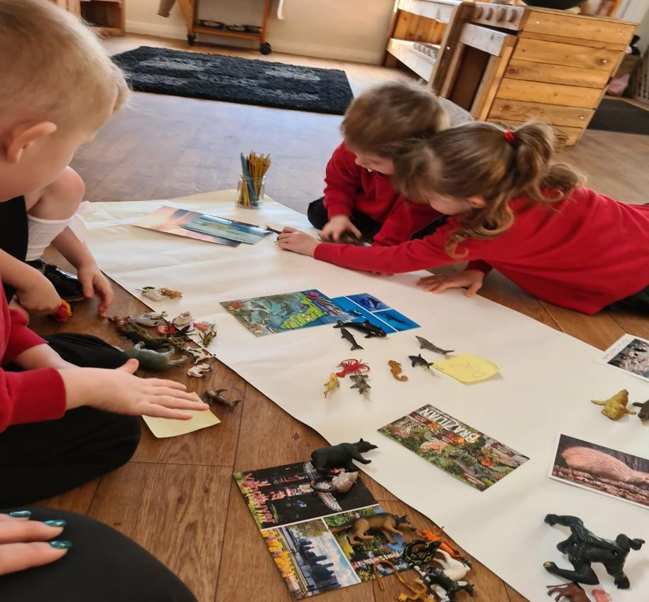 |  | 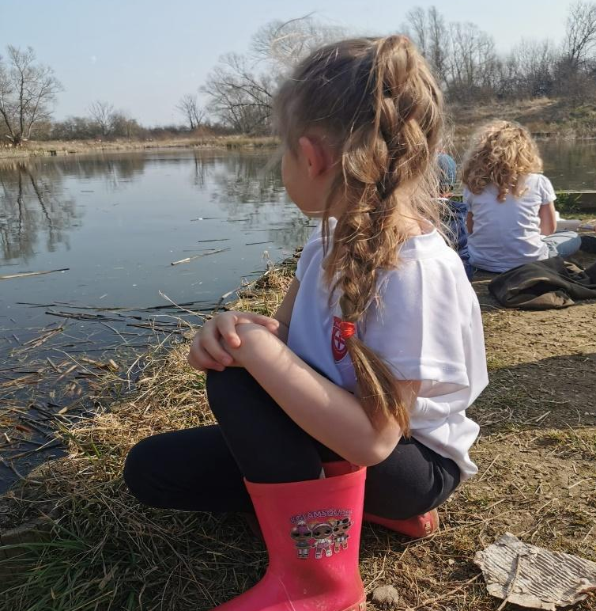 | 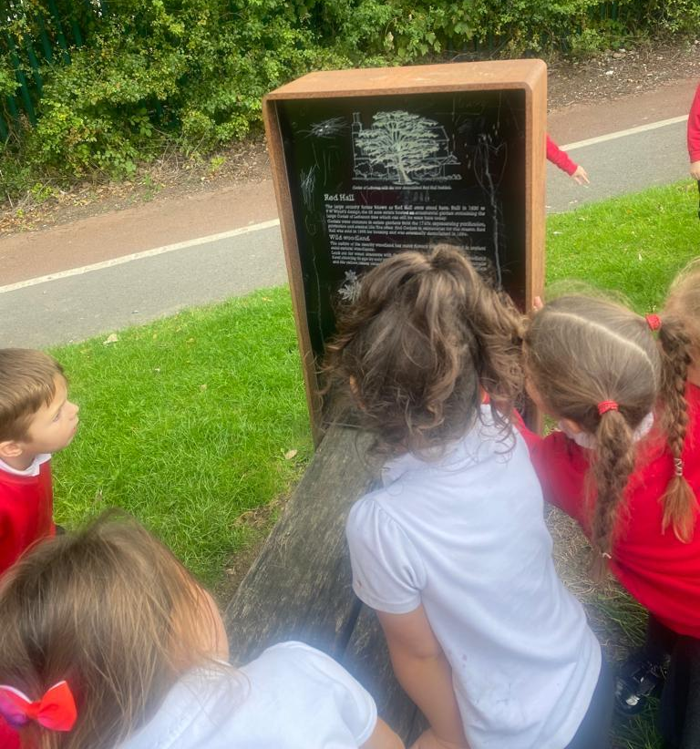
What is the intent of our Geography curriculum?  Red Hall Primary school aims to foster children who are interested in and value all aspects of geography. To inspire children to develop a curiosity and fascination about the world. We will provide exciting teaching and fieldwork to develop their knowledge and skills, which then remain with them for the rest of their lives. Staff will ensure children have a broad understanding of contextual knowledge (social, religious, economic, and political conditions) and that they are able to define physical and human characteristics and how they provide understanding of actions and processes in this amazing subject. We aim to provide exciting lessons indoors and out, which will help to develop their skills in collecting, analysing and communicating their understanding about the data they are shown or have gathered. As teachers, we ensure there is lots of opportunity to apply prior knowledge and skills so children remember. Children will learn to use lots of different resources such as globes, diagrams and maps. We have planned a tailored curriculum for Geography, bespoke to the needs of our children and their backgrounds. We are aware that lots of our children see vandalism on our estate and some of their older siblings may not treat the environment with respect (by lighting fires, killing insects, ruining habitats etc) therefore we work together, with the children to ensure our curriculum not only informs them of the natural world, but also allows them to pass on these messages to other people within the community, resulting in a sense of pride where they live. This is part of our CARING school vision. Our curriculum ensures the expectations of National Curriculum are met and key terminology is learnt. All staff are aware of how the curriculum in geography is sequenced and is progressive from lower school to upper school which will equip children with knowledge about diverse places, people, resources and natural and human environments. Teacher will provide children with amazing challenges and provocations to inspire and encourage independence. As children progress through the year groups, their growing knowledge about the world should help them to deepen their understanding of the interaction between physical and human processes, and of the formation and use of landscapes and environments. Geography lessons focus on developing geographical skills and children working as geographers. We intend for our children to have real life, memorable experiences and learn about geography in a fascinating way. |  |  | How do we implement our Geography curriculum?  Geography is taught each term with each unit of work spanning half of the term. The geography curriculum is an enquiry based curriculum. The units develop in complexity and scale over time/key stage. There are opportunities to link with other curriculum areas e.g. data handling in maths, the water cycle in science and environmental issues in PHSE. There is a clear focus on key vocabulary when addressing new and previous learning. Misconceptions are addressed as teachers check prior knowledge and help children to embed what they know. The school uses a variety of teaching and learning styles in geography lessons and our principal aim is to develop the children’s knowledge, skills and understanding in geography. We believe in whole-class teaching methods and combine these with enquiry-based research activities. We encourage children to handle objects and to ask, as well as answer, geographical questions. We offer them the opportunity to use a variety of data, such as maps, globes, pictures, aerial photographs, geographical footage and we enable them to use IT in geography lessons where this serves to enhance their learning. Wherever possible, we involve the children in ‘real’ geographical activities, e.g. research of a local environmental problem, visiting relevant sites and carrying out fieldwork. Effective use of assessment ensures that next steps are accurately planned for. Teachers are consulted as to the order of teaching and adaptations are made to the geography curriculum as and when appropriate based on teacher feedback. Additional to our planned National Curriculum, the children will partake in field work using the school and surrounding area and, where possible, also go further afield e.g. Roseberry Topping to stimulate their interest and learning. We believe this will raise the profile of geography in the school and help make geography skills more recognisable to the children.
What is the impact of our Geography curriculum?  The geography curriculum is well constructed and children are taught geography in a planned and regular way ensuring they learn the key geographical knowledge they need to progress. Pupils will know more and remember more so that knowledge is committed to long term memory through the focussed and practical lessons. Leaders at all levels check how well pupils are doing through lesson visits, work scrutinies and talking to both staff and pupils to ensure pupils are benefitting from the way geography is taught in school. Disadvantaged and SEND pupils acquire the knowledge they need in order to move onto the next stage. |  |  | What experiences will the children receive?  Children will be provided with memorable moments and will be given many opportunities during their time at Red Hall, from exciting education trips, to wonderful fieldwork experiences in their local environment. We create whole school geography projects, amazing express events for both children and parents to attend and learn to interpret a range of sources of geographical information (including maps, globes and diagrams) which will help them to explore the world forever.  We are forever looking at new and exciting ways for our children to have real life experiences and learn about Geography in an active and creative way. We use our school budget to provide amazing experiences to see things in the world, which we know they may otherwise not be given the chance to see. Many of our children have never left Darlington and because of this we feel it is vital to create exciting fieldwork opportunities. Through our child led ‘hook books’ we will make links to History, Science and other subject areas to allow children to make these important connections. The planning of learning always begins with the skills and knowledge that need to be taught and enrichment opportunities are applied to our learning are carefully mapped to build on prior knowledge.
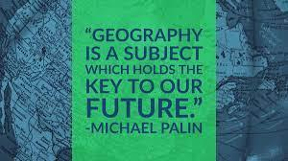 | By the end of their time at Red Hall, what will all of our children have?  A passion for Geography and a will to carry on discovering the wider world. By the end of Red Hall, we would  like children to see themselves as Geographers and have developed a love for the subject which continues into  secondary school. It is our aim that every child makes at least good progress within Geography and to be proud of  their efforts and all of the achievements they have made. We hope children are enthusiastic about  learning and remember all of the learning they have completed. We believe they will become more  independent, eager to share their learning and to become the thinkers and doers of the future.

How is geography taught at Red Hall?
EYFS | Year 1 – Year 6
In Red Hall Early Years, we want to ensure all children have chances to experience as much real life geography as possible with activities, experiments and hands-on opportunities that may not be offered at other schools.  During their time at Red Hall School we hope to offer your child some or all of the following experiences:  - Open ended activities which allow the children to develop their independence.  - Activities and discussions which follow the children’s own interests and experiences.  - Visits and trips which provide real life experiences.  - Invitations within the classroom to support the development of exploration, investigation and working geographically skills.  - Encouraging children to persevere and be resilient learners when faced with challenges.  - Outdoor as well as indoor learning with real life experiences. | At Red Hall we want to ensure all children have chances to experience as much real life geography as possible with a range of activities and field work.  During their time at Red Hall School we hope to offer your child some or all of the following experiences:  - High quality teaching from teachers and TAs  - Real life experiences, e.g. trips to the seaside, a woodland  - Whole school geography events  - Opportunities to have their work celebrated in assemblies or on social media  - Lots of field work and outdoor activities  - Access to high quality and varied geography equipment and resources

Lesson Sequence

Reflection | Main Input | Task | Reflection
A reflection of prior learning: last year, last term, last week and yesterday.  Green Pen  Concept Map  Opportunity to pre-teach future learning. | Introduce new learning  Introduce new vocabulary | Independent learning | Recap learning  Use big thinking questions or real life links

Whole School Themes
Autumn 1: Community  A Moment In Time | Autumn 2: Aspirational  Tell Me A story… | Spring 1: Respect  The Most Amazing Journey | Spring 2: Inclusive  Our Wonderful World | Summer 1: Nurturing  Magic, Mystery and Mayhem | Summer 2: Growing together  Dream BIG
Year 1 – Map work  Year 2 – Compare characteristics of capital cities to the past  Year 3 - Key topographical features – how they have changed |  |  |  | Year 1 – United Kingdom  Year 2 – Continents and Oceans

EYFS
Lullaby Lane | Nursery | Reception
Notices detailed features of objects in their environment.  Can talk about some of the things they have observed such as plants, animals, natural and found objects.  Explore our local environment e.g. shop, river, woodlands, pond. Use IT to show children places they may not have experienced e.g. farms, train stations. Share any tapestry trips children may attend with the class to broaden understanding for all.  Enjoys playing with small world reconstructions, building on first-hand experiences, e.g. visiting farms, garages, train tracks, walking by river or lake.  Uses a variety of questions (e.g. what, where, who) | Comments and asks questions about aspects of their familiar world such as the place where they live or the natural world. Explore our local environment to build on knowledge from LL.  Questions why things happen and gives explanations. Asks e.g. who, what, when, how.  Builds up vocabulary that reflects the breadth of their experiences.  Understand position through words alone.  Discuss routes and locations using words like ‘in front of’ and ‘behind’. | Describe their immediate environment using knowledge from observation, discussion, stories, non-fiction texts and maps.  Thinks about life in this country and life in another country.  Explain some similarities and differences between life in this country and life in other countries, drawing on knowledge from stories, nonfiction texts and – when appropriate – maps.  Know some similarities and differences between the natural world around them and contrasting environments, drawing on their experiences and what has been read in class.  Looks closely at similarities, differences, patterns and change in nature (leaves falling from trees).  Understand some important processes and changes in the natural world around them, including the seasons and changing states of matter. Describe what they see, hear, and feel whilst outside.  Has fun exploring maps and looking through nonfiction texts with curiosity.  Talks about the features of their own immediate environment and how environments might vary from one another.
Key Vocabulary
Hot, cold, wet, dry, snow, sun, wind, rain, farm, train, garage, beach, sea, river, wood, field, pond, hill, who, what, when, where, how, why | School, shop, road, park, garden, farm, train, garage, beach, sea, river, wood, field, pond, hill, forest, who, what, when, where, how, why, in front of, behind | Compare, similar, different, same, change, places- desert, wood, river, sea, beach, forest, jungle, polar/arctic, who, what, when, where, how, why
Cultural Capital
Library trip |  | Topic Hook – Shipwreck  Nature Reserve Walk  Chinese New Year

Progression of Skills
 | Year 1 | Year 2 | Years 3 | Year 4 | Year 5 | Year 6
Locational Knowledge | Name and locate the four countries and capital cities of the United Kingdom. | Name and locate the world’s seven continents and five oceans.  Name, locate and identify characteristics of the four countries and capital cities of the United Kingdom and its surrounding seas. | Name and locate counties and cities of the United Kingdom, geographical regions and their identifying human and physical characteristics, key topographical features (including hills, mountains, coasts and rivers), and land-use patterns; and understand how some of these aspects have changed over time. | Locate the countries, using maps to focus on Europe (including the location of Russia) concentrating on their environmental regions, key physical and human characteristics, countries and major cities. | Locate the countries in North America concentrating on their environmental regions, key physical and human characteristics, countries and major cities.  Identify the position and significance of latitude, longitude, Equator, Northern Hemisphere, the Tropics of Cancer and Capricorn, Arctic and Antarctic Circle, the Prime/Greenwich Meridian and time zones (including day and night). | Locate the countries in South America concentrating on their environmental regions, key physical and human characteristics, countries and major cities.
Place Knowledge | Understand geographical similarities and differences through studying the human and physical geography of a small area of the United Kingdom, and of a small area in a contrasting non-European country. |  |  | Understand geographical similarities and differences through studying the human and physical geography of a small area of the United Kingdom, and of a small area in a contrasting European country. | Understand geographical similarities and differences through studying the human and physical geography of a region of North America and a region in another country.
Human and Physical Geography | Use basic geographical vocabulary to refer to key physical and human features.  Identify seasonal and daily weather patterns (Science link) | Use basic geographical vocabulary to refer to key physical and human features.  Identify seasonal and daily weather patterns in the United Kingdom and the location of hot and cold areas of the world in relation to the Equator and the North and South Poles. | Describe and understand the key aspects of UK:  - Physical geography: climate zones, biomes, and vegetation belts, rivers and mountain  - Human geography: types of settlement and land use, economic activity including trade links and the distribution of natural resources including energy, food and minerals and water. | Describe and understand the key aspects of Europe:  - Physical geography: climate zones, biomes, and vegetation belts, rivers and mountains and the water cycle.  - Human geography: types of settlement and land use, economic activity including trade links and the distribution of natural resources including energy, food and minerals. | Describe and understand the key aspects of South America:  - Physical geography: climate zones, biomes, and vegetation belts, rivers and mountain, volcanoes and earthquakes.  - Human geography: types of settlement and land use, economic activity including trade links and the distribution of natural resources including energy, food and minerals and water. | Describe and understand the key aspects of North America:  - Physical geography: climate zones, biomes, and vegetation belts, rivers and mountain  - Human geography: types of settlement and land use, economic activity including trade links and the distribution of natural resources including energy, food and minerals and water.
Geographical skills and field work | Use world maps, atlases and globes to identify the United Kingdom and its countries.  Use simple compass directions (North, South, East and West) and locational and directional knowledge [for example, near and far; left and right], to describe the location of features and routes on a map.  Use aerial photographs and plan perspectives to recognise landmarks and basic human and physical features’ devise a simple map.  Use simple fieldwork and observational skills to study the geography of their school and its grounds and the key human and physical features of its surrounding environment. | Use world maps, atlases and globes to identify the United Kingdom and its countries, as well as the countries, continents and oceans studied at this key stage.  Use aerial photographs and plan perspectives to recognise landmarks and basic human and physical features’ devise a simple map; and use and construct basic symbols in a key. | Use maps, atlases, globes and digital/computer mapping to locate countries and describe features studied (in the United Kingdom).  Use the eight points of a compass, symbols and key (including the use of Ordnance Survey maps) to build their knowledge of the United Kingdom.  Use fieldwork to observe, measure, record and present the human and physical features in the local area using a range of methods, including sketch maps, plans and graphs, and digital technologies. | Use maps, atlases, globes and digital/computer mapping to locate countries and describe features studied (in Europe).  Use the eight points of a compass, four-figure grid references, symbols and key (including the use of Ordnance Survey maps) to build their knowledge of Europe. | Use maps, atlases, globes and digital/computer mapping to locate countries and describe features studied (in North America).  Use the eight points of a compass, six-figure grid references, symbols and key (including the use of Ordnance Survey maps) to build their knowledge of North America. | Use maps, atlases, globes and digital/computer mapping to locate countries and describe features studied (in South America).  Use the eight points of a compass, six-figure grid references, symbols and key (including the use of Ordnance Survey maps) to build their knowledge of South America.

National Curriculum Coverage
YEAR ONE
Autumn 1 | Autumn 2 | Spring 1 and Spring 2 | Summer 1 | Summer 2
To be able to use simple fieldwork and observational skills to study the geography of their school and its grounds.  To be able to use aerial photographs and plan perspectives to recognise landmarks  To be able to devise a simple map. | To be able to find key human and physical features of the school and its surrounding environment.  To be able to use simple compass directions (North, South, East and West) and locational and directional knowledge to describe the location of features and routes on a map. | To be able to identify seasonal and daily weather patterns in the location of hot and cold areas of the world in relation to the Equator and the North and South Poles. | I know the names and locations of the four countries of the United Kingdom.  To be able to use world maps, atlases and globes to identify the United Kingdom and its countries. | To be able to use simple compass directions and locational and directional knowledge, to describe the location of features and routes on a map of the United Kingdom.
 | Key Vocabulary
fieldwork, observation, school grounds, aerial photographs, plan perspectives, landmarks, simple map, | compass directions, North, South, East, West, near and far; left and right | seasons, weather, patterns, hot areas, cold areas, Equator, North Pole, South Pole | world maps, atlases, globes, United Kingdom, countries, England, Scotland, Wales, Northern Ireland | compass directions, North, South, East, West, near and far; left and right, countries, United Kingdom, England, Scotland, Wales, Northern Ireland, features, routes
Suggested Activities/Cultural Capital
Walk around the school grounds. Take clipboards for drawings, take iPads for pictures.  Aerial photographs of the classroom for recognition. Piece together the pictures to create a map of the classroom.  Walk around the local area. Take clipboards for drawings, take iPads for pictures. Use the pictures of the local area to devise a simple map. | Walk around the school grounds and local area with clipboards and iPads drawing or taking pictures of human and physical features.  Have clues hidden around the school grounds pointing to the next clue using compass directions and locational and directional language to find the object. | Act out the weather forecast.  Meerkat Mail – compare the weather in different countries.  Compare the weather to different countries that family live in/have visited.  Lost and found – Oliver Jeffers story – South Pole | Competition in the hall in groups to see who can get all the names of the countries in the right place the quickest.  Carousel of activities: world map, atlas and globe. Each group needs to find the UK on each different map. | Treasure hunt using a map.

YEAR TWO
Autumn 1 and Autumn 2 | Spring 1 and Spring 2 | Summer 1 and Summer 2
I know the names, locations and can identify characteristics of the four countries and capital cities of the United Kingdom and its surrounding seas.  To be able to use world maps, atlases, and globes to identify the United Kingdom and its countries.  To be able to use aerial photographs and plan perspectives to recognise landmarks and basic human and physical features’ devise a simple map; and use and construct basic symbols in a key.  To be able to use basic geographical vocabulary to refer to key physical and human features. | I know and understand geographical similarities and differences through studying the human and physical geography of a small area of the United Kingdom, and of a small area in a contrasting non-European country. | I know the names and locations of the world’s seven continents and five oceans.  To be able to use world maps, atlases and globes to identify the continents and oceans studied at this key stage.
Key Vocabulary
characteristics, United Kingdom, England, Wales, Scotland, Northern Ireland, North Sea, Irish Sea, Celtic Sea, The English Channel, world map, atlases, countries  aerial photographs, plan perspectives, landmarks, human features, physical features, simple map, symbols, key | similarities, differences, human, physical, United Kingdom, non-European, country, contrast | continents, Asia, Africa, North America, South America, Antarctica, Europe, Australasia, oceans, Atlantic Ocean, Indian Ocean, Pacific Ocean, Artic Ocean, Southern Ocean, world maps, atlases, globes
Suggested Activities/Cultural Capital
Dress as a UK country/bring in items as a UK country.  Hidden jigsaw pieces of the world map around the woodland. Find and out together and identify the UK.  Water tray with UK floating in, label the seas around it.  Create a map to us on school field for a partner to find hidden item(s).  Local area walk, take pictures of key features to compare and discuss. | Walk around the local area and point out features. Compare the similarities and differences of these to the chosen small area in a contrasting non-European country. | Songs of the oceans.  Corners game – match picture to continent.  Dress as a continent/bring in items as a continent.

YEAR THREE
Autumn 1 | Autumn 2 | Spring 1 and Spring 2 | Summer 1 | Summer 2
To be able to use fieldwork to observe, measure, record and present the human and physical features in the local area using a range of methods, including sketch maps, plans and graphs, and digital technologies.  I know the geographical regions and their identifying human and physical characteristics of the United Kingdom.  I know the key topographical features (including hills, mountains, coasts and rivers), and land-use patterns of the United Kingdom; and understand how some of these aspects have changed over time. | To be able to use maps, atlases, globes and digital/computer mapping to locate countries and describe features studied in the United Kingdom.  To be able to use the eight points of a compass, symbols and keys (including the use of Ordnance Survey maps) to build their knowledge of the United Kingdom. | I know the names and location of the counties and cities of the United Kingdom.  Children should know: County Durham, North Yorkshire, Tyne and Wear, Northumberland, Cumbria – these are the neighbouring counties.  Major cities: Birmingham, Liverpool, Newcastle, Bristol, Sheffield, Bradford, Nottingham, Plymouth, Durham, Coventry, London, Manchester, York, Leeds.  Counties to know with these cities: West Midlands, Merseyside, Bristol, South Yorkshire, West Yorkshire, Nottinghamshire, Devon, Greater London, Greater Manchester.  Look at the full map, however, the expectation isn’t to know every single one. | To be able to describe and understand the climate zones of the United Kingdom.  To be able to describe and understand the biomes of the United Kingdom.  To be able to describe and understand the rivers of the United Kingdom.  To be able to describe and understand the mountains of the United Kingdom. | To be able to describe and understand the types of settlement and land use of the United Kingdom.  To be able to describe and understand the economic activity including trade links and the distribution of natural resources including energy, food, minerals and water of the United Kingdom.
Key Vocabulary
fieldwork, observe, measure, record, present, human features, physical features, sketch maps, plans, graphs, digital technologies, geographical regions, topographical features, hills, mountains, coasts, rivers, land-use, United Kingdom | maps, atlases, globes, digital mapping, countries, features, United Kingdom, eight-point compass, symbols, keys, Ordnance Survey map | United Kingdom, counties, cities, County Durham, Tyne and Wear, Northumberland, Cumbria, West Midlands, Merseyside, Bristol, South Yorkshire, West Yorkshire, Nottinghamshire, Devon, Greater London, Greater Manchester, Birmingham, Liverpool, Newcastle, Bristol, Sheffield, Bradford, Nottingham, Plymouth, Durham, Coventry, London, Manchester, York, Leeds. | United Kingdom, climate zones, biomes, vegetation belts, rivers, mountains | Settlements, land use, United Kingdom, economic activity, trade links, distribution, energy, food, minerals, water
Suggested Activities/Cultural Capital
Local park.  Broken Scar.  Roseberry Topping. | Orienteering – Parent connection, JMc?  Geocaching – see Abbi.  Following compass directions. | Teesport Map lesson?  Tourist board advert. | Broken Scar – walk the river.  Hamsterley visit.  Shoe box biomes.  Tees barrage visit.

YEAR FOUR
Autumn 1 | Autumn 2 | Spring 1 and Spring 2 | Summer 1 | Summer 2
I know the location of the countries, using maps to focus on Europe (including the location of Russia).  I know the environmental regions of European countries including Russia.  I know the key physical and human characteristics of countries and major cities in Europe. | To be able to use maps, atlases, globes and digital/computer mapping to locate countries and describe features studied (in Europe).  To be able to use the eight points of a compass, four-figure grid references, symbols and key (including the use of Ordnance Survey maps) to build their knowledge of Europe. | I know and understand geographical similarities and differences through studying the human and physical geography of a small area of the United Kingdom, and of a small area in a contrasting European country. | To be able to describe and understand the climate zones in Europe.  To be able to describe and understand the biomes in Europe.  To be able to describe and understand the vegetation belts in Europe.  To be able to describe and understand the rivers and mountains in Europe.  To be able to describe and understand the water cycle. | To be able to describe and understand the types of settlements in Europe.  To be able to describe and understand the land use in Europe.  To be able to describe and understand the economic activity including trade links and the distribution of natural resources including energy, food and minerals in Europe.
Key Vocabulary
countries, map, Europe, Russia, environmental regions, physical characteristics, human characteristics, major cities | Maps, atlases, globes, computer mapping, locate, features, eight points of a compass, North, North East, East, South East, South, South West, West North West, four-figure grid reference, symbols, keys, Ordnance Survey map, Europe | Similarities, differences, human, physical, United Kingdom, European country | Europe, climate zones, biomes, vegetation belt, rivers, mountains, water cycle | Europe, settlements, land use, economic activity, trade links, natural resources, energy, food, minerals
Suggested Activities/Cultural Capital
Postcards.  Barney Bear.  Staff to speak about their experiences. | Orienteering – Parent connection, JMc?  Geocaching – see Abbi.  Following compass directions. | Teesport Map lesson?  Tourist board advert. | Bags for water cycle – See DH  Shoe box biomes  Visit a river.

YEAR FIVE
Autumn 1 | Autumn 2 | Spring 1 and Spring 2 | Summer 1 | Summer 2
I know the location of the countries in South America.  I know the environmental regions of South America.  I know the physical characteristics of South America.  I know the human characteristics of South America.  I know the major cities of South America.  To be able to use maps, atlases, globes and digital/computer mapping to locate countries and describe features studied in South America. | To be able to use the eight points of a compass, six-figure grid references, symbols and key (including the use of Ordnance Survey maps) to build knowledge of South America.  To be able to identify the position and significance of latitude and longitude.  To be able to identify the Equator, Northern Hemisphere, the Tropics of Cancer and Capricorn, Arctic and Antarctic Circle  To be able to identify the Prime/Greenwich Meridian and time zones (including day and night). | To be able to describe and understand the types of settlements in South America.  To be able to describe and understand the land use in South America.  To be able to describe and understand the economic activity including trade links and the distribution of natural resources including energy, food and minerals in South America. | To be able to describe and understand the climate zones in South America.  To be able to describe and understand the biomes in South America.  To be able to describe and understand the vegetation belts in South America.  To be able to describe and understand the rivers and mountains in South America. | I know and understand geographical similarities and differences through studying the human and physical geography of a region of South America and a region in another country.
Key Vocabulary
South America, countries, environmental regions, physical characteristics, human characteristics, major cities, maps, atlases, globes, computer mapping, locate, features | South America, eight points of a compass, North, North East, East, South East, South, South West, West North West, six-figure grid reference, symbols, keys, Ordnance Survey map, latitude, longitude, Equator, Northern Hemisphere, Tropics of Cancer, Tropics of Capricorn, Arctic Circle, Antarctic Circle, Prime/Greenwich Meridian, time zones, night, day | South America, settlements, land use, economic activity, trade links, natural resources, energy, food, minerals | South America, climate zones, biomes, vegetation belt, rivers, mountains | similarities, differences, human, physical, contrast, South America, region, country
Suggested Activities/Cultural Capital
Road Trip USA – Cornerstones – hook.  Food Tasting – hook.  Mexico. |  |  | Paper mâché designs.

YEAR SIX
Autumn 1 | Autumn 2 | Spring 1 and Spring 2 | Summer 1 | Summer 2
I know the location of the countries in North America.  I know the environmental regions of North America.  I know the physical characteristics of North America.  I know the human characteristics of North America.  I know the major cities of North America. | To be able to use maps, atlases, globes and digital/computer mapping to locate countries and describe features studied in North America  To be able to use the eight points of a compass, four-figure grid references, symbols and key (including the use of Ordnance Survey maps) to build their knowledge of North America. | To be able to describe and understand the climate zones in North America.  To be able to describe and understand the biomes in North America.  To be able to describe and understand the vegetation belts in North America.  To be able to describe and understand the rivers and mountains in North America. | Erosion  Explore Rivers in depth – mouth of river etc  Time Zones | To be able to describe and understand the types of settlements in North America.  To be able to describe and understand the land use in North America.  To be able to describe and understand the economic activity including trade links and the distribution of natural resources including energy, food and minerals in North America.
Key Vocabulary
North America, countries, environmental regions, physical characteristics, human characteristics, major cities, maps, atlases, globes, computer mapping, locate, features | North America, eight points of a compass, North, North East, East, South East, South, South West, West North West, six-figure grid reference, symbols, keys, Ordnance Survey map, latitude, longitude, Equator, Northern Hemisphere, Tropics of Cancer, Tropics of Capricorn, Arctic Circle, Antarctic Circle, Prime/Greenwich Meridian, time zones, night, day | North America, climate zones, biomes, vegetation belt, rivers, mountains |  | North America, settlements, land use, economic activity, trade links, natural resources, energy, food, minerals
Suggested Activities/Cultural Capital
Comparisons between NA and the UK.  Create a mood board of physical characteristics, walk around local area to compare/edit mood board.  Food tasting – hook.  Road Trip USA – cornerstones – hook. | Paper mâché globe – understand longitude, latitude, equator etc.  Create a world outside/physical.  Compass – use it to find items.  - How many steps/directions?  - Treasure hunt? | Time zones maps.  Globe – shine a light on it, what’s the time?  If the time is ____ In the UK, what is the time in _______? |  | Food miles.  Pollution.  Climate change.  Design a meal – food miles plate.  Impact on the environment.

