Objective:
Handwriting is a basic yet crucial skill that impacts the quality of work pupils produce throughout the curriculum. By the end of Year 6, pupils should have the ability to produce fluent, legible and, eventually, speedy joined-up handwriting, and to understand the different forms of handwriting used for different purposes. Our intention is to make handwriting an automatic process that does not interfere with creative thinking.
Aims:
- To develop a neat, legible, speedy handwriting style using continuous cursive letters, which leads to producing letters and words automatically in independent writing.
- To establish and maintain high expectations for the presentation of written work.
- To foster a positive attitude towards writing.
- For pupils to understand, by the end of Year 6, the importance of neat presentation and the need for different letterforms (cursive, printed or capital letters) to help communicate meaning clearly.

Expectations:
All teaching staff are encouraged to model the correct style of cursive writing (see letter and number formation below), whether on whiteboards, displays or in pupils’ books.
Letterjoin fonts must be used across all Notebook slides, presentations and worksheets.
Pupils should experience coherence and continuity in the learning and teaching of handwriting across all school years and be encouraged to take pride in the presentation of their work.

Pen licenses:
Pupils will begin handwriting lessons and complete all work using pencils. Once fine motor skills have been established and pupils can clearly present their work in a joined form, pupils may be awarded their pen license. This is awarded by Head of School or the English lead, for pupils in year 3 and above.

Key Stage Teaching

Early Years
For our youngest pupils we teach short handwriting lessons on a daily basis, which will include the following:
- enhancing gross motor skills such as air-writing, patternmaking and physical activities
- exercises to develop fine motor skills such as markmaking on paper, whiteboards, sensory trays, light boards, etc.
- becoming familiar with letter shapes, their sounds, formation and vocabulary
- correct sitting position and pencil grip for handwriting
Lesson Planner Module 1 for EYFS teaches patterns and lower case letters. It starts with Getting Ready for Handwriting including fine and gross motor skills warm-up exercises, correct sitting position and tripod pencil grip.
The first module is divided into three sections covering:
- patterns
- easy letters and words
- harder letters and words
At the end of this module, children should be able to recognise and form all the lowercase letters of the alphabet and write words using the correct formation.
In EYFS, handwriting outcomes will be:
- Children develop hand eye coordination, gross and fine-motor skills needed to support handwriting.
- Children use a range of tools to develop drawing lines and circles using gross motor skills. e.g. swirling ribbons, painting, peg work and mark-making.
- Children use a range of materials to develop fine motor skills. e.g. shaving foam, sponges, felt tips etc
- Children practice manipulative skills through play.

Key Stage 1: Years 1 and 2
Teaching progresses from five short, to four longer lessons per week:
- continuing with gross and fine motor skills exercises
- strengthening cursive handwriting, learning and practice
- numerals, capitals and printed letters; where and when to use, learning and practice
- KS1 SATs SPaG exercises

Year 1
Lesson Planner Module 2 for Year 1 contains lessons for teaching how to write capital letters, printed letters, numbers and symbols, whilst reinforcing cursive handwriting using Letter-join’s on-line and printed resources. It is divided into three sections covering:
- capital letters
- printed letters
- numbers and symbols
In Year One, handwriting outcomes will be:
- Children taught how to sit correctly at a table and pencil grip consolidated
- Children begin to form lower case letters in the correct direction by starting and finishing in the correct place
- Children form capital letters
- Children able to form digits of 0-9
- Children to make links between letters which join to make sounds
- Children continue to build on EYFS letter formation.
- Children may start to use some diagonal and horizontal strokes needed to join letters
Year 2
Lesson Planner Module 3 for Year 2 includes lessons to improve letter formation and orientation of letters through regular practice and to support spelling, grammar and punctuation in readiness for KS1 SATs. The sections in this module cover:
- letter families (see appendix)
- high frequency words
- joining techniques
- sequencing sentences
- dictation exercises
- times table facts
- SPaG practice for KS1 SATs
In Year Two, handwriting outcomes will be:
- Children form lower case letters of the correct size relative to one another
- Children start using some diagonal and horizontal strokes needed to join letters (a National Curriculum requirement)
- Children write capital letters and digits in the correct size, orientation and relationship to one another and to lower case letters
- Children use finger spacing between words

Lower Key Stage 2: Years 3 and 4
Handwriting lessons will continue twice a week in Lower Key Stage 2, with plenty of opportunites for further practise..
Lesson Planner Module 4 for Year 3 is targeted at children in lower KS2 where pupils should be using a cursive style throughout their independent writing in all subjects, helping to refine their handwriting in line with the requirements of each lesson. This module covers topics such as dictation, double letters, number vocabulary, palindromes, tongue twisters, MFL (French) onomatopoeia, simile and statutory spellings.
Completion of Module 4 should ensure improvement in the legibility, consistency and quality of the children’s handwriting through a variety of resources which link handwriting to other areas of the curriculum.

Lesson Planner Module 5 for Year 4 focuses on using handwriting practice to support other subjects in the curriculum and, at the same time, builds on fluency and consistency. This module aims to promote meaningful links with other subjects such as English, maths, science, geography, French and Spanish.
Making such links enables children to apply the skills they are learning in context and also provides depth to the curriculum. Learners will continue to build on producing fluent, consistent and legible handwriting through the regular practice offered in this module’s lessons.
On concluding this module, children will have practised applying size-appropriate handwriting to all areas of the curriculum whilst maintaining fluency and legibility
In Years Three and Four, handwriting outcomes will be:
- Children use diagonal and horizontal strokes to join letters in a continuous cursive style.
- Children’s handwriting will increase in legibility, consistency and quality
- Children produce writing that is spaced sufficiently and begin to develop their own style

Upper Key Stage 2: Years 5 and 6
More advanced handwriting techniques will be taught during two weekly lessons, as well as additional sessions for further opportunities to practise:
- reinforcing cursive handwriting across the curriculum
- form-filling/labelling using printed and capital letters
- dictation exercises promoting quick note-taking and speedy handwriting writing skills
- KS2 SATs SPaG practice

Lesson Planner Module 6 for Year 5 continues to build on combining fluent handwriting with other subjects across the curriculum. In this module, learners will have plenty of opportunity to develop the stamina and skills to write at length, with accurate spelling and punctuation. With Letter-join’s wide range of resources they will be able to work towards producing consistently neat and well-presented handwriting in all curriculum subjects.
On completing this module, children should be producing cursive writing automatically, enabling them to focus on the content of their work rather than the process of writing.

Lesson Planner Module 7 Year 6 presents learners with a range of tasks where they have to decide on an appropriate style of handwriting. Promoting speedy, fluent writing continues to be a strong feature. Challenging dictation exercises will refine pupils’ revising and checking skills as well as boosting their handwriting speed, stamina and fluency. A range of curriculum-based worksheets will give pupils the opportunity to practise writing at length.
Module 7 also contains a series of worksheets to aid KS2 SATs SPaG revision. They are designed to support year 6 pupils in meeting expected standards for spelling, punctuation and grammar, with lots of SPaG preparation and plenty of handwriting practice.
By the end of this module, children should be able to adapt their handwriting for a range of tasks and purposes and to create different effects. They should be clear about what standard of handwriting is appropriate for a particular task, for example, quick notes, a final handwritten version, an un-joined style or capital letters. All of these writing styles are covered in this module.

In Years Five and Six, handwriting outcomes will be:
- Children use diagonal and horizontal strokes to join letters in a continuous cursive style (a National Curriculum requirement)
- Children write legibly, fluently and with increasing speed and personal style
- Children choose which shape of a letter to use as part of their personal style
- Children choose the writing implement that is best suited for a task
- Children regularly create extended (long) pieces of writing

Correct posture and pencil grip
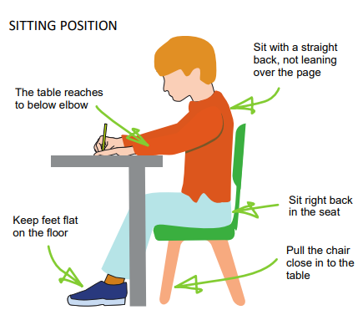 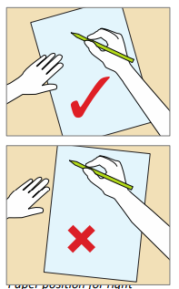Position for right handed children.

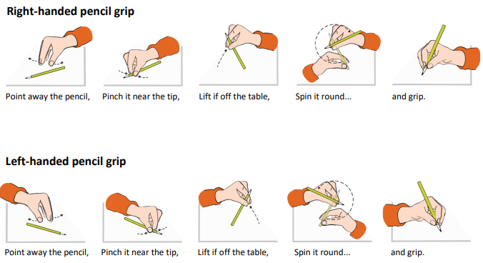

Letter and number formation
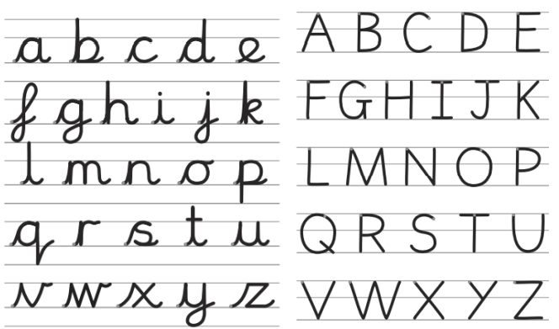
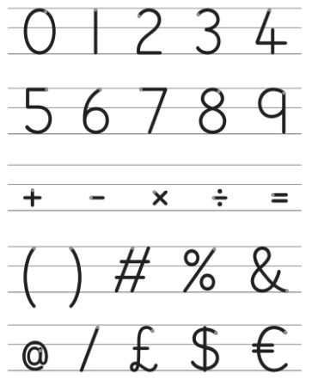

Letter families
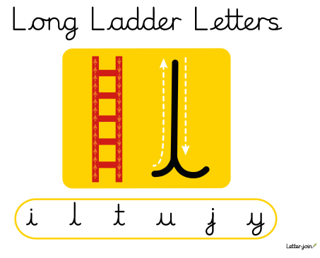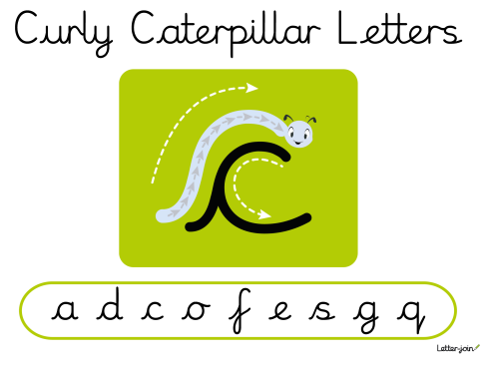
Pupils are taught long armed letters, then curly caterpillars, then one-armed robots before finally zig-zag letters.

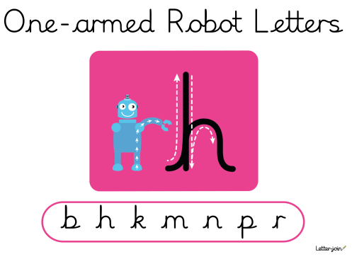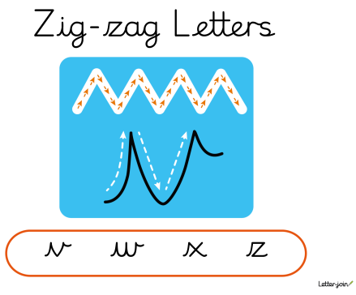
Left-handed pupils
LEFT-HANDED CHILDREN Left-handed children may find it difficult to follow the movements of right-handed teachers as they model letter formation (and vice versa). Teachers should demonstrate to left-handers on an individual or group basis.
- Left-handed pupils should sit to the left of a right-handed child so that they are not competing for space.
- Pupils should position the paper/book to their left side and slanted, as shown.
- Pencils should not be held too close to the point as this can interrupt pupils’ line of vision.
- Extra practice with left-to-right exercises may be necessary before pupils write left-to-right automatically
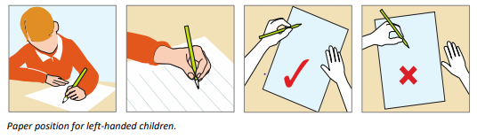

WAGOLL:

Handwriting assessment checklist
This list can be used to help support staff with identifying which areas in handwriting a pupil may need further support with.
Posture – is the correct posture used by the child?
Pencil grip –is the tripod grip used?
Paper position correct?
General letter formation | Legible?
 | Correct letter shape and size?
 | Even spaces between letters?
 | Sits neatly on writing line?
Lower case letter formation | Above the Line Letters b, d, f, h, k, l, t
 | Below the Line Letters g, j, p, q, y
 | Curly Letters a, c, e, m, n, o, s, u
 | Letters with Corners i, r, v, w, x, z
Upper case letter formation | Correct Capital Letter Size
 | Vertical Lines Formed Top to Bottom
 | Horizontal Lines Formed Left to Right

Handwriting at home
Parents can support their children’s handwriting at home by using the Pupil log-in for Letter-join.
Please ask your child’s class teacher for the log in details.
Children can watch the word and letter animations and practice and explore other handwriting resources on Letter-join including;
- Magic Patterns
- Magic Words
- Phonics Match
- Word Search
- Word Bank
- Write it Right!
There are lots interactive and engaging activities for all year groups to support letter formation, cursive handwriting and spelling, grammar and punctuation.

