RED HALL PRIMARY SCHOOL
GEOGRAPHY CURRICULUM OVERVIEW
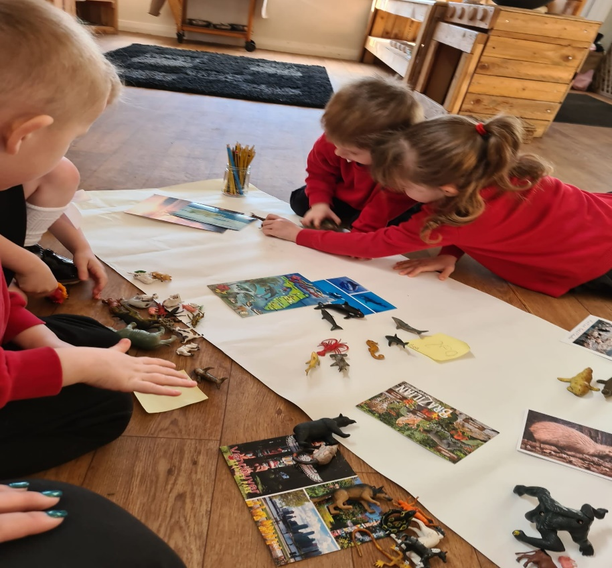 |  | 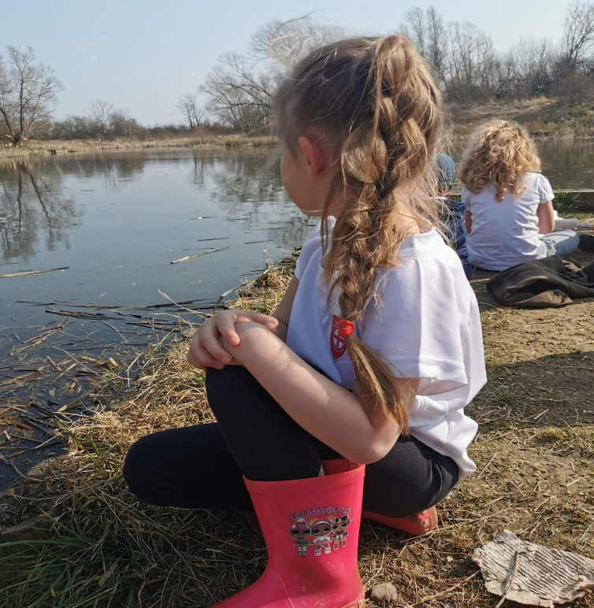 | 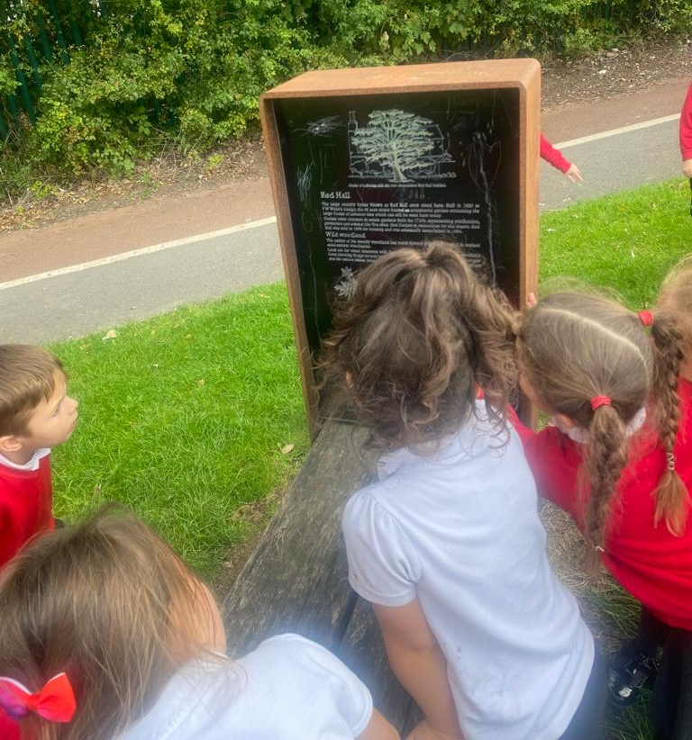 |  | 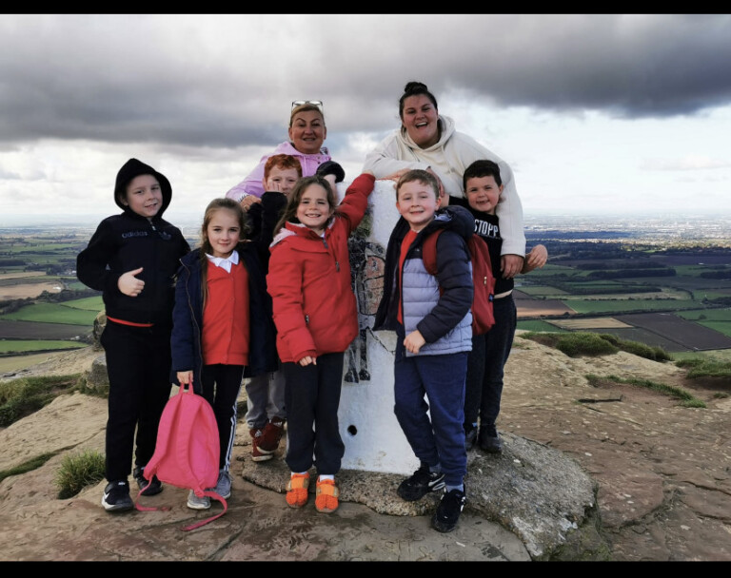
What is the intent of our Geography curriculum?  To inspire children to develop a curiosity and fascination about the world. We will provide exciting teaching and fieldwork to develop their knowledge and skills, which then remain with them for the rest of their lives. Staff will ensure children have a broad understanding of contextual knowledge (social, religious, economic, and political conditions) and that they are able to define physical and human characteristics and how they provide understanding of actions and processes in this amazing subject. We aim to provide exciting lessons indoors and out, which will help to develop their skills in collecting, analysing and communicating their understanding  about the data they are shown or have gathered. As teachers, we ensure there is lots of opportunity to apply prior knowledge and skills so children remember. Children will learn to use lots of different sources such as globes, diagrams and maps. We have planned a tailored curriculum for Geography, bespoke to the needs of our children and their backgrounds. We are aware that lots of our children see vandalism on our estate and some of their older siblings may not treat the environment with respect (by lighting fires, killing insects, ruining habitats etc) therefore we work together, with the children to ensure our curriculum not only informs them of the natural world, but also allows them to pass on these messages to other people within the community, resulting in a sense of pride where they live. This is part of our CARING school vision. Our curriculum ensures the expectations of National Curriculum are met and key terminology is learned. Our teaching will equip children with knowledge about diverse places, people, resources and natural and human environments. Teacher will provide children with amazing challenges and provocations to inspire and encourage independence. As children progress through the year groups, their growing knowledge about the world should help them to deepen their understanding of the interaction between physical and human processes, and of the formation and use of landscapes and environments. Geography lessons focus on developing geographical skills and children working as geographers. We intend for our children to have real life, memorable experiences and learn about geography in a fascinating way. |  |  |  | What experiences will the children receive?  Children will be provided with memorable moments and will be given many opportunities during their time at Red Hall, from exciting education trips, to wonderful fieldwork experiences in their local environment. We create whole school geography projects, amazing express events for both children and parents to attend and learn to interpret a range of sources of geographical information (including maps, globes and diagrams) which will help them to explore the world forever.  We are forever looking at new and exciting ways for our children to have real life experiences and learn about Geography in an active and creative way. We use our school budget to provide amazing experiences to see things in the world, which we know they may otherwise not be given the chance to see. Many of our children have never left Darlington and because of this we feel it is vital to create exciting fieldwork opportunities. Through our child led ‘hook books’ we will make links to History, Science and other subject areas to allow children to make these important connections. The planning of learning always begins with the skills and knowledge that need to be taught and enrichment opportunities are applied to our learning are carefully mapped to build on prior knowledge.
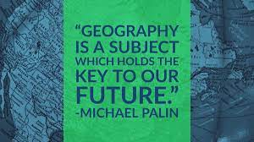 | By the end of their time at Red Hall, what will all of our children have?  A passion for Geography and a will to carry on discovering the wider world. By the end of Red Hall, we would  like children to see themselves as Geographers and have developed a love for the subject which continues into  secondary school. It is our aim that every child makes at least good progress within Geography and to be proud of  their efforts and all of the achievements they have made. We hope children are enthusiastic about  learning and remember all of the learning they have completed. We believe they will become more  independent, eager to share their learning and to become the thinkers and doers of the future.

Whole School Themes
Autumn 1: Community  A Moment In Time | Autumn 2: Aspirational  Tell Me A story… | Spring 1: Respect  Magic, Mystery and Mayhem | Spring 2: Inclusive  The Most Amazing Journey | Summer 1: Nurturing  Our Wonderful World | Summer 2: Growing together  Dream BIG

Progression of Skills
 | Year 1 | Year 2 | Years 3 | Year 4 | Year 5 | Year 6
Locational Knowledge | I can name the place and town where I live. | I can name the 4 capital cities  within the UK.  I can name the seas surrounding  the UK.  I can locate the North & South  Pole.  I can compare the human and  physical features of our local area. | I can name the five oceans.  I can name the world’s seven continents.  I can locate some of the world’s  countries using a map focussing on Europe (UK, Australia, Egypt, Italy, and Greece). | I can name and locate on a map  counties (County Durham, Tyne and Wear, Northumberland and N Yorkshire) and key cities within them. | I can locate North and South America and their environmental regions.  I can identify the  Tropics of Cancer & Capricorn.  I can name some major cities in leading world countries. | I can describe time zones.  I can name and locate some European countries, detailing their physical and human characteristics.  I can identify land-use patterns.  I can understand how some of these aspects have changed over time.
Place Knowledge | I can talk about the weather in my local areas.  I can talk about my local area and places of significance to me. (e.g school, home, shop, library etc) | I can locate hot and cold places  such as The North Pole &  Australia and Oceania.  I can talk about the location of hot and cold areas of the world in relation to the Equator and the North and South Poles.  I can describe some Geographical similarities &  differences of a small area of the  UK (Darlington/Country Durham) and a place within Arctic circle.  I can talk about places close  and far away. | I can describe some geographical  similarities and differences within a region of the UK (County Durham).  I can compare Country Durham and Egypt or  Italy/Greece (European). | I can explain some of the  geographical similarities and  differences of regions of the UK  (County Durham, Teesside, Newcastle) | I can explain geographical similarities and differences of the UK and a region  within North or South America.  I can explain why people choose to live in contrasting areas.  I can compare settlements within the UK. | I can explain patterns in physical and human changes.  I can describe how change can lead to similarities between places.
Human and Physical Geography | I can observe and describe the weather.  I can identify some human physical features in my local area e.g. park, nature reserve, railway station, river.  I can begin to use basic Geographical vocabulary to describe places. | I can use basic geographical  vocabulary.  I can name key physical features.  I can name key human features. | I can describe how a place has  changed over time (Red Hall/Darlington). | I can explain how environments  can change & how this can pose  dangers. (Darlington & Ice Caps)  I can explain how volcanoes are  formed & where they are found.  I can describe and compare different types of settlement and land use. (Red Hall & Darlington) | I can identify climate zones and  biomes.  I know where some of the key rivers are (Amazon, Nile, Tees, and Skerne.) I can describe the River Skerne.  I can talk about the stages of the  Water Cycle. | I can present the distribution of natural resources including energy, food,  minerals and water.  I can discuss how economic activity including trade links across the world is  affected by the distribution of natural resources (Russia).
Geographical skills and field work | I can use a simple map of my school.  I can record weather in simple ways. | I can use simple compass  directions (N, S, E, W).  I can use locational and directional language (near and far; left and right) to describe the location of features and routes on a map.  I can create a simple map with a  key. I can use large maps to mark key locations, e.g. continents, UK, County Durham, Darlington. | I can use the eight points of a compass.  I can read a simple map & key.  I can identify some standard OS map symbols.  I can record information in a given format, e.g. sketch, bar chart. | I can use four figure grid references.  I can identify symbols and keys when using maps (including the use of Ordnance Survey maps).  I can suggest ways to record my observations. | I can discriminate between sources of information.  I can collect and present information about people and places. (Line graphs)  I can suggest questions for my fieldwork.  I can offer explanations for some features in fieldwork. | I can use digital technologies to  describe and create a map.  I can use 6 figure grid references.  I can give accurate conclusions using information.  I can analyse data about populations  and places.

National Curriculum Coverage
YEAR ONE
Previous Knowledge | Autumn |  | Spring |  | Summer
•Children have been developing their understanding and knowledge of the world in early years.  •They learn about the world and the people and communities within it. | Children will be developing their fieldwork and observational skills this term. They will begin by exploring the school and grounds, before beginning to learn about Red Hall and the local area where they live. They will begin to learn about compass directions (N, E, S and W) and will learn new vocabulary such as near, far, left and right to describe places within the school grounds. They will also be learning about the weather patterns in the UK and the different seasons. |  | Children will know and understand the school, it’s grounds and the immediate surrounding area. They will begin doing more fieldwork in their local area e.g. looking more closely at Red Hall and Darlington and reflecting on places they have been such as Saltburn beach and Roseberry Topping. Children will learn new geographical vocabulary including beach, coast, forest, mountain, ocean, valley. These are ‘physical features’. They will also learn vocabulary of ‘human features’ such as: railway, farm, town, city and shop. The children will also look at the UK and the four countries, being able to identify which country they live in. |  | This term children will learn more about identifying some of the geographical features of Red Hall and Darlington. The children will reflect on the weather changes they have recorded over the seasons of the year. Children will deepen their understanding of all of the key geographical vocabulary from least term so that this knowledge is remembered and consolidated.
Locational Knowledge | • I can name areas of my school and grounds.  • I can name the place and town where I live in. |  | • I can name the place, town and county where I live in.  • I can name the country I live in. |  | • I can name the place, town and country I live in.
Place Knowledge | • I can talk about the weather in my local area & in my country. |  | • I can talk about the weather in my local area & in my country.  • I can talk about my local area and places of significance to me. E.g. school, home, shop, library etc. |  | • I can talk about the weather in my local area & in my country.  • I can talk about my local area and places of significance to me. E.g. school, home, shop, library etc.
Human and Physical Geography  (Name, explain & compare) | • I can observe and describe weather associated with the seasons |  | • I can observe and describe weather associated with the seasons  • I can identify some human and physical features in my local area. E.g park, nature reserve, railway station and town hall. |  | • I can observe and describe weather associated with the seasons  • I can begin to use basic Geographical vocabulary to describe places.
Skills and fieldwork (Observe, collect and present) | • I can record the weather in simple ways.  • I can talk about the weather I have seen and recorded. |  | • I can use a simple map  • I can use large maps to mark key locations, e.g. UK, County Durham & Darlington. |  | • I can use a simple map  • I can use large maps to mark key locations, e.g. UK, County Durham & Darlington.
Suggested activities linked to themes | • Local observation walk or hunt.• Record the weather in simple ways • Weather reports- Ipads. • Posting a letter home. • Sort and classify |  | • Local observation walk or hunt. • ‘Pin the school on the map’. • Photo gallery with talking tins. |  | • Close or far away game • Sort & classify locations, weather • Pack a bag, choose an outfit for each season & compare items. • Look at photos & maps to answer questions.
Key Vocab - Sticky words | map  school  path  road  grass  trees  here  there  my  our  direction  compass  near  far  left  right  school | weather  autumn  winter  spring  summer  cool  wet  warm  climate  local  pattern  changes  same  different | nature reserve  pond  river  trees  pond  woodlands  beach  coast  mountain  railway  farm  shop  library  town  city | weather  autumn  winter  spring  summer  cool  wet  warm  climate  local  pattern  changes  same  different | nature reserve  pond  river  woodlands  beach  coast  mountain  ocean  valley railway  farm  shop  library  house  town  city  country  locate  buildings  fields  woodlands | close  far  same  different  here  where  there  my  our
 | Links to learning and assessment points
Outcomes – Geographical knowledge | To know I live in Red Hall, Darlington, England.  To use basic vocabulary such as school, trees, roads, town to describe where I live.  To collect information (photos) and talk about what I can see.  To recognise different types of weather.  To name all four seasons.  To be able to compare the seasons using basic vocabulary. |  | To name where I live & locate Darlington on a simple map of the UK.  To name & locate the country I live in on a simple world map. |  | To know the geographical features of the local area.  To be able to use a simple map.  To reflect on the weather changes I observed throughout the year in relation to the seasons.

YEAR TWO
Previous Knowledge | Autumn |  | Spring |  | Summer
• Simple map skills  • Going from learning about our local environment to the UK.  • Referring back to our key geography vocabulary | Children will be expected to name, locate and identify characteristics of the 4 countries and capital cities of the UK and its surrounding seas. The children will use a map to identify the UK and its countries, and the surrounding seas. They will also use photographs to recognise different landmarks. They will use prior knowledge to create a simple map and use and create symbols in a key. Children will be referring back to all of the key vocabulary learned in Year 1. Can they remember this and confidently use these terms? |  | Children will use their knowledge to identify countries, continents and oceans in world maps, atlases and globes. Children will know the location of hot and cold areas in the world, learning about the equator and the north and south poles. |  | This half term the children will focus on developing their knowledge of human and physical features in the local area and creating maps with a key. They will complete fieldwork to build on their knowledge from Year 1 and use more geographical skills and vocabulary to document their findings.
Locational Knowledge | I can name the village, city and country I live in.  I can name & locate the 4 countries within the UK and identify the borders.  I can name the 4 capital cities within the UK.  I can name the seas surrounding the UK. |  | I can locate the North & South Pole.  I can name the 5 oceans and 7 continents of the world. |  | I can compare the human and physical features of our local area.
Place Knowledge | I can talk about places close and far away.  I can use basic geographical vocabulary. |  | I can locate hot and cold places such as the North Pole & Australia. I can talk about the location of hot and cold areas of the world in relation to the Equator and the North and South Poles. I can describe some similarities & differences of a small area of the UK (Darlington) & a place within Arctic Circle. |  | I can talk about places close and far away.  I can talk about some geographical similarities and differences between Red Hall (Darlington), County Durham and a wider world country.
Human and Physical Geography  (Name, explain & compare) | I can use some geographical vocabulary.  I can name some physical and human features. |  | I can use some geographical vocabulary.  I can name some physical and human features. |  | I can use some geographical vocabulary.  I can name key physical features such as rivers, fields.  I can name key human features such as bridges, Amazon?
Skills and fieldwork (Observe, collect and present) | I can use locational and directional language (near and far; left and right]) to describe the location of features and routes on a map.  (N, S, E, W), e.g. Scotland is North.  I can use large maps to mark key locations, e.g. continents, UK, Country Durham, Darlington. |  | I can use simple compass directions  I can use large maps to mark key locations, e.g. UK, hot and cold countries. |  | I can use locational and directional language (near and far; left and right]) to describe the location of features and routes on a map.  I can use simple compass directions (N, S, E, W), e.g. Scotland is North.  I can use locational and directional language (near and far; left and right]) to describe features of Red Hall.  I can create a simple map with a key of Red Hall/Darlington incl Amazon.
Suggested activities linked to themes | • ‘Jigsaw’ of the UK. Put the countries back together again. • Plan a family/school trip to visit geographical locations around the UK. |  | • Compare the Arctic & Antarctic.  • How Cold? Ice cube experiments.  • Ask & answer questions about temperatures in hot and cold places.  • Distinguish between what Earth was like then and now |  | • I spy with images - Same? Different? • Map symbol pairs (match the symbol to its feature). • Create a simple map (physical features). • Meet and talk to village residents • Look at the past & present location of industrial buildings on/near Red Hall. • Create geography ‘Must Haves’ for Amazon distribution centre, e.g. rivers or roads for transport. Villages for workers. • Look at images of Red Hall and Darlington. What’s the same? What’s different? • Create a simple map & key of the Amazon centre
Key Vocab - Sticky words | UK: England  Ireland  Scotland  Wales  North Sea  English Channel  Irish Sea  Atlantic Ocean  North, South, East  & West  Country  Ocean  Sea  Key  fieldwork | name  compare  local  changes  industry  water  mud  trees  past  think  thought  another | North Pole  South Pole  Equator  map/globe  Earth  glaciers  freeze  land  changes  compare  North & South  locate | habitats  sort  classify  changes  find  cold  past  water | Amazon  Red Hall  Darlington  Distribution centre  factory  rivers  fields  roads  locate  transport | same  different  village  transport  left, right  North, South, East  & West
 | Links to learning and assessment points
Outcomes – Geographical knowledge | To name the 4 countries & capital cities within the UK and locate on a simple map.  To name the seas surrounding the UK.  To recognise and locate N,S,E,W on a compass & simple map. |  | To locate the North & South Poles on a map or globe.  To explain why the North & South Poles are cold.  To know of the Equator & countries near it are hot.  To use geographical vocabulary when describing Arctic Circle. To name the 5 oceans and 7 continents of the world. |  | To use physical and human geography terms such as factories, rivers, roads, transport when describing.  To create a map with relevant key symbols such as footpath, road & building.  To know that the Earth (land) has changed over time.  To know that in the past there were more physical features than human.  To identify and name some key symbols, e.g. trees, water, mud & river.

YEAR THREE
Previous Knowledge | Autumn |  | Spring |  | Summer
• Knowing about the UK and now beginning to develop knowledge of the wider world  • Children using their knowledge of N, E, S and W to develop understanding when using 8 points of a compass  • Recapping on key vocabulary | Children will be learning to name and locate geographical regions and their human and physical characteristics e.g. hills and mountains. Children will use 8 points of a compass, symbols and keys to build of their knowledge of the UK and map skills. Children will use a range of methods to observe, measure and record geographical features in their local environment e.g. sketching, maps, plans and graphs. They will also begin to look at erosion. |  | Children will use prior knowledge of geographical regions and human and physical features to locate countries on a map focussing on Europe and the Equator. Children will begin to understand how things have changed over time. They will compare UK to Egypt, key features of these countries and develop their comparison skills. They will begin to look at the Rover Skerne and compare to the Nile in Egypt. |  | It is vital that children revisit prior learning all of the time so that they REMEMBER more. Children will use atlases, maps, globes and computer mapping to locate and describe the areas they have been learning about and the wider world. Children will develop their knowledge of the UK and the wider world focussing on compass skills, maps with keys, OS Mapping and recording information.
Locational Knowledge | I can compare the human and physical features of our local area. |  | I can locate some of the world’s countries using a map focussing on Europe (UK, Italy, and Greece).  I can locate the Equator. |  | I can locate some of the world’s countries using a map focussing on Europe (UK & Egypt).  I can locate the Equator.
Place Knowledge | I can describe some geographical similarities and differences within a region of the UK (County Durham). |  | I can locate I can compare geographical features of Darlington and Egypt, e.g. location, climate, terrain, and rivers.
Human and Physical Geography  (Name, explain & compare) | I can describe how a place has changed over time (Darlington). I can use physical and human features in my descriptions. |  | I can describe the River Skerne/Tees. I can explain that rivers have a source and a mouth.
Skills and fieldwork (Observe, collect and present) | I can use the eight points of a compass.  I can read a simple map & key. |  | I can record information in a given format, e.g. diagram of a river. I can begin to talk about the eight points of a compass, e.g. From the UK, Egypt is South East |  | I can talk about the eight points of a compass, e.g. Italy is mostly North West from Greece.  I can identify some standard OS map symbols. I can record information in a given format, e.g. sketch of the Red Hall or map with OS symbols.
Suggested activities linked to themes | • Map work (locating). Pin ‘where we’ve been in lessons, e.g. UK, Egypt, Italy & Greece’. • Build on from KS1, can they also locate & name the continents & oceans/seas, e.g. Italy is in Europe. Its capital is Rome and it is in the Mediterranean Sea. • Label & use 8 points of a compass to describe direction from one another.  • Understand the location of Red Hall compared to Darlington, England etc. |  | Look at photos of the River Skerne/Tees & Nile.  • Same? Different?  • Create a foil tray or soil replica (Forest Schools) of the Skerne/Tees.  • Rice Krispie rivers.  • Compare areas around Darlington & a small area of Egypt, e.g. Geography Globes. • Fieldwork walk to the river. Create sketches, take photos. |  | • Look at now and then images • OS Symbol BINGO! • Explore OS maps of Red Hall/Darlington. Can they identify some symbols? • Map how the village has changed. Side by side comparison. • Answer questions about the changes.  • Understand the location of Red Hall compared to Darlington, England etc.
Key Vocab - Sticky words | Red Hall  Darlington  village  physical & human  compare  change  develop  map  location  fieldwork  Ordinate Survey  symbol  key  same/different  North East  South East  North West  South West | reliability  period  relevant  information  variety  historical  build  business  busy  centre  complete  decide  earlier  famous  natural  position  purpose  through  various  solid  rock  sediment  metamorphic  centre  earth  organic matter | country &area  UK  Egypt & Cairo  Ouse  Nile  river  source & mouth  tributary  floodplain  bend/ meander  terrain  environment  biome  North East  South East  North West  South West  fieldwork Italy  Rome  Greece  Athens  Equator  Mediterranean Sea  Continents  Europe | compare  appearance  properties  diagram  label  describe  extreme  famous  important  island  natural  notice  position  through | Red Hall  Darlington  village  physical & human  compare  change  develop  map  location  fieldwork  Ordinate Survey  symbol  key  same/different  North East  South East  North West  South West | identify  sketch  diagram  describe  earth  important  island  country  capital city  continent  oceans  length  natural  position  purpose  through
 | Links to learning and assessment points
Outcomes – Geographical knowledge | To know and describe how Red Hall has changed.  To compare physical and human geography terms such as overtime the village has more human features such as houses, shops & transport links when describing.  To read & create simple maps with standard OS symbols such as footpath, school, nature reserve, road & building. |  | To locate Egypt & the Equator on a world map.  To name the continent in which Egypt is on & its capital city.  To know rivers are physical features and start from a source.  To know & identify the basic features of a river: source, mouth, bend/meander, tributary & floodplain.  To name their local rivers: Skerne and Tees. |  | To locate different countries on a world map.  To name the different continents, identify countries and their capital cities.  To know the 8 points of a compass & use them when describing locations/positions.

YEAR FOUR
Previous Knowledge | Autumn |  | Spring |  | Summer
• The use of an 8 points of a compass.  • Using what they have learned about the wider world to locate countries in Europe and to compare these to NE England. | Children will explore countries of the world and locate countries with volcanoes. Children will use prior knowledge of geographical regions and human and physical features to understand how things have changed over time Also how land use has changed over time. Do children know what topographical features are? (hills and mountains) Do children understand the term physical geography? (mountains, hills, rivers and coast) |  | Children will learn about settlements in the UK - Linked to Vikings and explore how environments can change over time. Compare types of settlements. Begin to use 4 figure gid references, symbols and keys when exploring with maps. Children will also be expected to use Ordnance Survey maps to build on their knowledge of the United Kingdom and the wider world |  | Continue to explore different types of settlements related to the local area. Children will look closely at the regions in the UK, Children will embed all of the learning they have done on the use of an 8 points of a compass, 4 figure grid reference, symbols and keys.. To observe, measure, record and present the human and physical features in our local area. Children will also be expected to use Ordnance Survey maps to build on their knowledge of the United Kingdom.
Locational Knowledge | I can locate some of the world’s countries using a map focussing on Europe (UK, Italy, and Greece). I can locate the Equator. |  | I can name some major cities in other world countries, e.g. Sweden: Stockholm, Norway: Oslo & Denmark: Copenhagen. |  | I can name and locate on a map counties (County Durham, Tyne and Wear, Northumberland and North Yorkshire) and key cities within them. I can explain that Darlington is within County Durham.
Place Knowledge |  |  |  |  | I can explain some of the geographical similarities and differences of regions of the UK (County Durham, Tyne and Wear, Northumberland and North Yorkshire)
Human and Physical Geography  (Name, explain & compare) | I can explain how environments can change and how this can pose dangers.  I can explain how volcanoes are formed & where they are found.  I can explain that volcanoes are a feature of physical geography. |  | I can describe and compare different types of settlement, e.g. Viking homeland & where settled in UK. I can identify types of settlement and land use, e.g. areas of trade. |  | I can explain that land use changes over time. The swapping the land’s use for a different purpose by humans.  I can compare how land use has changed in Red Hall, e.g. more housing, school, factories, farming, and nature reserves.
Skills and fieldwork (Observe, collect and present) | I can present a labelled, cross-section diagram of a volcano. I can talk about the eight points of a compass, e.g. Italy is mostly North West from Greece. |  | I can discriminate between sources of information. |  | I can identify symbols and keys when using maps (including the use of Ordnance Survey maps) of local counties. I can begin to use four figure grid references.
Suggested activities linked to themes | • Map work (locating). Pin ‘where we’ve been in lessons, e.g. UK, Egypt, Italy & Greece’. • Build on from KS1, can they also locate & name the continents & oceans/seas, e.g. Italy is in Europe. Its capital is Rome and it is in the Mediterranean Sea. • Label & use 8 points of a compass to describe direction from one another. • Science links: build a volcano. • Cross-Section diagram of volcano |  | An in depth study of the Vikings and their invasion, rating sources and drawing conclusions. History link. • Mapping Viking trade routes across Europe & beyond. Locating starting points & key destinations. • Would you rather…? Game. Scenarios of where Vikings could settle. Ranking importance of physical/human features. • Reliability of primary & secondary sources. |  | • Add grid references to a given map of the local area, e.g. Red Hall, Darlington. • Battleship grid references, e.g. put a cross in 03, 04. • Locate OS symbols on a grid reference, e.g. where is the shop, where is the church? • Articulate game with previous and new OS symbols. • Label counties on a UK map. • Introduce a couple of new counties by giving clues, e.g. I’m further South & London is my main city = Greater London.
Key Vocab - Sticky words | Italy  Rome  Greece  Athens  Equator  Mediterranean Sea  Continents  Europe  rocks  volcano  vent  ash  magma chamber  conduit  lava  physical features | compare  appearance  properties  organic matter  Vesuvius  diagram  label  solid  rock  sediment  metamorphic  describe  centre  earth  extreme  famous  important  island  natural  notice  position  through | source  site  settlers  settlements  communities  excavate/dig  physical & human  map  ruins  rivers  aerial  land-use  locality  advantages  disadvantages  discriminate | replica  cardboard  past  historical  artefacts  remains  accommodate  ancient  community  develop  equipment  existence  explanation  environment  foreign  occupy  persuade  recognise | county  counties  County Durham  Tyne and Wear  Northumberland  North Yorkshire  Darlington  Newcastle  nearby  locate  symbol  Ordinate Survey  grid reference  N,S,E & W  Greater London. | Land  area  region  compass points  answer  consider  group  knowledge  position  remember
 | Links to learning and assessment points
Outcomes – Geographical knowledge | To locate Italy & Greece on a world map. To name the continent in which Italy & Greece are on & their capital cities. To know volcanoes are physical features. To know & identify the basic features of a volcano: vent, ash cloud, magma chamber, lava & conduit. To know the 8 points of a compass & use them when describing locations/positions. |  | To name the different types of settlement: hamlet, village, town & city. To know typical land-use of a Viking settlement, e.g. houses, work, fertile land to farm, defensive location… To describe a range of physical & human features of a Viking settlement. To explain reasons behind Darlington settlements using appropriate geographical vocabulary, e.g. links, rivers, small population, area, land… |  | To use four figure grid references in their own map work. To know we use the bottom left hand corner of a square when reading four figure grid references. To explain that land use change is the swapping the land’s use for a different purpose by humans. To name a range of physical features of Red Hall/Darlington past & present. To recognise an increasing number of OS symbols

YEAR FIVE
Previous Knowledge | Autumn |  | Spring |  | Summer
• Using the mapping skills learned around the United Kingdom to now study the wider world. • Observing human and physical features of geography. | Children will use their skills for further map work and study contrasting areas, building an understanding of how environments can change and why people choose to live there. They will study the wider globe, identifying countries and capitals. They will study the Arctic and Antarctic circles/hemispheres. |  | Children will explore Tropics, Biomes, South America and Brazil using maps. Identifying key cities. They will create a comparison study between the UK and South America. They will further develop their understanding of contrasting environments and why people choose to live there. Children will look closely at climate zones. |  | Children will learn about regions within the UK and counties in the North East. They will use their skills to identify and compare human and physical geographical features. Study an area over time to reflect on how the environments can change. The children will look closely at the water cycle and identify significant rivers of the local area and wider world, building on previous learning.
Locational Knowledge | I can locate the Arctic & Antarctic Circles & their hemispheres.  I can name some major cities in leading world countries. |  | I can locate North and South America and their environmental regions.  I can identify the Tropics of Cancer and Capricorn. |  | Children will learn about the water cycle and look more into rivers and hills.
Place Knowledge | I can explain why people choose to live in contrasting areas. |  | I can explain geographical similarities and difference of the UK and a region with North or South America.
Human and Physical Geography  (Name, explain & compare) | I can explain how environments can change & how this can pose dangers. (Darlington and flooding & Ice Caps) |  | I can identify climate zones and biomes. |  | I can know where some of the key rivers are (Amazon, Nile, Tees and Skerne) I can describe the river Skerne.  I can name and explain the 4 stages of the Water Cycle.  I can talk about evaporation and condensation in more detail.
Skills and fieldwork (Observe, collect and present) | I can suggest ways to record my observations, e.g. labelled diagram, voiceover. |  | I can collect and present information about people and places. (Line Graphs) |  | I can discriminate between sources of information.  I can suggest questions for my fieldwork. I can offer explanations for some features in fieldwork
Suggested activities linked to themes | • Map work to include hemispheres, 8 point compass and Arctic & Antarctic Circles. • Which continents are in each hemisphere? |  | • Map of the World: colour coded climate zones. • Biome jars, e.g. Tundra |  | • Sandwich bag water cycle or shaving foam clouds. • Voiceover/documentary on Water Cycle, e.g. David Attenborough style. • Look at local flooding, e.g. Skerne and Tees • Fieldwork walk to the Skerne or Tees Create sketches, take photos of potential flooding risk. • Debate what can be done to prevent flooding.
Key Vocab - Sticky words | locate  globe/map  hemisphere  Arctic Circle  Antarctic Circle  climate zone  biome: tundra,  polar  temperate  tropical  ice-caps | local issues  observation  consider  discuss  answer  believe  build  circle  difficult  disappear  extreme  imagine  increase  learn  natural  notice  position  possible  separate | longitude  latitude  Tropic  Cancer  Capricorn  Brazil: Brasilia  S.America  hemisphere  Amazon  source  effect  Darlington  land-use  people  housing | apply  justify  present  accommodate  community  develop  explanation  environment  foreign  guarantee  opportunity  persuade  recognise  temperature | flooding  water cycle  evaporation  condensation  precipitation  collection  fieldwork | local issues  observation  consider  discuss  answer  believe  build  circle  difficult  disappear  extreme  imagine  increase  learn  natural  notice  position  possible  separate
 | Links to learning and assessment points
Outcomes – Geographical knowledge | To locate the Arctic & Antarctic Circles & their hemispheres. To name some countries in each hemisphere, e.g. UK = northern, Australia Southern etc. To know the three major climate zones: polar, temperate and tropical. To explain some examples of changing environments and how they pose danger such as flooding, melting ice-caps. |  | To locate South America & Brazil on a map. To identify the Tropics & their direction. To explain reasons behind people’s choices to live in specific areas using appropriate geographical vocabulary, e.g. transport links, greenbelt, population, effect… |  | To know all 4 stages of the Water Cycle. To name key rivers such as Amazon, Nile, Thames & Skerne/Tees (local) and know their location.

YEAR SIX

Previous Knowledge | Autumn |  | Spring |  | Summer
• Using the mapping skills learned around the United Kingdom and the wider world to now develop an understanding of its coasts  • Spring is a recap of learning in year 5 to consolidate learning.  • Last year children learned about North and central America and this year will learn about South America | Children will use of an 8 points of a compass, 4 figure grid reference, symbols and keys. Children will also be expected to use Ordnance Survey maps to build on their knowledge of the United Kingdom and coasts. Recap on geographical skills taught to check all children have learned and remembered them. Describe and understand land use changes during Victorian period and Industrial revolution, explain changes human and physical geography. |  | Children will use their knowledge of the globe to Identify world wide countries linked to war and the impact on human and physical features.  Children will use digital maps to identify and study data in patterns |  | Children will demonstrate their knowledge of the world and associated time zones.  Summer project - to study trade links. Locate countries on a map focusing on Russia. Recap on the types of settlement and land use, economic activity including trade links and the distribution of natural resources such as food, energy, minerals and water which was learned in year 5.
Locational Knowledge | I can identify land-use patterns, e.g. mills, coal mines. |  | I can name and locate some European countries, detailing their physical and human characteristics such as Germany & France. |  | I can describe time zones  I can identify land-use patterns, e.g. housing, greenbelts, woodland, farming.  I can understand how some of these aspects have changed over time.
Place Knowledge | I can explain patterns in physical and human changes. |  | I can explain patterns in physical and human changes. |  | I can explain patterns in physical and human changes. I can describe how change can lead to similarities between places.
Human and Physical Geography  (Name, explain & compare) |  |  |  |  | I can discuss how economic activity including trade links across the world is affected by the distribution of natural resources, e.g. rationing, food shortages
Skills and fieldwork (Observe, collect and present) | I can use digital technologies to describe and create a map. I can give accurate conclusions using information. I can analyse data about populations and places. |  | I can use 6 figure grid references.  I can use digital technologies to describe and create a map |  | I can give accurate conclusions using information. I can analyse data about populations and places.
Suggested activities linked to themes | •Study of Darlington and Stockton Railway • Digital map of Titanic route including place names, ocean & time zones. Explore the increased physical features the Industrial Revolution brought, e.g. railways. • How did the land change? From agricultural to large scale industry. • Map the rise of Coal Mines to meet the demand of distribution. • The effect of coal mines & factories on towns etc. • Layers of tracing paper, e.g. mapping effect of coal mines on populations, industry etc • Children to add or locate OS symbols and give locations via 6-figure grid references. • Then & now, e.g. OS symbols. |  | • Use grid references to link to battlegrounds, e.g. deaths in each square, section of the square. • Crack a wartime code using grid references. Where can the enemy be found? • Take a map of wartime Red Hall/Darlington. • Analyse population of Red Hall/Darlington over the war & give conclusions, e.g. lives lost. • Provide conclusions to the comparison, e.g. fewer houses, increase in transport links… |  | • Use grid references to compare Red Hall then & now, e.g. OS symbols. • Provide conclusions to the comparison & outcomes, e.g. fewer houses, smaller populations, increase in transport links… • Create digital map comparisons of the village, e. g. Wartime & now. • What changed in Red Hall/Darlington which still stands?
Key Vocab - Sticky words | natural resources  water/energy  transport  distribution  railways  population  industrialisation  land use  conclusion  analyse  digital/map  mapping  time zones  import/export | achieve  available  community  convenience  develop  explanation  hindrance  sufficient  vehicle | UK  Germany: Berlin  France: Paris  Poland: Warsaw  Europe  Eastings/Northings  Grid  Conclusion  Analyse  Population  Change  Land-use  Resources/food  patterns | wartime  rationing  battleground  aggressive  available  controversy  convenience  develop  disastrous  explanation  hindrance  neighbour  sufficient  vehicle | Infrastructure  build  comparison  analyse  data  population  increase  decrease  change  Ordinate Survey  Transport  Village  Suburban  Industrial | wartime  achieve  available  community  convenience  develop  explanation  sufficient  vehicle
 | Links to learning and assessment points
Outcomes – Geographical knowledge | To use standard OS symbols to map, e.g. railway. To know & explain land use changes during the Industrial Revolution e.g. increase physical features such as railways, towns, factories. To explain the effects of land use changes during the Industrial Revolution. To know the natural resources that were imported and exported during the Industrial Revolution, e.g. textiles, raw cotton. To recognise and use a wide range of OS symbols. |  | To name & locate key countries linked to the Wars, e.g. German, France & Poland including their capitals. To know that each square on a map is divided into 10 to make a 6- figure grid reference |  | To know how to read 6-figure grid references. Create digital maps to show specific data I know land use patterns change over time. I know Red Hall has grown from…. To describe the changes that have taken place in Darlington and Red Hall the reasons for them.

