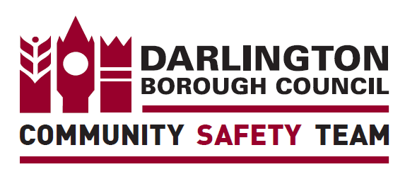
A Request from the Darlington Open Water Safety Group
As both warmer weather and the easing of some lockdown restrictions approach, we understand that many families and young people in Darlington will be thinking of heading to our parks and other outdoor attractions, particularly at weekends and during the school holidays. In many areas the open water is one of the main reasons to visit (Broken Scar picnic area, South Park lake, etc.) and we don’t want to stop that, but we do want to ensure that people act responsibly in and around that water.
Many ‘water safety’ presentations and activities have been curtailed due to Covid 19 restrictions, but it is vital that we still get those safety messages to parents, carers and young people. Can we ask you to post our water safety messages on your website and social media platforms as well as including them in any weekly newsletters/e-mail updates to parents/carers please? These messages are on the sheet below.
You may have seen press releases and social media posts in regards to water safety already and we intend to maintain our media presence over the coming months with the intention of reaching as wide an audience as we can. We do still need your help to reach some people in Darlington though, as we know many people will not see social media posts put out by local authorities, Police, Fire and Rescue and our other partners. We would really appreciate you doing this, particularly if you can do so before the imminent spring break.
If you have a chance to deliver water safety advice directly to your young people as well, that would be even better, but we appreciate you are experiencing additional pressures due to Covid 19 and this may not be possible. There is guidance and some really useful resources you can use on the Royal Life Saving Society and Royal National Lifeboat Institution websites -
https://www.rlss.org.uk/open-water-safety
https://rnli.org/safety/respect-the-water
If I can be of any further assistance or if you have any questions please do not hesitate to contact me.
Thanks,
Andrew
Andrew Allison – he / him,
Community Resilience Officer
Member of the Darlington Open Water Safety Group

Mobile 07384 797779 Landline 01325 406786 e-mail - Andrew.Allison@darlington.gov.uk

The Darlington Open Water Safety group is made up of Police, Fire and Rescue, Council, North East Ambulance Service, Teesdale and Weardale Search and Mountain Rescue Team and other partners with an interest in water safety.
Secondary Schools
Copy of ‘Water Safety Code’ attached with e-mail.
Text for e-mail or newsletter –
Please share this water safety information with your children.
Look out for warning signs and take notice of them!
Over 60% of drownings are of people who have ended up in the water by accident. Watch out for slippy riverbanks and trip hazards!
Remember that there are dangers below the water surface that you might not be able to see – strong currents, debris, hidden traps.
Download ‘what3words’ onto your mobile – this will give you an exact location to pass to the 999 services if you need to summon help for someone.
Cold Water Shock
When you enter cold water suddenly your body will initially ‘gasp for breath’ and then you will hyperventilate. As your body tries to control your temperature and keep you warm, your muscle control will reduce and you will be unable to control your movement well enough to swim. All waters around the UK are cold enough to induce the cold shock effects, even in high summer.
- Roll onto your back to keep your mouth clear of the water so you can breathe
- Float to save energy and call for help
- If you can, get to something that floats so you can stay afloat and call for help

Primary schools
Copy of ‘Water Safety Code’ attached with e-mail.
Text for e-mail or newsletter –
“Please share this water safety information with your children and don’t let them go near open water without adult supervision.
Download ‘what3words’ onto your mobile – this will give you an exact location to pass to the 999 services if you need to summon help for someone.”

