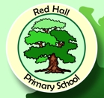

RED HALL PRIMARY

**Welcome Back and Hello to 2018!**

It has been a fantastic start to the New Year at Red Hall Primary School with the children returning to school looking smart and ready to learn. As you walk around school you see children proudly wearing their Red Hall uniforms with black shoes from Year 6 to the 2 year olds in Lullaby Lane. If you need to find out where to get school uniform and the correct PE kit then just pop into the office.

**In the TOP TWO in Darlington!**

Just before Christmas the government published the results from all the schools in the country. How do you think Red Hall did? How much progress did the children in our school make by the end of year 6? We are one of only two schools to score above average in reading, writing and maths. Out of 30 schools we are in the top two! Big well done to ALL the staff and of course the fabulous pupils. Special mention to the parents as well, because without your support we couldn’t achieve this. We are very proud!

**Crash Landing Leads to Fabulous Writing!**

Excitement swept across the school last Tuesday morning when Miss Snowdon announced that a mysterious object had crashed into our woodland from outer space! The children were incredibly curious as police and forensic teams arrived with a reporter from the Northern Echo to investigate further. Analysis of rock debris showed that there was nothing to fear, but it did lead to the children creating some amazing pieces of writing!

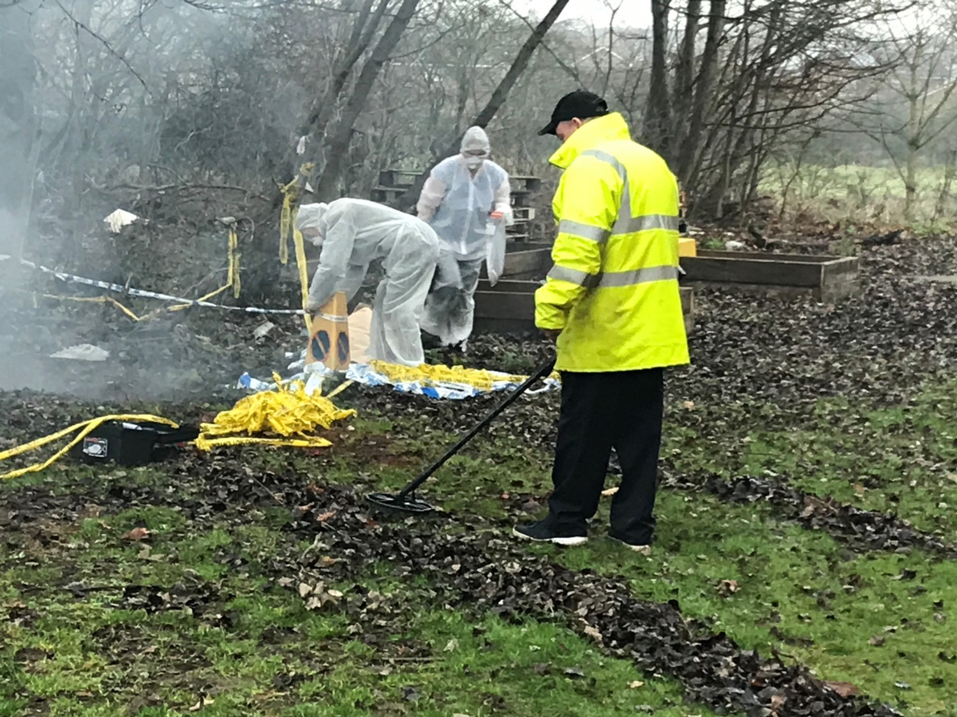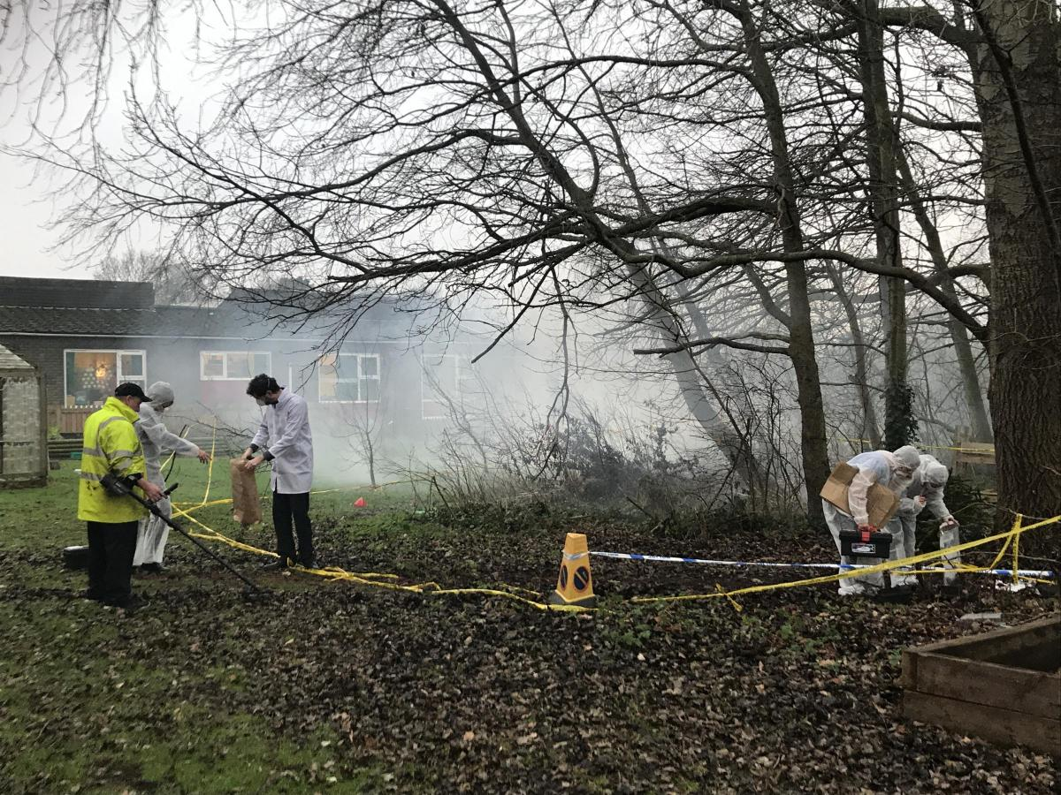

**Don’t forget to check out the Red Hall Primary School Website address:**

[**www.redhallprimary-darlington.co.uk**](http://www.redhallprimary-darlington.co.uk)



* 11th June is phonics screening for year 1.
* KS1 will being doing their SATs throughout May and there are booster classes now (see Mrs Luxon for more details).
* SATs week for Year 6 is week beginning the 14th of May. Booster classes to start after half term (details to follow).
* 2nd February – World Number Day, children come dressed as a number with a £1 donation to NSPCC
* Science week begins on the 12th of March, expect the children to be involved in some amazing experimentation!

**Other news from around Red Hall…**



A big well done to Robert Scanlan from year 6 who won the Christmas Maths House Cup competition! A truly impressive performance from him winning the cup for Rosa Parks with Morgan Woods helping Albert Einstein achieve second place. We are so proud of the children’s maths skills at Red Hall being the ONLY school in Darlington to achieve 100% at the end of year 6 in both 2016 and 2017. Who will win the Easter Cup??



Reading has been high on the agenda across Key Stage 2 this year as you all know after we rolled out the ‘**Accelerated Reader’** programme across year 3, 4, 5 and 6 in September. Now we can announce that the House Reading Cup has been won by Marie Curie with the children in that House reading an incredible 2750 times over the autumn term! Incredible effort from them, but who will win the cup next time? Children need to read three times a week to be in with a chance of winning the cup. If your child has lost their record just download it from our website…

**We wish you all a happy and healthy 2018**

Ms Davidson, Mr Goffee, Miss Snowden and all the staff at…

Red Hall Primary School

18th January, 2018