Early Years

Our team are passionate about child-centred learning.
We have created a rich learning environment where children can explore, create and investigate.
These principles are the foundation for all the learning that takes place within our provision.
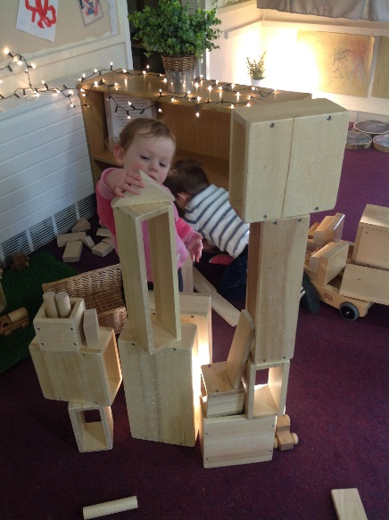
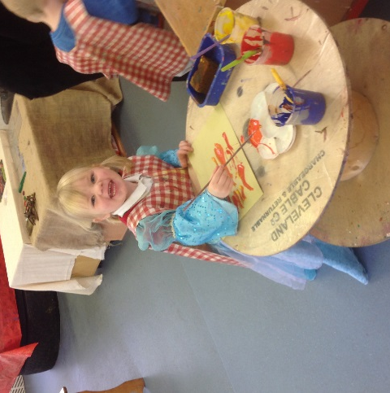
Creative and Critical Thinkers
We support the children to view problems as opportunities for new learning, allowing them to have their own ideas and find new ways to do things.
The children are encouraged to make links and recognise similarities in their learning and experiences.
Staff model the creative process, using high level questioning and vocabulary to enhance learning and inspire sustained thinking.
Playing and Exploring
We encourage the children to explore their own interests and to discover new things. We aim to provide open ended activities which will engage the children and support them to become lifelong independent learners.
We encourage the children to take risks, to develop a can-do attitude and to learn through trial and error.
Investigation and Active Learning
We help children to become motivated investigators and to take ownership of their own learning.
Our environment enables children to develop high levels of fascination and wonder.
We aim to develop persistent learners who show satisfaction when meeting goals and who persevere when challenges occur.

