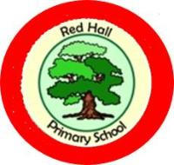
Red Hall Newsletter!

Borrow a Book

As we are sure you know because of council budget cuts there is no longer a mobile library service and the main library is also facing cuts.

Although we can’t match the range of books the library provides we have set up a free “borrow a book” bookcase in the school waiting area.

These books have been donated by all of the school staff so please make sure you respect this and return the books when you are finished with them and keep them in a good condition.

Please feel free to read the books while you are waiting for an appointment, to take them home to read or even to take them for a friend or family member to enjoy.

These are books for adult readers and some may not be suitable for children, e.g. horror stories.

