Red Hall Primary School, Headingley Crescent, Darlington, Co Durham, DL1 2ST
Tel: 01325 254770
www.redhallprimary-darlington.co.uk
Email:admin@redhall.darlington.sch.uk

25th June 2018
Dear Parent/Carer,

NEW SCHOOL MEALS MENU – COMMENCING 03rd SEPTEMBER 2018

Please find attached the new school meals menu that will be served to children from Monday 03rd September 2018 until we break up, in February half term. I hope you agree there are many choices to choose from.

Please take the time to go through this with your child and select a meal that they would like, as changes to menu choices will not be able to be made after your request has been submitted.

If your child is on home packed lunches and would like to change to our delicious school dinners, please contact the office to have this change implemented.

School dinners offer great value for money at £2.00 a day - £10.00 per week, payable at the school office.

You can view our nutritious school dinner menu on the school website, found in the Parents section, under school meals.

Please complete the order form and return it to the school office, no later than Monday 02nd July 2018.

If we do not receive an order form back, your child will be given automatically the red meal choice if in KS1.

Yours faithfully,

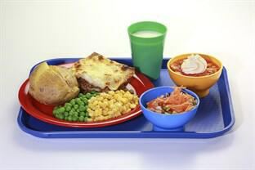
Mrs Heseltine
School Administrator

*Please note all copies of school letters can be viewed on the website at www.redhallprimary-darlington.co.uk

