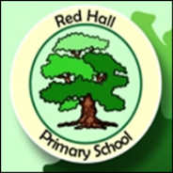
Parent Post

News for Parents and Carers at Red Hall Primary School March 2018
GOODBYE AND A FINAL INVITATION

As you know I will be leaving Red Hall Primary School after nearly four years next Thursday. I have had an amazing time and will miss the children, the staff and the parents. Working with parents is vital today if schools are to do the very best for the children in their care. Over these past few years I have tried to strengthen the links between the school and its parents and I believe that we now have vibrant and positive relationships between you and the staff in the school.

What a brilliant set of staff we have here, I have loved every minute of my time at Red Hall. Myself, Ms Davidson and Miss Snowdon have made a fabulous leadership team (if I don’t say so myself) and I’ll look back on our time together with fondness and pride. My best wishes for the future go to them and all the staff at this simply marvellous school.

I should like to invite you to one more of my Parent Meetings, next Tuesday the 27th of March at 2.30pm. It is essential that as many of you turn up as possible as I will be talking about the changes we have made to our reporting and marking systems. By coming along it will help you understand how we as a school operate and what a growth mindset is.

The meeting will also give me the opportunity to thank you for your support and for helping make the past four years so enjoyable. I really do hope to see as many of you as possible next Tuesday and can I thank you again for giving the school such wonderful, amazing children to work with (most of the time)!

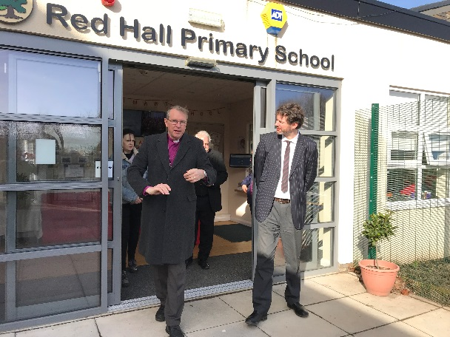

With the Bishop of Durham two weeks ago, proudly showing off the school that we have worked so hard to grow.

Check out our website: http://redhallprimary-darlington.co.uk/

