Red Hall Primary School
Headingley Crescent
Darlington
Co Durham
DL1 2ST

Tel: 01325 254770
www.redhallprimary-darlington.co.uk

Email:admin@redhall.darlington.sch.uk

@RedHallSchool @ RedHallPrimarySchool

06th March 2018

Dear Parent/Carer,

World Book Day – New Date of Friday 09th March 2018

Due to the adverse weather, we had to postpone our ‘World Book Day’. We are now celebrating this event on Friday 09th March, all children are allowed to dress up as a character from their favourite book. (Book – not film!) and throughout the day in school, we will be looking at adventure books and stories. If your child has a favourite adventure book, they are more than welcome to bring in this book to share.

If your child does NOT want to get dressed up - this is fine, please send them in school uniform.

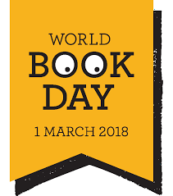
Thank you for your patience and support.

Ms L Snowdon
Assistant Headteacher

*Please note all copies of school letters can be viewed on the website at www.redhallprimary-darlington.co.uk

