Parent Post

News for Parents and Carers at Red Hall Primary School February 2018
BISHOP OF DURHAM VISIT

As you know there have been many changes to Red Hall over the past few years; changes for the better with new housing and play parks. As part of the regeneration project, we have invested in a set of bicycles to be used for PE and Ms Davidson has made it her mission to have EVERY CHILD able to ride a bicycle by the time they leave us. This week, we had the honour to welcome the Bishop of Durham to the school, so he could see first-hand, some of the great changes.

He met the children riding the bicycles, then he saw some PE action in the gym and even had time to hear some Rock and Pop singing in our music room before catching up with Little Leaps who were litter picking! He was so impressed with the calm and happy atmosphere we have in school and congratulated staff and pupils. Have a look at some of the photographs from his fantastic visit:
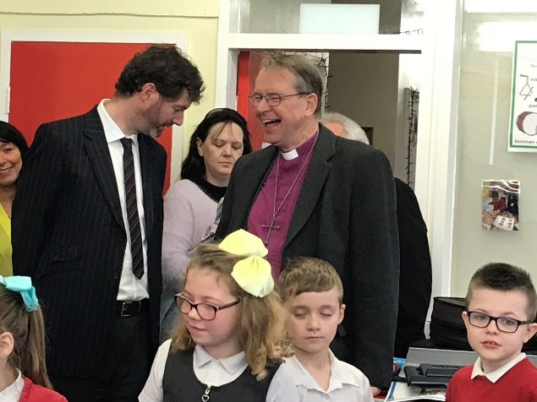
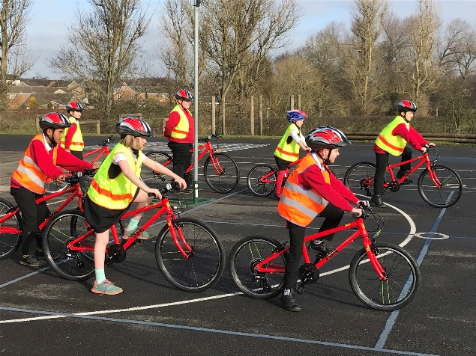

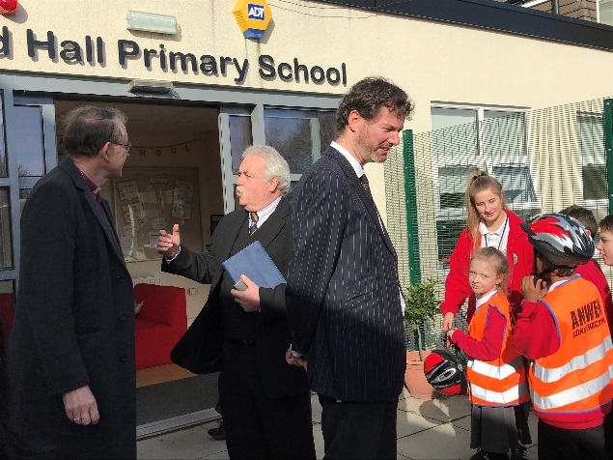
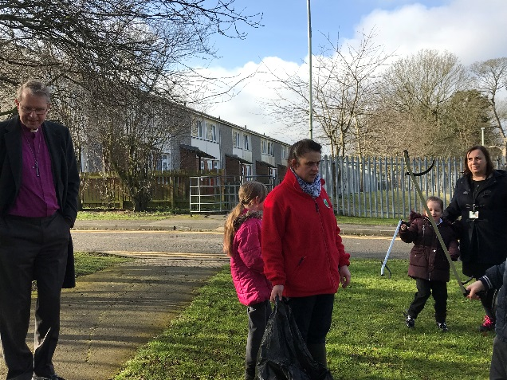

Check our website: http://redhallprimary-darlington.co.uk/

