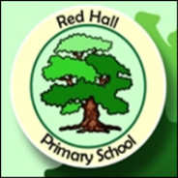
Parent Post

News for Parents and Carers at Red Hall Primary School January 2018
MR GOFFEE INVITES YOU TO RELAX!

Are you free next Thursday at 2.30pm? Mr Goffee would like all parents and carers of Red Hall Primary School to listen to a talk about Mindfulness and take part in a relaxing session! Last term he was in year 5 giving them a 6 week course on Mindfulness; it is a series of relaxation techniques intended to take away the worries of the world for a few minutes each day. The techniques he taught them have even been used at home by some of the children to help them relax.

So if you can make it in on the 18th of January next week you can learn all about Mindfulness and learn how to take away some of your own stresses. Red Hall is committed to helping our pupils live happy, healthy lives and we see Mindfulness as a technique that can really help this. By the end of the year we want all children to be taught the techniques so this is your chance to find out what it is all about. SEE YOU NEXT WEEK AT 2.30pm!

METEOR LANDS IN OUR WOODLAND!
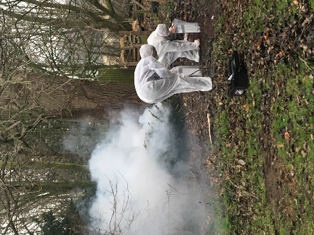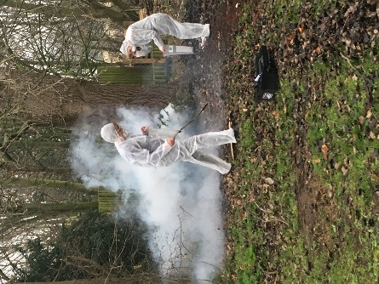

Excitement swept across the school on Tuesday morning when Miss Snowdon announced that a mysterious object had crashed into our woodland from outer space! The children were incredibly curious as police and forensic teams arrived with a reporter from the Northern Echo to investigate further. Analysis of rock debris showed that there was nothing to fear, but we are hoping the children will use this amazing opportunity to create some fabulous writing!

And finally… We have a couple of courses starting at school, just for parents and carers. Would you like to learn more about family budgeting and healthy eating, or how to make a fresh start with a new confident you in 2018? If so come and find out more from the office.
Check our website: http://redhallprimary-darlington.co.uk/

