Red Hall Primary School
Headingley Crescent
Darlington
Co Durham
DL1 2ST

Tel: 01325 254770
www.redhallprimary-darlington.co.uk

Email:admin@redhall.darlington.sch.uk

24th January 2018
Dear Parent/Carer,

School Menu Choice Options

Due to the resounding success of the school menu now including four different menu choices to choose from; which came directly as a result of the parental feedback survey conducted in June, we have decided to carry on with this menu until the end of this academic year.

If your child is still on home packed lunches and would like to change to school dinners, please contact the office to have this change implemented.

School dinners offer great value for money at £2.00 a day - £10.00 per week, payable at the school office.

You can view our delicious, nutritious school dinner menu on the school website, found under Parents>school meals.

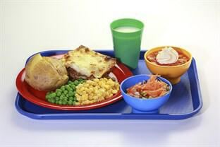

Yours faithfully

Mrs L Keeley & Mrs L Heseltine
Office admin

