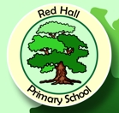

RED HALL PRIMARY

**Merry Christmas and a Happy New Year!**

The holidays are coming and there is a festive feel around Red Hall with Santa Claus on his way! It has been another brilliant term at the school, we discovered that last year’s children in Y6 and Y2 achieved brilliant SATS results; for the second year in a row we scored 100% for maths in Y6 (the ONLY school in Darlington to achieve this!). A big well done to the children and a thank you to our wonderful staff.

**Are You Signed Up to Marvellous Me?**

Marvellous Me is a **free** app which parents and carers can download onto their smartphones. Teachers and school staff use the app to let you know when your child has done something AMAZING! The Parent Action Group voted to adopt the app in 2016 and it has gone on to be used by 173 families, that’s 82% of all pupils at the school! Since September this year, staff have sent OVER 5000 marvellous messages home! So don’t miss out, make sure you are signed up and if you change phones make sure you pop into reception to get a new password to download the app again… For FREE!

**Attendance**

Here is our attendance data for the end of the Autumn Term. Our overall school attendance now stands at **95.5%**

**Reception 94.30%**

**Class 1 94.23%**

**Class 2 96.42%**

**Class 3 96.49%**

**Class 4 95.90%**

**Class 5 97.14%**

**Class 6 95.16%**

***CONGRATULATIONS to Class 5 who win the attendance prize for this term!***

**Don’t forget to check out the Red Hall Primary School Website and remember we have a brand new web address;** [**www.redhallprimary-darlington.co.uk**](http://www.redhallprimary-darlington.co.uk)

**Farewell and Thankyou**

This term we say goodbye to two teaching assistants, Kirsty McGill and Clair Hughes. We say a big thankyou to all they have done for the school, Clair was a large part of the reason why the school achieved the Arts Mark. Next half term will be the last one for our Year 1 teacher Wendy Togher (who has been working at Red Hall for over 10 years) she will be missed, especially by the choir! We wish them all the best of luck in the future.



* 16th January – Year 3 and 4 Visiting Great North Museum to Launch Stone Age Topic – cost £5.00 a child to cover coach travel, etc.
* 18 January 2.45pm - Mindfulness Taster Session for all parents and carers with Mr Goffee – everyone welcome. Refreshments will be available!
* 9th January – Year 1 and 2 Memorable Experience during the Day to Launch Memory Box Topic – cost £2 to cover resources, etc.
* 9th January – Year 5 and 6 Memorable Experience that Evening to Launch Stargazing Topic – cost £3 to cover food and resources, etc.

**Other news from around Red Hall…**

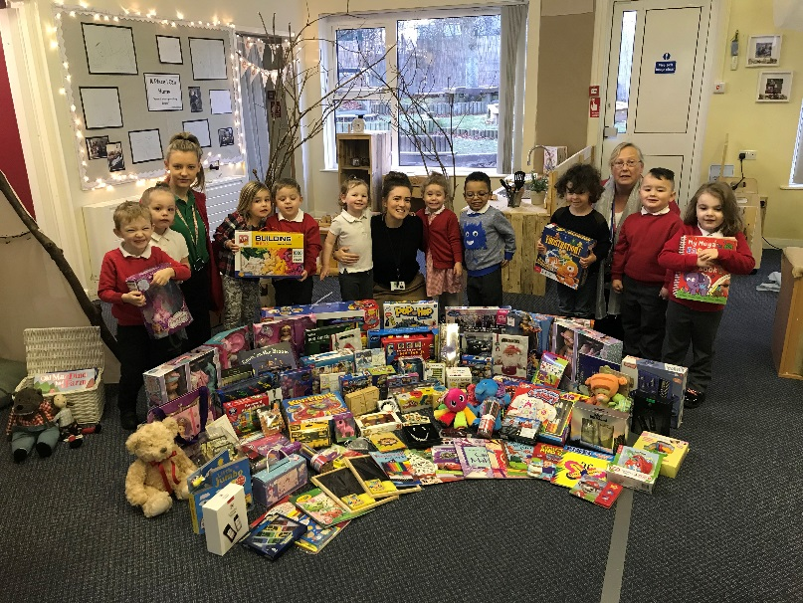



Reading has been high on the agenda across Key Stage 2 this term as we have rolled out the ‘**Accelerated Reader’** programme across years 3, 4, 5 and 6, following a successful trial last year. The children love the quizzes and the results look brilliant with loads of children moving up a level in their reading and it’s only been going just over a term! Remember to read with your child **at least 3 times a week** to keep the improvements coming.

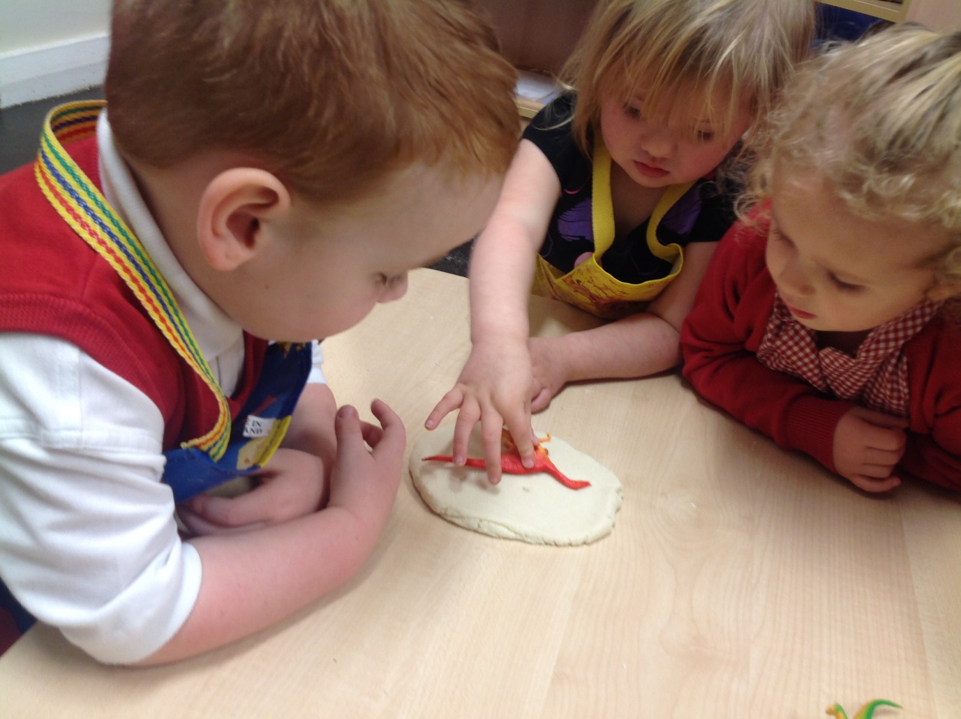

A big thank you to everyone who donated a gift to our Christmas present appeal. We raised 98 gifts to go to families in need and are still expecting some more gifts which we will take to the hospital! Well done to Miss Egglestone, Miss Hart and Miss Sewell and our Nursery children!

This half term our topic in Lullaby Lane has been: ‘Which dinosaur is the biggest?’ We have been on a dinosaur hunt, it was very scary when we heard it “Roar” but we were very brave! We learnt about how fossils are dug up and made our very own dinosaur egg.

**News from around Red Hall continued…**

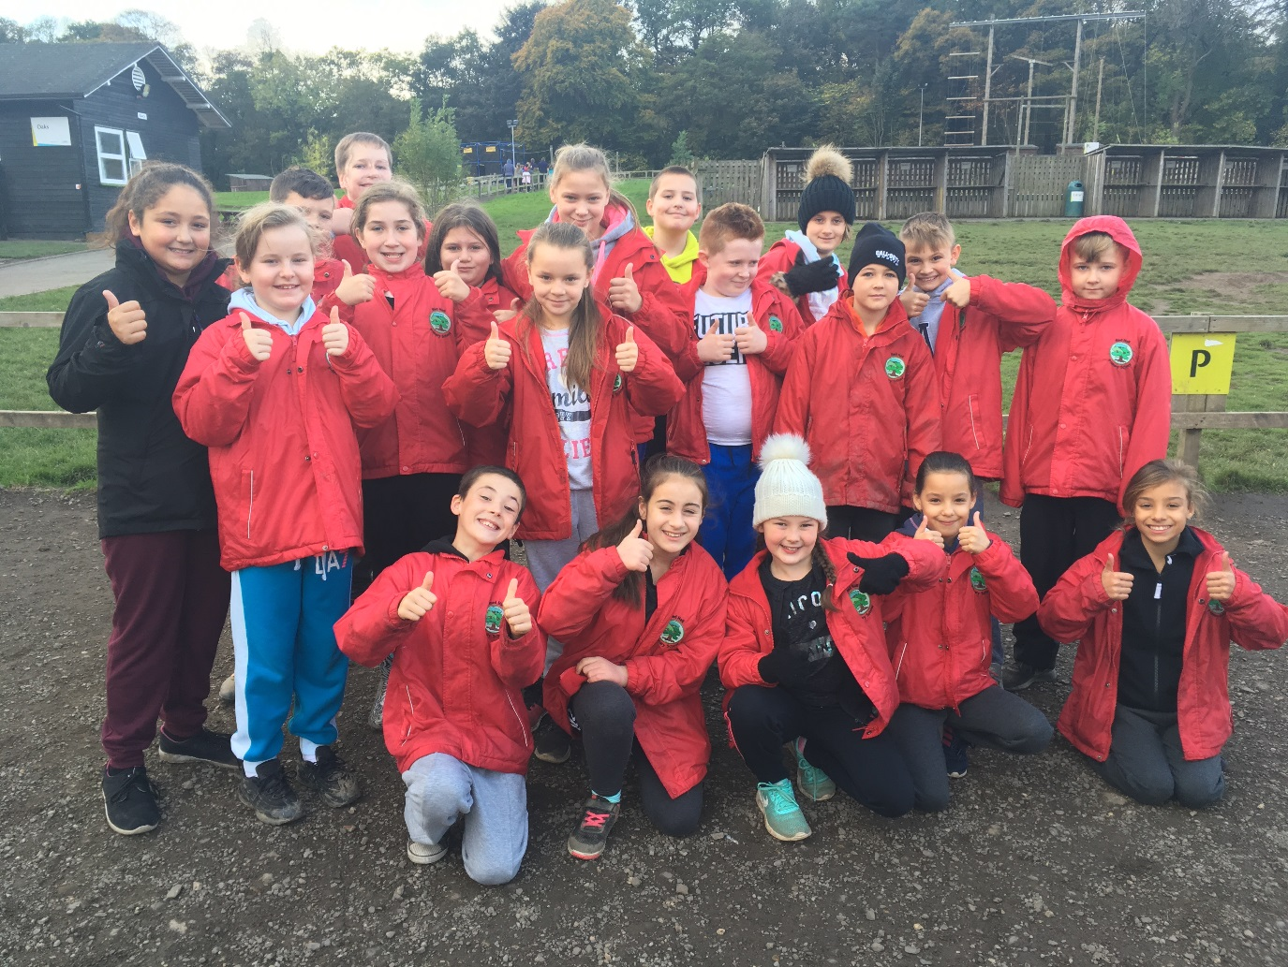

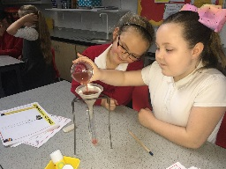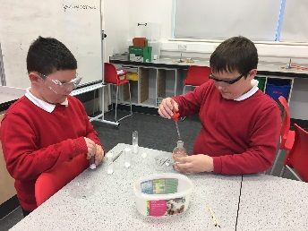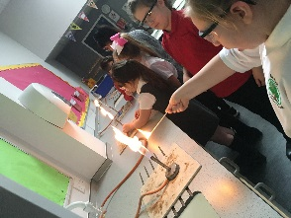

This term in Class 5, we have loved going to Science lessons at the Education Village. We were specially asked to go there and help them solve a Crime Investigation. We identified suspects by looking at the finger prints in blood, substances found at the crime scene and the DNA at the crime scene and on the victim.

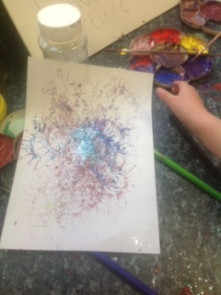

Key Stage 1 have been so busy this half term and we have loved our topic of Beat, Band, Boogie. We had two memorable experiences, a whole day of music activities including watching the Trooping of the Colours, making our own shakers, recreating STOMP with pots and pans, listening to a huge range of music including classical, jazz, rock and roll, heavy metal and many others as well as lots of other fun activities.

Year 6 have had an exceptional first term in their final year at Primary School. They have been working hard in all subjects. All children have produced some wonderful writing based on Harry Potter. In Maths, children have enjoyed developing their understanding of the four operations, then working on shape and space with Mr Goffee. Miss Snowdon and Mr Beadle are incredibly proud of all pupils and their brilliant effort!

Our topic this term in year 3 and 4 was called ‘The Blue Abyss’ and we kicked off the year with a visit to the Blue Reef Aquarium on Tyneside! The children got to meet some rather wet new friends and began to understand how very different the creatures in our oceans are and how they are adapted to the three main zones.

The topic linked into our Science and Literacy work too. In science we looked at what predators are and who are the prey they hunt underwater. The children constructed food chains and discovered all about carnivores, herbivores and omnivores.

In literacy we have been writing underwater adventures and letters to the manager of the aquarium, convincing them that we had a fabulous time using persuasive openers! Finally the children put on their own art show with luminous paints!

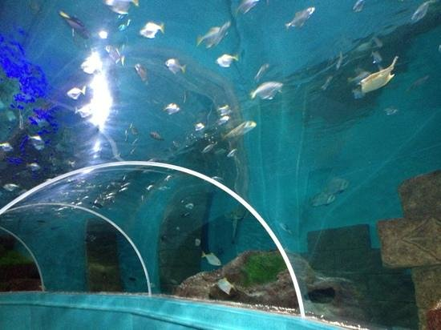

In Reception the week after **Bon Fire night** we made fire work pictures by cutting a cardboard tube and splatting the paint. We also mixed paint to make different coloured fireworks. In **Maths** we have been measuring by capacity and length. One day there was a footprint in Reception and toys were missing! The Class measured the length of the footprint and then everyone’s feet to see who could have stolen the toys. In turned out Miss Newhouse had the same length feet as the foot print so she stole the toys!

**Other news from Red Hall continued…**

Key Stage 1 have been so busy this half term and we have loved our topic of Beat, Band, Boogie. We had two memorable experiences, a whole day of music activities including watching the Trooping of the Colours, making our own shakers, recreating STOMP with pots and pans, listening to a huge range of music including classical, jazz, rock and roll, heavy metal and many others as well as lots of other fun activities.

Key Stage 1 continued… Then we had a visit from Alex who is a real musician and he played some fantastic music for us on his guitar and answered all our questions about being in a band and what it is like to be a musician.

We followed this up with a whole half term of great activities, exploring famous musicians including Ed Sheeran and Gustav Holst. We also created art like the famous Kandinsky (who used music to inspire his art), then exploring how music makes us feel and finally planning our own mini Talent Show.

It's been a fantastic topic and all the teachers think we might have some future X Factor winners in Key Stage 1!

**Overall**

Thank you for another wonderful year at Red Hall. We thank you whole heartedly for your support. Our successes with your children are down to the fantastic work from teachers, pupils and parents. It is clear that when working together, we can achieve phenomenal results! Red Hall has other staff from other schools regularly coming to work with us and to look round, to see what we are doing and how we achieve such wonderful things!

Please continue to support us as we move into 2018. Remember, you are welcome in school anytime!

All that is left to say is, have a wonderful Christmas, enjoy your time off and make some wonderful memories!

**We will see you all on Monday 8th January, 2018**

Ms Davidson, Mr Goffee and Miss Snowdon

15th December, 2017



