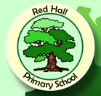

Shoebox Appeal
Mrs Marshall and I are organising the 'shoe box appeal' this year in school. Family shoe boxes are given to families who often have to make a choice between buying food or fuel at Christmas time- buying presents is not an option for these families. Many of their homes do not have running water, heating or electricity. They often share just one or two rooms per family and every day is a struggle.
If you could spare some of the suggested items below to bring into your child’s class teacher we can combine all of the gifts together to create class shoeboxes in school. If you would like to create a full shoebox yourself please feel free to do so. In this case could you please bring the completed box to Miss Egglestone (Nursery) or Mrs Marshall (Class 3) and complete a form to send with the box. Also a £2 delivery fee will be needed to send away your box.
If you require more information or to watch the videos about the appeal please look on the website www.linktohope.co.uk/shoebox-appeal or contact Miss Egglestone or Mrs Marshall. A list of suggested items are on the back.

Thank you for your support.

Miss Egglestone and Mrs Marshall

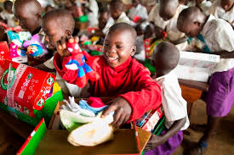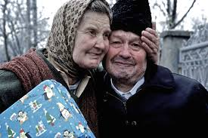

Items allowed in both family and elderly shoeboxes are:
- Sweets/Chocolates | - Candles and holders
- Gloves/Scalves/Hats | - Shampoo/shower gel (max 300ml)
- Small games (travel sized draughts, dominoes) | - Toothbrush/ Toothpaste
- Wind up torch or radio | - Brush/Comb
- Craft/sewing kit | - Plasters
- Socks/tights (new) | - Soap/Flannel

Extra items to in a family box are:
- Pens/Crayons/Felt Tip Pens | - Small toys (yoyo, toy cars etc.)
- Teddy/Doll/Soft Toys | - Simple calculator (solar powered)
- Screwdriver/Tape measure | - Hair Accessories
- Colouring books/ Writing pads

Extra items to put in an elderly box are:
- Tissues/ Handkerchiefs | - Sensory items (wind chime, beany item)
- Pens/Paper | - Reading Glasses
- Small Mirror

Any other items you think are appropriate may be added to your box but please DO NOT add food, biscuits, tins, medicine, out of date items, books or literature, tea or coffee.

