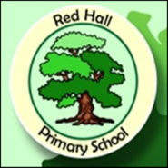

Red Hall Primary School
Parent/Carer Questionnaire 2017
 | Strongly Agree | Agree | Disagree | Strongly Disagree | Don’t know
My child is happy at this school.
My child feels safe at this school.
My child makes good progress at this school.
My child is well looked after at this school.
My child is taught well at this school.
My child receives interesting homework.
The school makes sure it’s pupils are well behaved.
The school deals effectively with bullying.
The school is well led and managed.
The school responds well to any concerns I raise.
I receive valuable information from the school about my child’s progress
There are many opportunities for me to celebrate my child’s successes.
I would recommend this school to another parent.
The school is welcoming and pleasant to visit.
There are a good range of clubs for my child to enjoy.
The school has a good reputation in the local community
The school’s website is helpful and informative.
If you wish to explain or elaborate on any of your answers above please comment below
How could we be even better? The more specific you are the more effective we can be.
What other feedback could you offer our school?

