Red Hall Primary School
Expectations and Choices Framework
(Red Hall Primary School’s Policy for Managing Behaviour)

Document History
Originally Written: | April 2015
Updated: | February 2017  June 2017
By: | SLT
Approved by Governing Body:
 | 15th March,2016
 | 14th March, 2017
Next Review Date: | September 2018

Introduction
Our framework is based on the belief that:
Children need support and guidance to make the right choices in their lives and Red Hall Primary school has developed an ethos and culture in school which enables our children to get into a positive high performance emotional state to succeed in education. We as a school do not recognise the term ‘bad behaviour’, instead we understand that emotional state can affect the choices that children make.
Defining Emotional State
Have you ever started your day in a great mood and everything just got better? When no matter what challenges you met you coped easily. On other days, the smallest difficulties seem overwhelming.
States act like a filter on our perceptions and interpretations, which in turn affect emotions. There are other kinds of states beside emotional ones of course, for example “a learning state” or a state of curiosity. We respond differently to any kind of situation depending on how resourceful our state is at the time.
At the end of a long hot day, when we are tired, hungry and irritable after a run in with the boss, we are likely to experience a different state (and behave differently) than when we are refreshed and looking forward to a pleasant day.
Emotional states indirectly affect behaviour. They do not cause it. When we are feeling angry, we are more likely to act aggressively. When we are relaxed, we will more likely take time to make decisions.
(http://nlp-mentor.com/emotional-states/)

Aims
It is a primary aim of Red Hall Primary School that every member of the school community feels valued and respected, and that each person is treated fairly and well. We are a caring community, whose values are built on mutual trust and respect for all. This policy is therefore designed to support the way in which all members of the school can work together in a supportive way. It aims to promote an environment in which everyone feels happy, safe and secure.

The school has three core codes of conduct:
- We look after ourselves
- We look after each other
- We look after our school
But this policy is not primarily concerned with rule enforcement. It is a means of promoting good relationships, so that people can work together with the common purpose of helping everyone to work together in an effective and considerate way.
This policy aims to help children grow in a safe and secure environment, and to become positive, responsible and increasingly independent members of the school community.
The school recognises and promotes ‘right choices’, as it believes that this will develop an ethos of kindness and cooperation. This policy is designed to encourage good choices and accountability, rather than merely deter anti-social behaviour.

Staff Responsibility
Behaviour Management is the responsibility of all staff.

Role of the Head teacher

It is the responsibility of the Head teacher to implement the policy consistently throughout the school, and to report to governors, when requested, on the effectiveness of the policy. It is also the responsibility of the Head teacher to ensure the health, safety and welfare of all children in the school.
The Head teacher supports the staff by implementing the policy, by setting the codes of conduct expected, and by supporting staff in their implementation of the policy.
The Head teacher keeps records of all reported serious incidents including bullying, homophobic and racist incidents.
The Head teacher has the responsibility for giving fixed-term exclusions to individual children for serious incidents. For repeated or very serious incidents, the Head teacher may permanently exclude a child. These actions are taken only after the school governors have been notified and only in the most extreme of cases.

The Role of the Class Teacher

It is the responsibility of class teachers to ensure that the school codes of conduct are enforced in their classes, and that their classes act in a responsible manner during lesson time.
The class teachers in our school have high expectations of the children with regard to learning attitudes and conduct, and they strive to ensure that all children work to the best of their ability.
The class teacher must be a role model for the children and treat each child fairly, and enforce the classroom code consistently. The teachers treat all children in their classes with respect and understanding.
The class teacher reports to parents and carers about the progress of each child in their class, in line with the whole-school policy. The class teacher may also contact a parent (in discussion with the Family Support Worker and the Head teacher) if there are concerns about the attitudes or welfare of a child.
Red Hall Aims:
- Our school motto is ‘Believe and Achieve. Red Hall Primary is a school where ALL children no matter what their home situations or academic levels are given the skills to ‘believe’ in themselves and to ‘achieve’ their very best.
- To have a behaviour management system that puts children’s choices at its heart.
- To make everyone in our school feel good about themselves.
Red Hall’s Culture and Ethos:
- Over the last three years the school has worked hard to develop an ethos which puts our children and the staff’s well-being at the heart of everything that we do. This is what sits at the core of the service we provide at Red Hall Primary School. At Red hall we recognise that feelings matter and support children to articulate those feelings through a nurturing environment.
- To make children aware of the consequences of their behaviour equipping them with the skills to make better choices in the future.
Red Hall’s Purpose is to;
- Improve, not only itself, but the lives of all of its stakeholders, offering them the best opportunities to succeed in the future
- Enable children to get into a positive high performance state to succeed in education.
- Recognise this process is a partnership between children, families and staff. The school is at the heart of the community. We support our families in many different ways and believe partnership is at our core. Creating strong links with parents and carers gives our children the best possible start to their educational success.
How is this Achieved?
- By focusing on the emotional state of children.
- By recognising this personal state we aim to proactively influence the transition to a more positive state.
- By using only positive language.
When children are unable to meet our schools expectations we will create opportunities for children to make informed choices.
We aim to give the children in our school the tools necessary to make the right choices in their lives that enable them to be considerate and respectful to others and set the conditions in a class that promotes progress and learning.
We do this through;
Rating Feelings in the Classroom
We focus on children’s feelings
Each class will have a visual representation of the emotional state of the children in the class. The child’s photograph can be moved by themselves or an adult. The first section shows the children in a happy settled state ready for work. The second section encourages them to think about the choices they are making. The next section is ‘time and space’ where children will leave the class for 5 minutes and sit in the designated ‘time and space’ area. The final section is when children continue to make choices which break the school’s code of conduct. Children in this section may need longer out of the class to complete a ‘right track’, they will typically be asked to stay in at break or lunchtime to further reflect. At this stage parents would be informed as will the Deputy Head or Head teacher.

‘Time and Space’
We recognise that when situations arise which can cause potential conflict, the child and staff may need the time and space to calm and reflect.
We offer the children the opportunity for a reflection talk where children are helped to:
- Focus on their feelings that drove the action.
- Identify or form better choices / options.
- To adopt the choice which enables them to manage their feelings in a more productive way so that consideration and respect are promoted.
We ensure we use our help script;
Name ...
I can see that ...
I am here to help ...
Talk and I will listen ...
Come with me ...
The ‘Time and Space’ process
‘Time and Space’ works through three possible stage
- Calm
- If a child is not meeting the school’s expectations then in a positive manner, staff say, ‘think about the choices you are making or you may need some ‘time and space’. (A time and space card may be used to signal this, see Appendix D).
- If a child is emotionally not ready to learn OR continues to break the school’s code of conduct (look after yourself, look after each other, look after our school) then in a positive manner, staff say, ‘you need some time and space’ (A time and space card may be used to signal this, see Appendix D).
- The child will then go to the designated time and space area just outside of the class room.
- Reflect
- Here they have the time and space to reflect on the choices they have made and:
- Return in a more positive state – checked on after 5 mins.
- Be supported with optional follow up time with a member of staff – where we * can explore different choices

- Support
- Some children may benefit from the support and facilitation of an adult to find better choices. We do this by focusing on process not content to identify how the alternative options a child can use in the future when faced with similar situations.
- Create a ‘right track’ (see Appendix A)
- A personalised journey which will give the child the tools they need to practise to enable them to make an informal choices in the future
- This is a partnership process between child and adult
- This same process can be used by members of staff when relationships become challenging.
Each class has a ‘time and space’ card which a child will take outside to the designated ‘time and space’ area. They can also use this card to facilitate discussion with the class teacher by showing the reverse side to them. This discussion may result in a ‘right track’ being written.
What do we mean by ‘MY Right Track’?
Am I on MY Right Track?
‘Am I on MY right track’ is a personalised journey which will give the child the tools they need to practise to enable them to make informed choices in the future. This is a partnership process between a child and adult*. It will aim to put the children in a high performing state to support them in succeeding.
A right track sheet will be completed at break or lunchtime if a child needs to be asked to have more ‘time and space’ following further breaches of the school code of conduct.
A right track sheet will also be completed over lunch if a child breaks the school’s code of conduct over a break or lunchtime.
MY Choices Pyramid (see Appendix B)
A minority of children may need a more visual representation of the effects their choices can make on their learning and that of others
These children will have a personalised pyramid sheet that sets out strategies to help them succeed in their learning
The pyramid will also set out a number of clear consequences for not making the right choice.
The ultimate goal is to put children into a high performing state that will promote good progress and harmony in the class and wider school.

Choice Contract (see Appendix C)
Should a pattern of behaviour arise where children continue to make choices which break our school’s code of conduct the senior leadership team will meet with parents and pupil to write a ‘choice contract’. This is only to be used in extreme circumstances when a ‘right track’ and ‘right choices pyramid’ have been tried and shown to uneffective.
The ‘choice contract’ would typically be invoked if a child is disrupting learning on a daily basis (perhaps by running out of class or continually shouting over the teacher), or where they are physically or verbally aggressive towards staff or pupils.
A child on a ‘choice contract’ will meet with a member of the senior leadership team on a Monday morning before starting lessons to review the specific targets on their contract. A follow up meeting will be held on the Friday to review the week, with a senior leader AND the child’s parent/carer. The contract must be for a fixed time period (6 weeks for example) and reviewed at the end with pupil and parent/carer.
The contract will make it clear what the consequences will be for the child if they decide not to meet the targets within it (these could include loss of breaks, lunchtimes, PE sessions with the whole class, etc.).
To be on a ‘choice contract’ is incredibly serious as the next step for that child is firstly internal exclusion (working out of class with a member of staff and having no contact with their peers for the duration of the exclusion) and then external exclusion (being required to work outside of the school environment). Children who receive more than one external exclusion may be considered for a ‘managed move’ away from Red Hall Primary School or in extreme cases face permanent exclusion.
Senior Leadership Choice Review
Each week the senior leadership team meets to discuss the children in school on ‘right choices pyramids’ and ‘choice contracts’. They will review the number of incidents these children have had where the school’s code of conduct has been broken (using CPOM records). The review is intended to help senior leaders decide if more support is needed in particular classes, but ultimately the goal is to return children to the ‘time and space’ system used by ALL pupils. The school wants only a minority of children to be on a ‘right choice pyramid’ or ‘choice contract’.
At each point LA authority guidance and advice will be followed.
Expectations and Choice Framework
In summary this is the procedure for managing behaviour and promoting ‘right choices’ in school:
- Time and Space – 5 minutes to calm and reflect before rejoining the class
- Right Track – a personalised set of choice options written with the class teacher to aid the child when they are about to break the code of conduct
- Right Choices Pyramid – a set of personal targets with consequences if they are broken. Written with the class teacher, the pupil and the parent/carer
- Choice Contract – a set of targets the child MUST meet or face internal / external exclusion. Written with a senior leader, the pupil and the parent/carer and reviewed on a weekly basis.

Praise and Reward
A key component to any successful ‘behaviour’ system is the way in which those children making good choices are praised and rewarded. At Red Hall we recognise that the vast majority of children make the right choice and support the school’s Code of Conduct at all times. These children need praise and recognition for the outstanding way in which they behave on a daily basis. Rewards are also a way of sending a message to those who have not made the right choices, hoping in the future that this will impact on their future decisions.
Marvellous Me
Red Hall uses the app – Marvellous Me. This is a way of sending messages to parents when their child has done something ‘marvellous’. It can be used in a plenary to showcase the learning from that lesson or could be used to highlight a child’s politeness. It is expected that teachers and staff will be using the app on a daily basis to send messages directly to parent’s smart phones. This is also a way of encouraging parents to ‘revise’ work learnt that day it is a key tool in our aim to engage parents more in their child’s learning.
House Points
Each child is placed in one of four ‘houses’ when they start key stage 1. The houses currently are: Nelson Mandela, Marie Curie, Albert Einstein and Rosa Parks. The children learn about the inspirational person behind the name and earn ‘house points’ for excellent work in class or for being kind, polite, etc. The ‘house’ with the most points earns themselves an end of year party. House points are displayed on a notice board in school and on the school’s website.
Jar of Good Choices
Each class, from reception to year 6, has a ‘jar of good choices’. The jar is filled with marbles each time a child in the class makes a good choice. This could have happened in class or at lunch or playtime. The jar is used straight after lunch to find out if anyone has earned a ‘golden ticket’ (see below); it is intended to be a way of focusing on the positives in everyday school life and is a crucial part of our practice towards becoming a ‘growth mindset’ school.
Golden Tickets
Golden tickets (see Appendix E) are given to pupils at lunchtime by the lunchtime supervisors to reward children who have made great choices. These choices link to the expectations we as a school set for lunchtimes, displayed in our hall at all times. Children with a golden ticket bring to back to class after lunch and it is exchanged for a marble (which is placed in the ‘jar of good choices’, see above). A discussion is had in class about how the ticket was earned and how others could earn such a ticket in the future. This is a crucial part of our practice towards becoming a ‘growth mindset’ school.
A Final Thought
As a school we know the importance of staff being in a high performance emotional state and the impact this has on our children. We recognise the importance of giving staff the opportunity to reflect and we will offer support to staff in these situations.
All staff have the right and responsibility to support colleagues to maintain a high performance emotional state.

Appendix A
Right Track Sheet (for use during class or at break times) *
Am I on MY Right Track?
Name …………………………………………………………… Date ……………………………………………………
Red Hall School Code of Conduct
We look after ourselves (copy underneath)
………………………………………………………………………………………………………………………………………
We look after each other (copy underneath)
………………………………………………………………………………………………………………………………………
We look after our school (copy underneath)
………………………………………………………………………………………………………………………………………
Which choices did I make when I broke the code of conduct?
…………………………………………………………………………………………………………………………………………
…………………………………………………………………………………………………………………………………………
…………………………………………………………………………………………………………………………………………
How was I feeling when I made these choices?
…………………………………………………………………………………………………………………………………………
…………………………………………………………………………………………………………………………………………
…………………………………………………………………………………………………………………………………………

What different choices could you make in the future to avoid this happening again?
…………………………………………………………………………………………………………………………………………
…………………………………………………………………………………………………………………………………………
…………………………………………………………………………………………………………………………………………
…………………………………………………………………………………………………………………………………………
…………………………………………………………………………………………………………………………………………

What will WE now do if the same situation happens again?
…………………………………………………………………………………………………………………………………………
…………………………………………………………………………………………………………………………………………
…………………………………………………………………………………………………………………………………………
…………………………………………………………………………………………………………………………………………
…………………………………………………………………………………………………………………………………………
Should you be allowed out at break / lunch? Yes or No ……………………

Signed Pupil ………………………………………………… Class Teacher ………………………………………

Appendix B
Right Choices Pyramid Sheet *
An example only – should be completed with child and steps worked out together

Right Choices Pyramid
What will we do?
Remind me what my targets are and give me a warning before moving me down the pyramid.
If I am stressed or upset I can:
- Ask to speak to Mr Goffee or Ms Davidson
- Ask to sit in the reading corner
Right Choices Pyramid
name TARGETS:
What must I do?
I will not push, move or hit anyone
I will not shout at anyone or call them names
I will finish a piece of work each lesson
A letter will be sent home today!

I will go and see Ms Davidson to show my work and be offered lunchtime club!

STARTING POINT: I can show my work off to my class and an adult of my choice!
TARGET BROKEN - I will miss 15 minutes of break or lunchtime, unless I sit at my desk ready to work…

TARGET BROKEN AGAIN - I will miss all of the next lunchtime and my mum will be told that I have made the wrong choice today, unless I sit at my desk ready to work…

TARGETS CONTINUE TO BE BROKEN – I will spend the rest of the session in internal exclusion and my mum will be called in for a meeting to decide my consequences, unless I make a good choice right now…

Appendix C
Choice Contract

Red Hall Primary School

Choice Contract

Pupil Name: ………………………………………. Date: …………….

The following contract is issued to allow Red Hall Primary, parents and (insert child’s name) to have clear guidelines and understanding as to the acceptable behaviour expected in school at all times and what the consequences for not meeting these standards will be.

This contract is to be reviewed each Monday morning before lessons start with a senior leader and a follow up session after school on a Friday will take place with the senior leader, the pupil and the parent/carer.

It should be noted that the choice contract is only used when ALL other procedures have been tried. It represents the last resort for a child at risk of exclusion.

(insert child’s name) Targets:
The following are examples only:

To remove themselves from situations which make them angry and allow themselves to cool down in the class’ ‘time and space’ area for no longer than 10 minutes.

To speak and act with respect to ALL adults and pupils.

To follow instructions from ALL adults immediately and with respect.

In order to work towards these targets (insert child’s name) will need to:
Understand that school has imposed these targets to support and help them in their future at Red Hall Primary. They need to follow ALL school rules and codes of conduct, because these have been put in place to ensure a safe learning environment for all the children and staff at Red Hall.

In order to help (insert child’s name) meet these targets staff in school will:
Continue to offer in-class support when needed, monitor behaviour during break and lunchtimes, remind them of their targets and reinforce any positive behaviour shown.

In order to help (insert child’s name) meet these targets parents will:
Actively support them to reach their targets, reinforce positive changes in their behaviour and attitude. Work together with staff to ensure a successful future for them at Red Hall Primary. This may include supporting them in school, if asked to go into internal exclusion.

If (insert child’s name) fails to meet his targets:

Failure to meet these targets will lead to exclusions from class or yard and if problems persist they could risk permanent exclusion from Red Hall Primary.

Where necessary ‘Team Teach’ will be used to ensure that they do not put themselves or anyone else in danger.

Putting any pupils or staff in danger or assaulting them or demonstrating threatening behaviour may lead to the Police being called to the school.

We understand the contract and will meet all targets or accept the consequences:

Signed: ……………………………………………………… (insert name of pupil)

Signed: ………………………………………………………. Parent / Guardian

Signed: ………………………………………………………. Teacher

Signed: ……………………………………………………….. Senior Leader

Appendix D
Time and Space cards
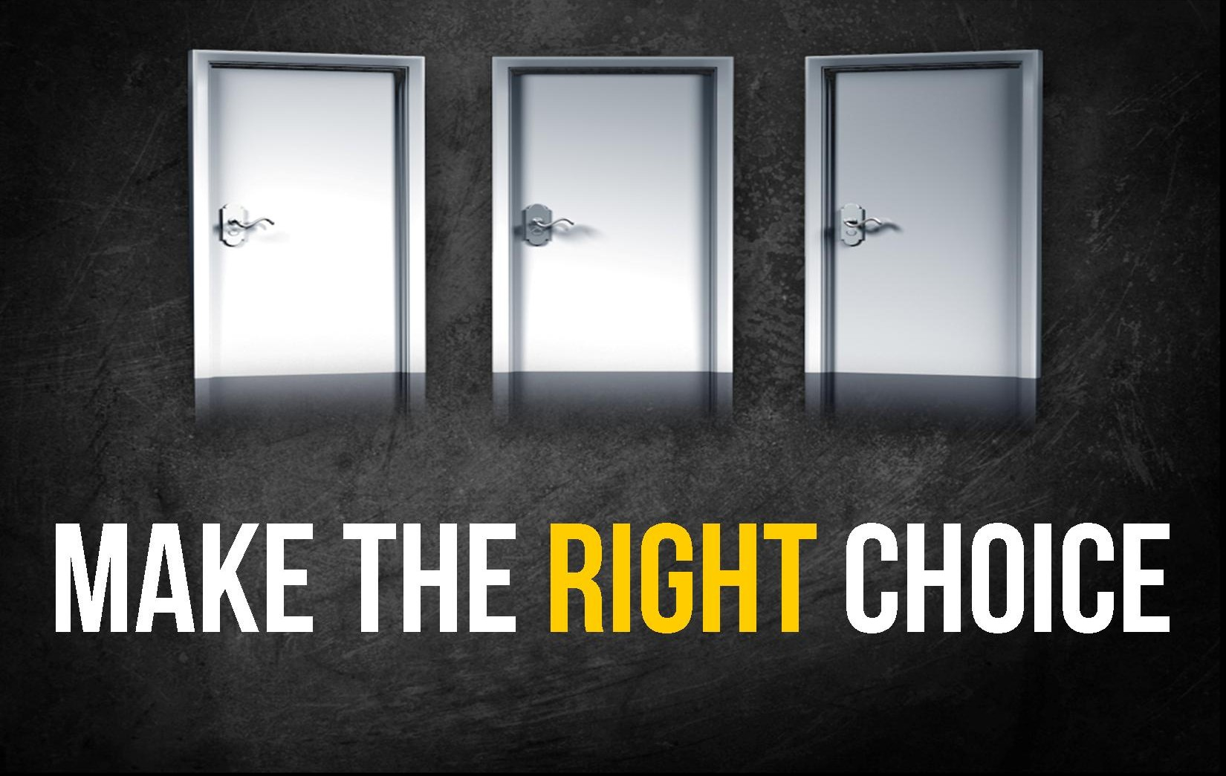
Think about the choices you are making.

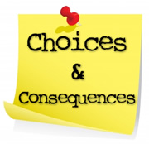
Move down the right choice path.

Appendix E
Golden Tickets for Lunchtime Supervisors use outside:

We are kind to each other
We line up sensibly
We ALWAYS do what Lunchtime Supervisors ask
We let others join in our games
We walk in when our House is called

Please exchange this for a good choice marble from your class teacher.
Name ……………………………………………………………..

Golden Tickets for Lunchtime Supervisors use inside:

We chat to the people next to us
We ALWAYS do what Lunchtime Supervisors ask
We are silent when asked for ‘our attention’
We say ‘please’ and ‘thank you’
We use a quiet voice in the hall
We stay in our seats when eating
We use a knife and fork
We are kind and helpful

Please exchange this for a good choice marble from your class teacher.
Fantastic choice! Name ……………………………………………………………..

