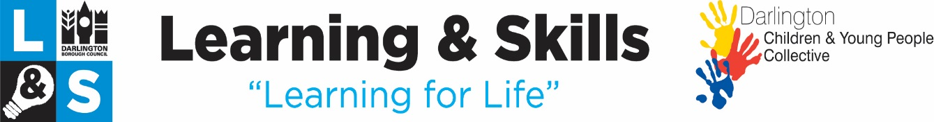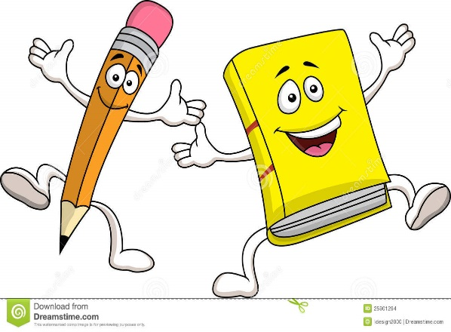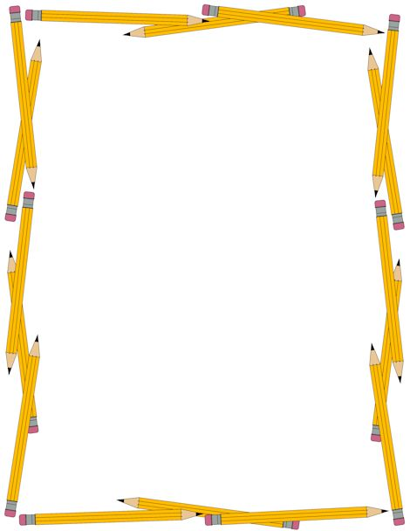

**Free 10 week course for parents , grandparents and carers.**

**Starting Wednesday 11th January**

**9.15am - 11.15am**

**Red Hall Primary School**

If you would like to book a place or require further information please telephone the Learning & Skills team on:   
**(01325) 405601**  
or email:   
**l&s@darlington.gov.uk**  
or text us on:  
**07932 869325**

**Fun with English**