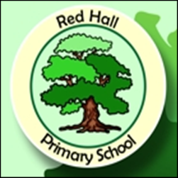

Red Hall Primary School
Parent Questionnaire 2016
Overview of responses
 | Strongly Agree | Agree | Disagree | Strongly Disagree | Don’t Know
My child is happy at this school. | 64% | 24% | 4% | 4% | 4%
My child feels safe at this school. | 64% | 32% |  | 4%
My child makes good progress at this school. | 74% | 18% | 4% | 4%
My child is well looked after at this school. | 74% | 22% |  |  | 4%
My child is taught well at this school. | 74% | 22% |  |  | 4%
My child receives interesting homework. | 64% | 22% | 14%
The school makes sure it’s pupils are well behaved. | 64% | 22% |  |  | 4%
The school deals effectively with bullying. | 50% | 18% |  | 4% | 28%
The school is well led and managed. | 58% | 32% | 4% |  | 6%
The school responds well to any concerns I raise. | 64% | 32% |  |  | 4%
I receive valuable information form the school about my child’s progress | 74% | 22% | 4%
I would recommend this school to another parent. | 74% | 18% | 4% |  | 4%
The school is welcoming and pleasant to visit. | 78% | 18% | 4%
There are a good range of clubs for my child to enjoy. | 52% | 22% | 4% |  | 22%
The school has a good reputation in the local community | 70% | 22% | 4% |  | 4%
The school’s website is helpful and informative. | 58% | 34% | 4% |  | 4%

