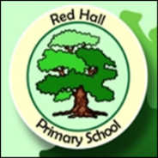
Parent Post

News for Parents and Carers at Red Hall Primary School September 2016
OUTSTANDING!

In July children from across the school filled in a questionnaire telling us what they think of Red Hall. We had over 120 responses and the results are simply fantastic! 76% of the children said that we are OUTSTANDING all the time. How brilliant is that? Our marking has been improving over the past year and now 78% of the children think that the marking really helps them to make progress.

Our marking gives the children challenges to give them the chance to improve and progress. The children love using the green pens we have and use them at the beginning of the day to level up and improve their work. Outdoor learning was also a big plus on the questionnaire with 81% of children feeling that these sessions are always brilliant.

The staff love being at Red Hall too! All 100% of them say that they feel proud to be a member of staff at the school. Isn’t that brilliant? We asked the Deputy Head, Mr Goffee, what he thinks and his response was, “Everyday is a fun day at Red Hall, I can’t wait to get in on a morning and hear all the children’s news. I love making progress with them!”

A big thumbs up to the pupils and staff at our fabulous school. Good luck to everyone as our journey to outstanding continues!! Check our website: redhallprimary.org.uk

