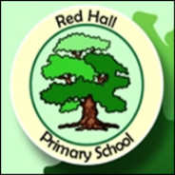
Parent Post

News for Parents and Carers at Red Hall Primary School October 2017
OUTSTANDING!

In May the children in year 6 took part in annual SATs week assessment, testing their reading, writing, maths and spelling and grammar skills. These tests were sat by children across Darlington and the whole of England. We’ve had the results back now and we are delighted to say that for the second year in a row ALL of them passed the maths test. Just to confirm: 100% of the children in year 6 passed the maths SATs papers! No other school in Darlington has such outstanding results and we are SO pleased for the children and for all the staff who worked so hard last year. Those children go on to secondary school really well prepared for the challenges ahead!

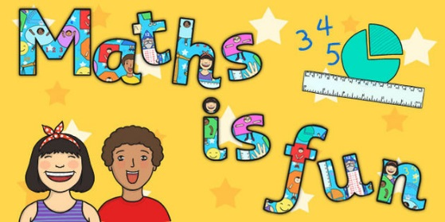

KEEP YOUR CHILDREN SAFE FROM HARM THIS CHRISTMAS

This Christmas your child will be looking forward to opening those presents and having a fabulous day! We all want Christmas Day to be a wonderful, magical time; what none of us want is to put our child at harm by exposing them to strong language and extreme violence. Some computer games include this kind of content and they can damage the child and expose them to things they shouldn’t see or hear at their age.

Games like ‘Call of Duty’ and ‘Grand Theft Auto’ have 18 age ratings because they have content that includes strong language and extreme violence. The children at Red Hall are no older than 11, none of them are equipped to deal with this kind of game – we have had a few examples of children using bad language in school who have been playing this kind of game. We want our children to develop into good, well rounded young people; exposing them to these sort of games when they are too young is not fair and right. The age ratings are there for a good reason.

Let’s make this Christmas safe and enjoyable. If you want to discuss the issues raised in this newsletter with someone in confidence ask to make an appointment with Mr Goffee in the office.
Check our website: http://redhallprimary-darlington.co.uk

