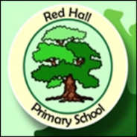
Parent Post

News for Parents and Carers at Red Hall Primary School May 2016
KEEPING SAFE ONLINE

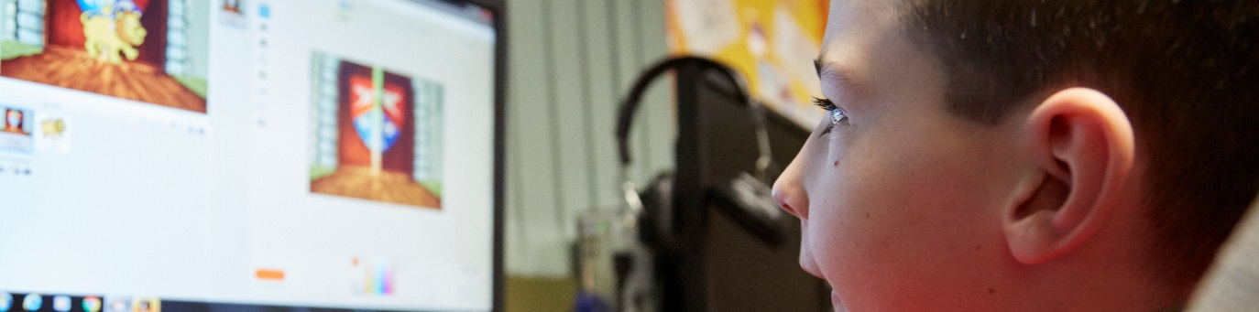

This last week of term has been all about keeping our pupils safe online. We all know that the internet can be a wonderful tool for discovering new information about our world. The latest news updates are just a click away. If you want to find out how many volcanoes there are in the world where do you look? The answer… ONLINE!

At Red Hall we want the children to learn all about the newly expanding digital world; in fact this year we have developed a brand new curriculum for computing that has got every child from year 1 to 6 learning how to use coding. This has led to the creation of hundreds of new online games – created by your children!

To use the internet safely though children need to know how to keep safe online. This is known as e-safety and this week the children have been learning about why it is so important to keep passwords secret and not message people online who they haven’t met face to face.

In a recent survey of the pupils in key stage 2 we found that over a third of them never have adult supervision when online at home. Another third of the children didn’t know who the people were they are messaging and have never met them.

These figures are worrying and we want to help the children be as safe as possible when online. The e-safety week has really opened their eyes up to the dangers of getting too close to strangers they meet online.

On June 16th we are running a special e-safety session just for parents – so pop along at 1.30pm to find out what you can do to keep your children safe online! Every parent who attends will be entered into our special raffle draw. For amazing prizes!

Have you checked out our new website? Go on and have a look! redhallprimary.org.uk

