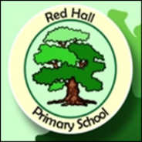
Parent Post

News for Parents and Carers at Red Hall Primary School June 2016
GRAND PRIX WINNERS!

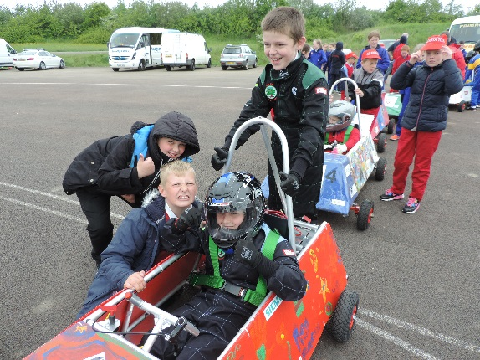

This year the children in year 6 have been working with a team of engineers from Cummins in Darlington – building and racing an electric powered car! As you know we are always looking for new experiences to expand the children’s learning and this project has certainly done that!

The children have had special lessons – delivered by the Cummins engineers – about the science behind a successful racing car. The children took their learning out of the classroom and into the ‘workshop’ (our newly decorated gym to be honest) where they learnt how to build and then drive the car.
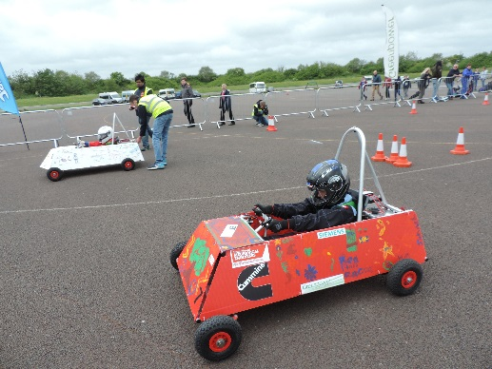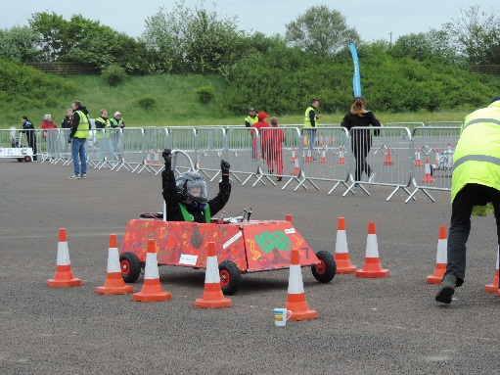

On the 25th of May the children travelled to the Nissan car plant in Sunderland for the big event. It was our first year competing in this prestigious event and the children came back with a trophy! FABULOUS!

Well done to all involved and a big ‘THANKYOU’ to Rachel and all the team from Cummins.

Have you checked out our new website? Go on and have a look! redhallprimary.org.uk

