Year 3 and 4
Newsletter

October 2017

What a busy half term we have had! The children have done so well and settled into their new classes. We are so impressed with how much effort they and their parents are putting into reading! Great to see so many signatures in those reading records!

The Blue Abyss
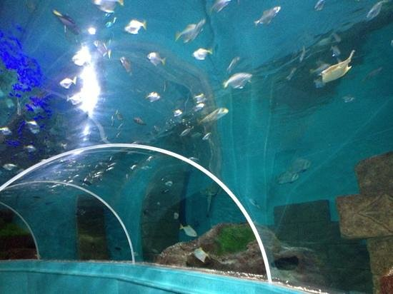
Our topic this term is called The Blue Abyss and we kicked off the year with a visit to the Blue Reef Aquarium on Tyneside! The children got to meet some rather wet new friends and began to understand how very different the creatures in our oceans are and how they are adapted to the three main zones.
The topic links into our Science and Literacy work too. In science we are looking at who are the predators and who are the prey underwater. The children are constructing food chains and discovering all about carnivores, herbivores and omnivores. In literacy we have been writing underwater adventures and letters to the manager of the aquarium, convincing them that we had a fabulous time using persuasive openers!
We are continuing with our topic after half term. Children are thoroughly enjoying the lessons associated with the Blue Abyss and we have lots more to learn finishing with the express stage event at the beginning of December (invitations to follow!).

Thank You for Coming
It was great to see so many of you at the Celebration Event last Friday. It means so much to the children having you there, they were talking about nothing else all morning. We love these events too, because it gives us a chance to show you the sorts of skills your children will be learning this year!

Staffing
Since September, Mr Taylor has been working alongside Mr Goffee in Year 4. After half term Mr Taylor will be taking on more responsibility for teaching the class, but Mr Goffee won’t be far away! This is an exciting opportunity for Year 4 as they will now have Mr Goffee, Mr Taylor and Mrs Wetton, meaning lots of support will be available on a daily basis, which should result in phenomenal amounts of progress being made! Fingers crossed! Mr Taylor is a trained chef, so he should cook up some interesting lessons…
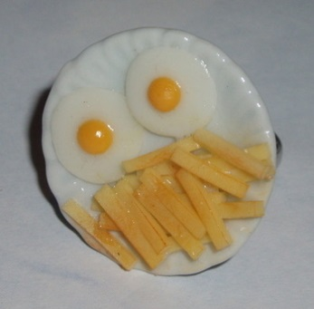
Reading Books!!
We need children reading at home each night and getting reading records signed at least 3 times a week. If your child has forgotten their reading book then get them to read a book from home and if they have forgotten or lost their reading record then you can simply download one from the website. Remember that EVERY child who reads at least 3 times a week over a term and has signatures to prove it in their record gets put into a prize draw for a brand new book!! We love reading at Red Hall, and hope you do too!
Times Tables
The children in years 3 and 4 CANNOT get to that next stage unless they know ALL their times tables. Does your child know them all up to 12 x 12? If not please help, they won’t get there unless we all work together!
Weekly Overview
Day | Year 3 | Year 4
Monday | PE and Red Hall Mile  Come in PE kit please! | PE and Red Hall Mile  Come in PE kit please!
Tuesday |  | Homework given out
Wednesday | PE with Miss Bright  Homework due in | PE with Miss Bright
Thursday
Friday | Times table challenge  Homework sent out  Spelling Test | Times table challenge  Homework due in  Spelling Test

If you have any questions or queries about the year, please do not hesitate to contact us.

Many thanks,
Mrs Marshall, Miss Wade, Mrs Wetton, Mr Taylor and Mr Goffee

